Tell us if you have a disability or a learning disability

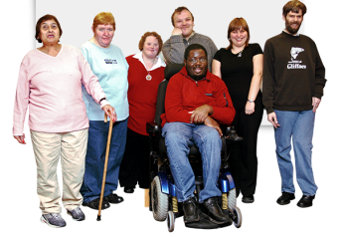 | If you are over 18 and have a disability or a learning disability you can fill in this form and send it back to us
 | We will send you back a card to keep that tells other people you have a disability.
You can use this card to help you with things like:

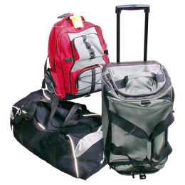 | - Booking travel and places to stay
 | - Getting in cheaper to some places like cinemas and concerts
 | - Housing points if you’re in social housing

Please fill this form in or ask someone to help you. You can also fill it in online: www.hertfordshire.gov.uk/adults

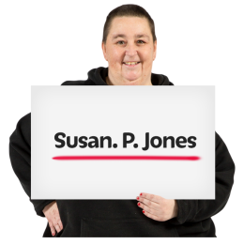 |  | Tell us your first name and surname:  _____________________________
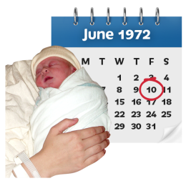 |  | Tell us your date of birth:  _____________________________
Tell us where you live:

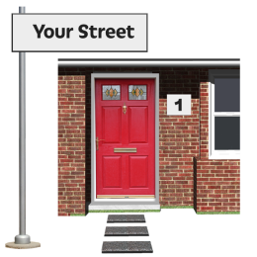 |  | House number and road:  _____________________________
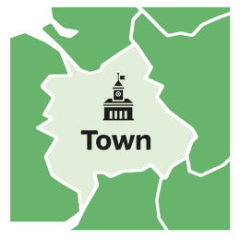 |  | Town:  _____________________________
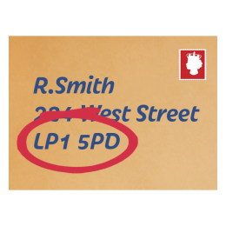 |  | Postcode:  _____________________________
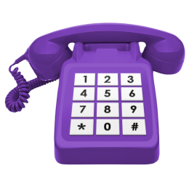 | Tell us your phone number:  _____________________________
Tell us your email address:

_____________________________

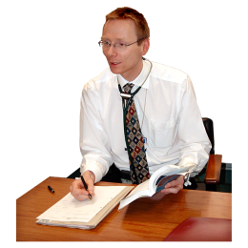 | Tell us your doctor’s name  _____________________________
Doctor’s house number and road:

_____________________________

Town:

_____________________________

Postcode:

_____________________________

Tell us about your disability:

_____________________________

_____________________________

_____________________________

_____________________________

_____________________________

Is there anything else we can help you with?
_____________________________

_____________________________

_____________________________

_____________________________

If you are filling this form out on behalf of someone else please tell us your name, address, phone number and relationship to the person registering.

Name:
Address:
Phone number:
relationship to the person registering:
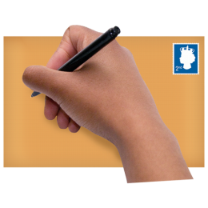
Post the form to: Disabled Registration, Health and Community Services, PO Box 153, Stevenage, SG1 2ST

We will post you back a card.

