Hertfordshire’s Outcome Bees:
An outcome is a change that results from something having been done; it is not an activity but, rather, the result of that activity. Outcomes can be positive or negative. Over a number of months we have consulted with a range of people across Hertfordshire to agree a set of outcomes that are most important to our work. The result of that consultation is illustrated below; we want children, young people, young adults and their families to:
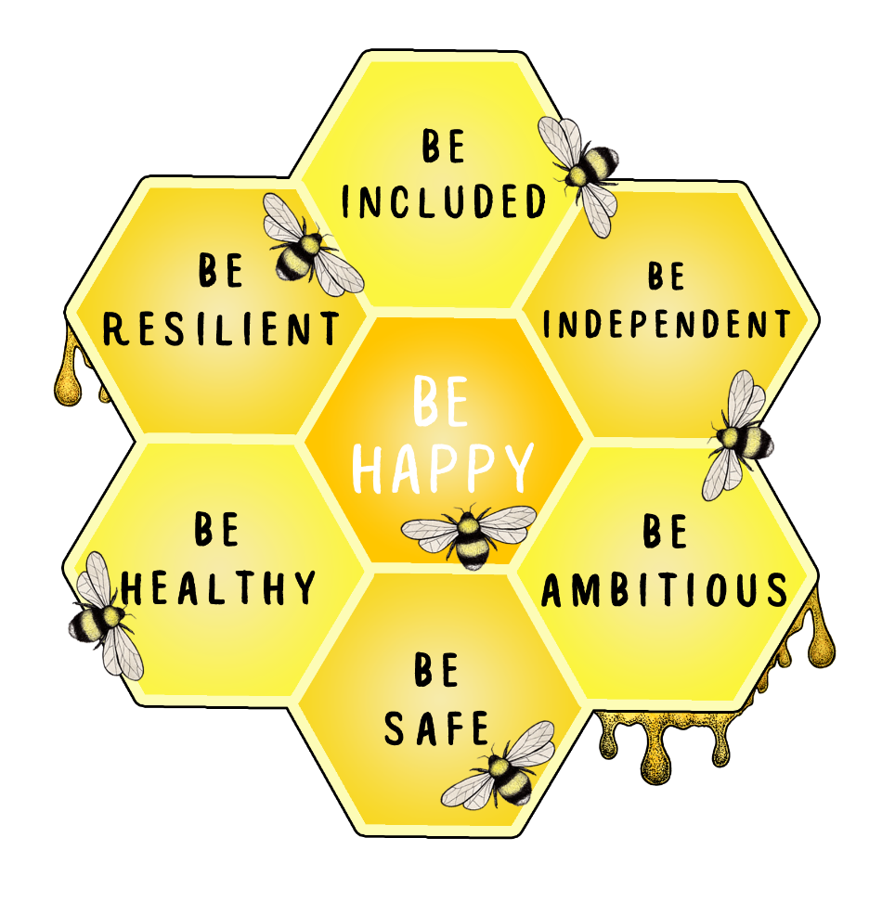

The six outcomes have been drawn in a way that shows they are inter-linked, all the ‘bees’ are important for the whole person and we would rarely expect to look at one outcome in isolation from the others. The layout also broadly reflects the psychologist Maslow’s thinking about needs, with the most fundamental needs along the bottom, moving up to happiness (or self-actualisation) at the top. The honeycomb represents our outcomes framework.
Each of the outcomes actually covers an outcome area, or domain, rather than a single change; for example, be healthy means many different things depending on the individual or family that we are working with. Below we have given some examples of the outcomes an individual may be looking to achieve in each of the domains.
Having a clear outcomes framework provides a vision that everyone can agree to and is important because it allows us to set clear targets. We can then look at both outcome measures and outcome indicators to consider how well we are meeting the targets. Outcome measures are things we can measure directly; for example, the number of children presenting at A&E with an accidental injury is a direct measure. Alternatively, the number of children who have had road safety training might be chosen as an outcome indicator, that is, a proxy measure rather than a direct measure.
- I feel accepted as I am, including my age, sexuality, disability, race, ethnicity, gender, religion, belief.
- I am involved and central in making decisions that affect my life.
- I have a voice and my opinions are heard and valued without being judged.
- I have a choice about the support I receive, when and where I get these and that they are sensitive and inclusive of my culture, faith and background.
- I feel like I belong, I have a sense of purpose and am part of a family/community.
- I have received feedback on how my views have made a difference

Be Included

- I am physically healthy
- I am mentally and emotionally healthy
- I have a positive and respectful approach to sexual health and relationships
- I live a healthy lifestyle and make healthy choices relating to diet and exercise
- I have spiritual wellbeing – I enjoy today and look forward to the future
- I have the information I need to understand risks and make the right choices.

- I am aware of, and can express, my rights and responsibilities
- I have good relationships with friends, family and in the community
- I am self-confident and able to deal with life’s challenges
- I can understand and manage / regulate my emotions
- I am positive about my identity and accept myself for who I am
- My talents are recognised and nurtured
- I am ready and able to access learning at school, college or another setting.
- I attend, engage and enjoy school/other learning settings
- I have the motivation and opportunity to learn and develop
- I am supported to perform to the best of my ability
- I am encouraged to learn and try new things, both in and outside the classroom
- I am developing the skills I will need in adulthood
- I am able to make good/positive choices in my life
- I get the help I need to manage my money
- I am developing the skills I need to be self-sufficient/manage my own care and support
- I am engaged in further education, employment or training on leaving school
- I am given the preparation and support I need to move into adulthood
- I am supported to work and to make a positive contribution to society
Be Ambitious
Be Resilient
- I am protected from abuse, neglect, violence and sexual exploitation
- I am safe from accidental injury and death
- I am safe from bullying and discrimination, including through social media
- I am safe from crime and anti-social behaviour
- I have safe relationships and feel safe and cared for in a home environment
- I make safe choices and am able to resist peer pressure
Be Independent
Be Safe
Be Healthy

- I feel like I belong, have a sense of purpose and am part of a family/community
- I feel valued, loved and cared for
- I have a good quality of life
- I do the things that matter to me and have a social life of my choice
- I have a voice and my opinions are heard and valued.
- I feel that my life has meaning

Be Happy

Be Included

Be Healthy

Be Ambitious
Be Resilient

Be Safe

Be Independent
Be Happy

Be Happy

