**Bishop’s Stortford Library Visual Story**

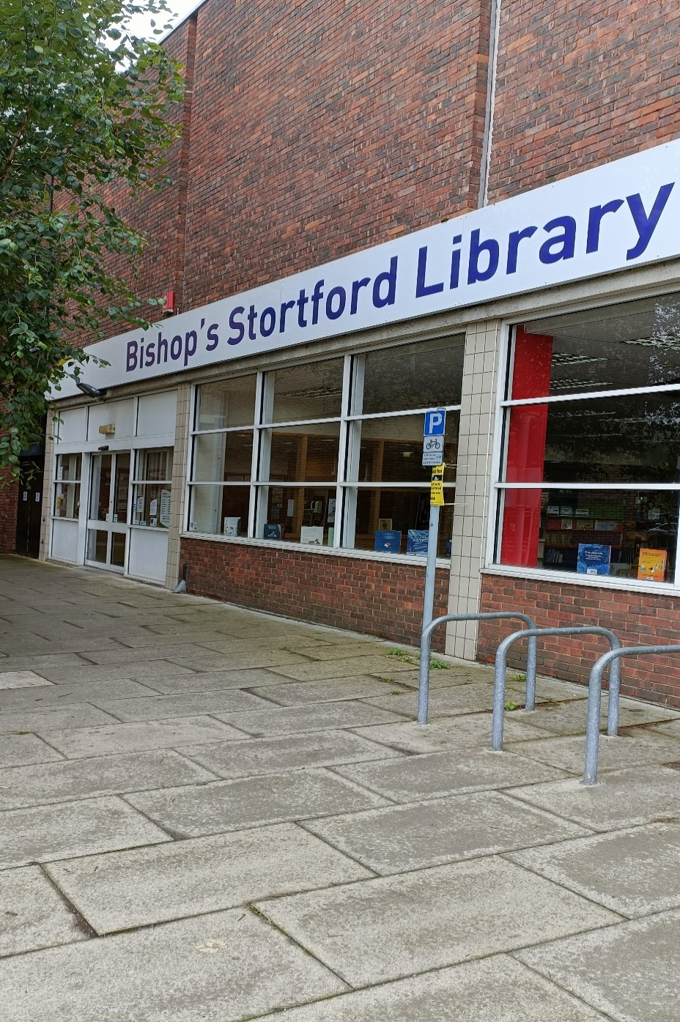

**Bishop’s Stortford Library, 6 The Causeway,**

**Bishop’s Stortford CM23 2EJ**

|  |  |
| --- | --- |
| www.hertfordshire.gov.uk/libraries | **HCC Logo GREEN (2019-02)** |

**Opening Hours:**

|  |  |  |  |
| --- | --- | --- | --- |
| **Monday** |  10.00am | - |  7.00pm |
| **Tuesday** |  10.00am | - |  6.00pm |
| **Wednesday** |  10.00am | - |  6.00pm |
| **Thursday** |  10.00am | - |  6.00pm |
| **Friday** |  10.00am | - |  6.00pm |
| **Saturday** |  10.00am | - |   5.00pm |
| **Sunday** |  12.00pm | - |   4.00pm |

This is a simple guide to help people visiting Bishop’s Stortford Library for the first time, if you have any questions

please ask the staff.

|  |  |
| --- | --- |
| outside view of a brick building with large glass windows and a sign above saying Bishop's Stortford Library | 👈  This is Bishop’s Stortford Library. |

|  |  |
| --- | --- |
| two people sitting at a desk in a library with a sign above saying enquiries | 👈  This is the help desk.  Ask here if you need help or have any questions.  If it is busy you may need to queue. |
| a woman smiling showing her staff badge | 👈    Library staff are here to help. All library staff wear a badge like this. |

|  |  |
| --- | --- |
| headphones | 👈  Sometimes we have noisy times in the library, and you may wish to visit at a quieter time.  Or you can bring some ear defenders to wear. |
| A hand holding two library cards in front of a bookshelf | 👈  This is a library card; you will get one when you become a library member.  You need a library card to borrow books, magazines, audiobooks and to use the computers.  To get a library card, ask the staff at the help desk. |

|  |  |
| --- | --- |
| pink self service kiosk | 👈  This is a kiosk. You can borrow and return books here.  Follow the instructions on the screen.  Ask the library staff if you need help.  If it is busy you may need to queue. |
| inside a library with bookshelves full of books | 👈  This is the main library area.  There are lots of books you can borrow. |

|  |  |
| --- | --- |
| A library with shelves of books | 👈  This is the children’s area. |
| shelves with magazines on display | 👈  You can borrow magazines. |
| audiobooks on a bookshelf | 👈  There are also audio books you can borrow.  These are recordings on CD of a book being read. |

|  |  |
| --- | --- |
| A library with desks and chairs | 👈  This is the quiet study area. There is free Wi-Fi in the library.  wifi logo  Ask staff for login details. |
| leaflet titled charges and concessions | We charge for some library services.  👈  Please ask staff for more information or for a leaflet. |
| A wooden door with a sign for toilet and baby change on the door | 👈  There is a toilet in the library. |

|  |  |
| --- | --- |
| books in a self service kiosk with a hand holding a library card | 👈  When you are ready to leave the library, take the things that you want to borrow to the kiosk and follow the instructions on the screen.  Ask the library staff if you need help. |
| hand taking a receipt from self service kiosk A screenshot of the library app on a phone  A screenshot of the library website homepage | You can take the things you have borrowed home.  Print a receipt so you know when you need to bring them back to the library.  Remember to return or renew your items on time to avoid charges.  You can renew your items at the kiosk or:   * ask at the desk * online at: [www.hertfordshire.gov.uk/libraries](http://www.hertfordshire.gov.uk/libraries) * Telephone: 0300 123 4049 * Textphone: 0300 123 4041 * On the Hertfordshire Libraries   app |

|  |  |
| --- | --- |
| someone putting books in a canvas bag | We hope you enjoyed the story.  If you need any extra help or information, please ask a member of staff.  👍  For more information on the library please visit our website:  [hertfordshire.gov.uk/bishopsstortfordlibrary](https://www.hertfordshire.gov.uk/bishopsstortfordlibrary)  Please come back soon. 😊 |