**Cheshunt Library Visual Story**

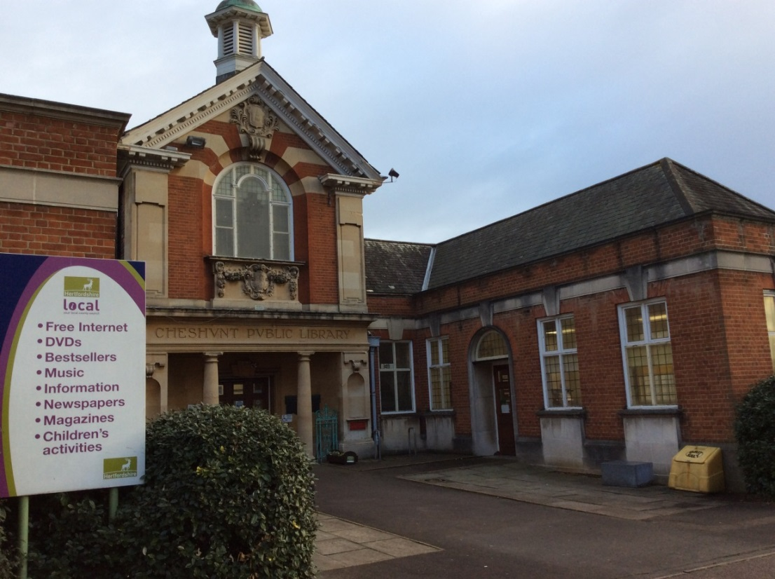

**Cheshunt Library, Turners Hill, Cheshunt, EN8 8LB**

**Opening Hours:**

|  |  |  |  |
| --- | --- | --- | --- |
| Monday | 9.00am | - | 6.00pm |
| Tuesday | 9.00am | - | 6.00pm |
| Wednesday | Closed |  |  |
| Thursday | 9.00am | - | 5.30pm |
| Friday | 2.00pm | - | 5.30pm |
| Saturday | 9.00am | - | 4.00pm |
| Sunday | Closed |  |  |

This is a simple guide to help people visiting Cheshunt Library for the first time.  
  
If you have any questions, please ask the staff.

|  |  |
| --- | --- |
| outside view of brick building | This is Cheshunt Library.   |
| 2 people sitting behind a desk | This is the help desk.    Ask here if you need help or have any questions.  If it is busy you may need to queue. |

|  |  |
| --- | --- |
| man smiling at camera and showing his staff badge | Library staff are here to help.  All library staff wear a badge like this.   |
| **headphones** | Sometimes we have noisy times in the library and you may wish to visit at a quieter time.    Or you can bring along some ear defenders to wear. |

|  |  |
| --- | --- |
| **library cards front and back** | This is a library card. You will get one when you become a library member.    You need a library card to borrow books or use the computers. To get a library card, ask the staff at the help desk. |
| pink self service kiosk | This is a kiosk. You can borrow and return books here.    Follow the instructions on the screen. Ask the library staff if you need help.  If it is busy you may need to queue. |
| large inside area with two children's tables and chairs, books shelves along the wall, a colourful carpet in the middle with wooden boxes full of picture books | This is the children’s area.   |
| rows of shelves with books | There are lots of books you can borrow.    If you cannot find a book you are looking for, you can ask the library staff to help. |
| shelves with audiobooksshelves with magazines on display | You can also borrow magazines, audiobooks or large print books.   |
| desk with computers | These are the computers. They are near the help desk. Library members can use them for free for two hours a day.    If the computers are busy you may need to book.  Ask the library staff if you need help. |
| low table with 2 tub chairs | There are comfy chairs in the library where you can sit and relax.   |
| study area with large tables and chairs | This is the study area. You can use the free Wi-Fi here with your own device.   wifi logo  Ask a member of staff if you need help using the Wi-Fi. |
| lady reading, sitting at a desk | Study spaces with special power sockets are available.    You can charge your own device here. |
| book on self service kiosk | When you are ready to leave the library, take the things that you want to borrow to the kiosk and follow the instructions on the screen.  Ask the library staff if you need help.  If it is busy you may need to queue.   |

|  |  |
| --- | --- |
| hand taking a receipt from self service kiosk | You can take home things you have borrowed. Print a receipt so you know when you need to bring them back to the library.    Remember to return or renew your items on time to avoid charges.  You can renew your items at the kiosk or:   * ask at the desk * online at [www.hertfordshire.gov.uk/libraries](http://www.hertfordshire.gov.uk/libraries) * Telephone: 0300 123 4049 * Textphone: 0300 123 4041 |

|  |  |
| --- | --- |
| outside view of brick building | If you need any extra help or information, please ask a member of staff.  We hope you enjoyed the story. Please come back soon. ☺  For more information on the library, please visit our website:  https://www.hertfordshire.gov.uk/services/libraries-and-archives/library-opening-hours/cheshunt-library.aspx |