**Hitchin Library Visual Story**

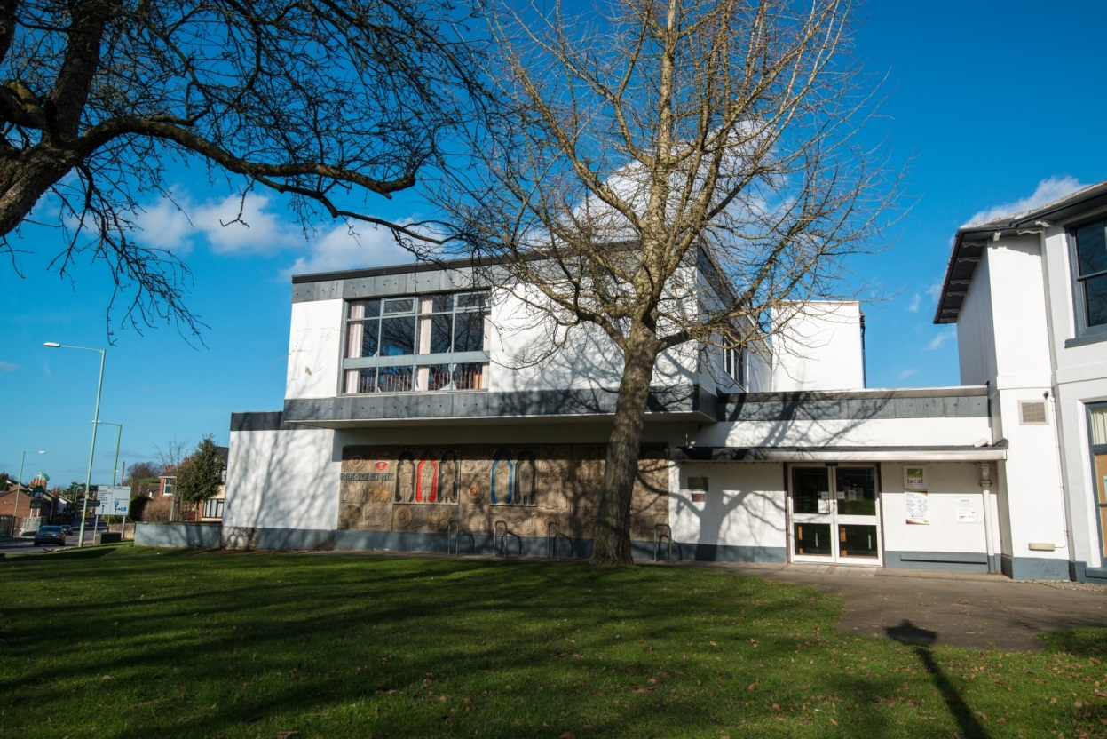

**Hitchin Library, Paynes Park, Hitchin, SG5 1EW**

**Opening Hours:**

|  |  |  |  |
| --- | --- | --- | --- |
| Monday | •1.00pm | - | 6.00pm |
| Tuesday | 10.00am | - | 7.00pm |
| Wednesday | Closed |  |  |
| Thursday | 10.00am | - | 6.00pm |
| Friday | 10.00am | - | 6.00pm |
| Saturday | 10.00am | - | 5.00pm |
| Sunday | Closed |  |  |

This is a simple guide to help people visiting Hitchin Library for the first time, if you have any questions please ask the staff.

|  |  |
| --- | --- |
| entrance with book shelves in the back and a display unit with books in the middle | This is the entrance to Hitchin Library   |
| desk with book display and a computer screen. A sign on the wall behind says enquiries | This is the help desk. Ask here if you need help or have any questions.    If it is busy you may need to queue. |
| a woman smiling showing her staff badge | Library staff are here to help. All library staff wear a badge like this.   |
| library card front and back | This is a library card, you will get one when you become a library member.    You need a library card to borrow books and DVDs and to use the computers.  To get a library card, ask the staff at the help desk. |
| **headphones** | Sometimes we have noisy times in the library and you may wish to visit at a quieter time.    Or you can bring some ear defenders to wear. |
| pink self service kiosk | There are 3 kiosks in the library. You can borrow and return books here. Just follow the instructions on the screen.    If you need help, our library staff are here to help you.  Sometimes it gets busy and you may need to wait in a queue. |
| small area with low table, 2 tub chairs with book shelves around | There are lots of books you can borrow.   |
| shelves with magazines on display | You can also borrow magazines.   |
| shelves with audiobooks | There are also audio books you can borrow. These are recordings on CD or cassette of a book being read.   |
| large inside space with book shelves in the back, 2 children's tables and chairs on the right and wooden boxes with picture books on the left | This is the children’s area.   |
| shelves with books | This is the Teenage area.   |
| **long row of computer desk with computer screens, keyboards and chairs** | These are the library computers, located upstairs. There is a lift available.    Library members can use the computers for free for one hour a day.  If the computers are busy you may need to book.  Ask the library staff if you need help. |
| large inside area with tables and chairs | This is the study area upstairs.   wifi logo  There is free access to the internet via Wi-Fi in the library.  Ask staff for login details. |
| toilet sign with stylised pictures of a woman, a man, a person changing a baby and a person in a wheelchair | There is a toilet in the library.    If it is busy you may need to queue. |
| cid:e43681d1-e20f-4615-8f86-7795d43b3938@Hertfordshire.gov.uk | When you are ready to leave the library, take the things that you want to borrow to the kiosk and follow the instructions on the screen. Ask the library staff if you need help.    If it is busy you may need to queue. |
| hand taking a receipt from self service kiosk | You can take the things you have borrowed home. Print a receipt so you know when you need to bring them back to the library.    Remember to return or renew your items on time to avoid charges.  You can renew your items at the kiosk or:   * ask at the desk * online at [www.hertfordshire.gov.uk/libraries](http://www.hertfordshire.gov.uk/libraries) * Telephone: 0300 123 4049   Textphone: 0300 123 4041 |
| cid:38b11f0d-3e1d-4975-99eb-d73f8a421c04@Hertfordshire.gov.uk | We hope you enjoyed the story.  If you need any extra help or information please ask a member of staff.     For more information on the library please visit our website:  [www.hertfordshire.gov.uk/hitchinlibrary](https://www.hertfordshire.gov.uk/hitchinlibrary)  Please come back soon. ☺ |