EHM How to Guide – Restarting a TAF Meeting after a meeting cancellation

TAF meetings should not normally be cancelled in EHM, the meeting should be rescheduled instead. However, should a meeting have been accidentally cancelled, so that there is no active (blue) TAF meeting showing in the pathway map, you will have to restart the meeting in order to proceed with your case. The procedure is as follows:
- Click on the grey TAF/Review Meeting box in the pathway
- Then click on Restart

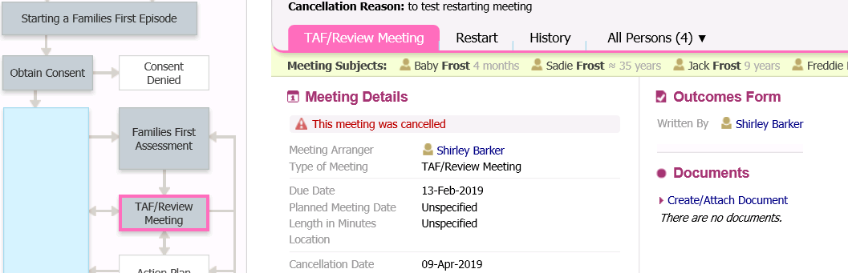

- On the next screen, you must enter a date. This date should be 6 weeks prior to the actual date of the TAF meeting that you want to start, in order for the system to calculate the correct date of the TAF meeting.
- Then click on ‘Start this step’

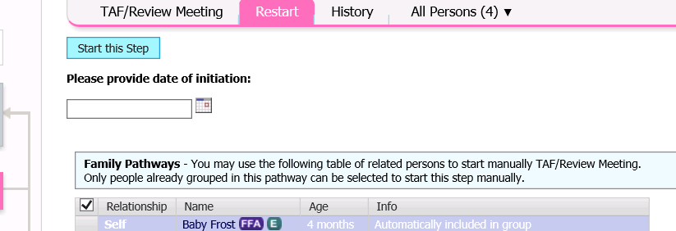

The TAF/Review Meeting box in the pathway will now turn blue - the TAF meeting is now open and ready for you to update the meeting details and scheduling and add the attendees.

