To: All people that receive  Direct Payments from  Hertfordshire County Council | Hertfordshire County Council  Adult Care Services  County Hall  Pegs Lane  Hertford  SG13 8DQ  Date: 18th January 2021

Dear Direct Payment User,

Help for people who use Direct Payments

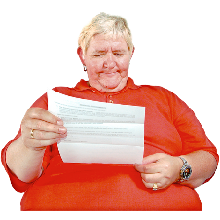 | I am writing to let you know about the help that is available to you due to Covid-19 (coronavirus).
 | We have included some frequently asked questions with this letter to support you to keep safe and get the care you need.
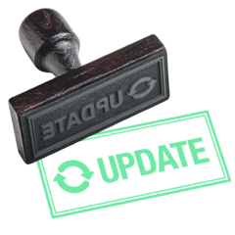  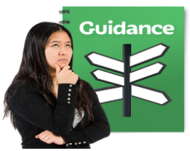 | We will update our frequently asked questions regularly in line with Government guidance.
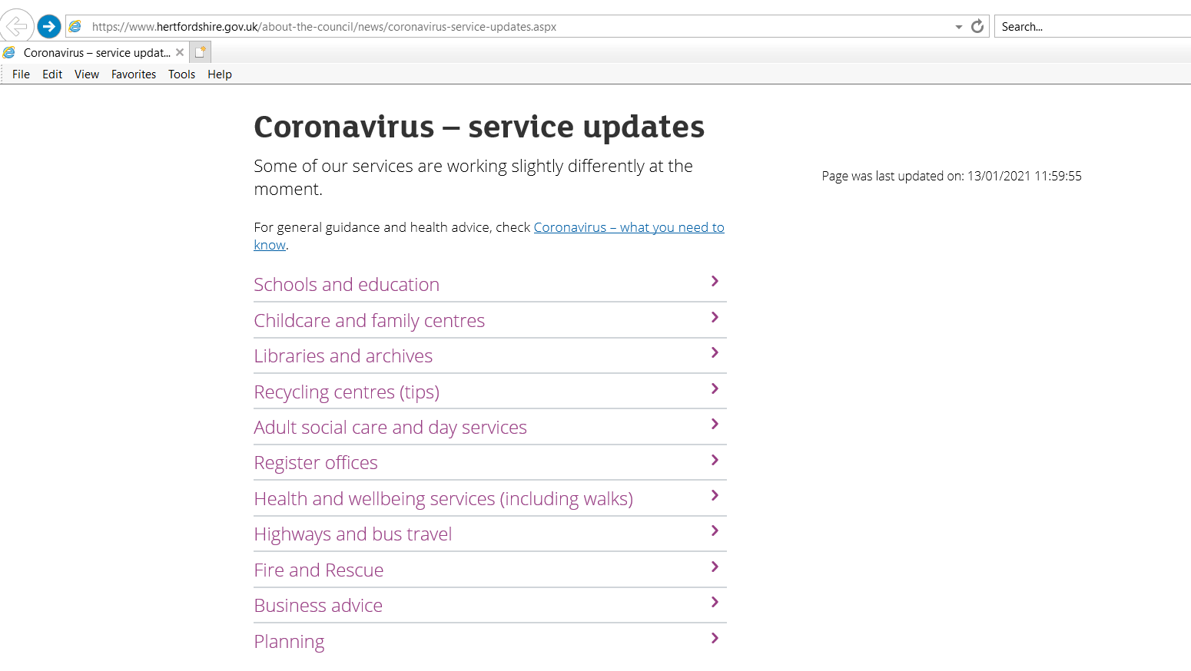 | To see all our frequently asked questions. Go to our website:  www.hertfordshire.gov.uk/serviceupdates
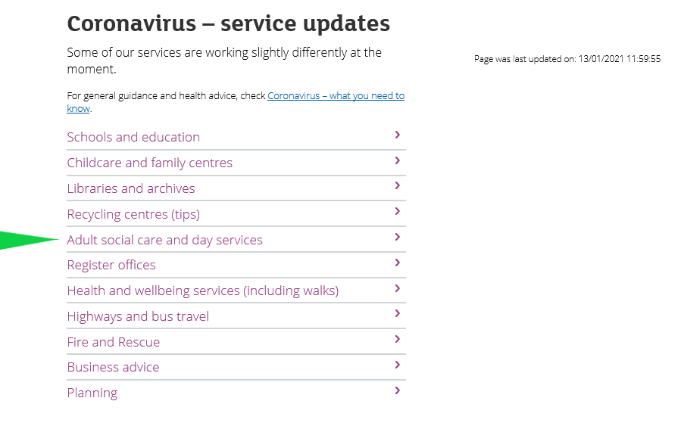 | Choose ‘Adult Social Care and Day Services’.
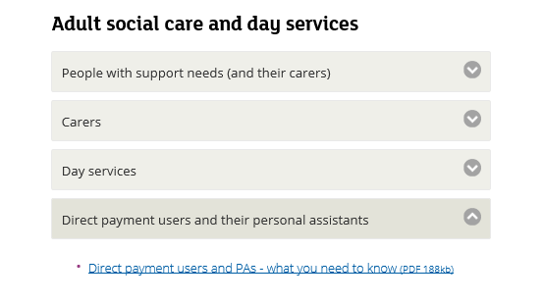 | Then ‘Direct Payment Users and their Personal Assistants’
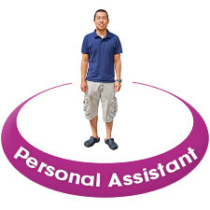 | Our frequently asked questions include important information for your Personal Assistant (PA).
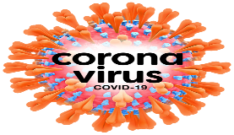 | Coronavirus may mean it is difficult to use your Direct Payment in the way you usually do.
 | What matters most is that you can use your Direct Payment in a way that allows you to stay safe and well.
 | Please continue to use your Direct Payment to meet your needs in your care plan.
If you are unsure on what you can spend your Direct Payment on.
Please call 0300 123 40 42 and ask to speak to your social care management team.

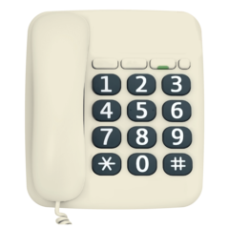 | If you cannot visit our website or need any further help please call Leonard Cheshire on:  01462 439 000.
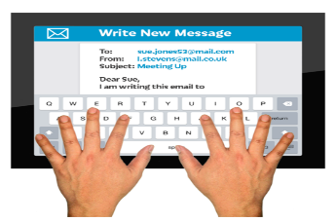 | If you would like a copy of the Direct Payment frequently asked questions in easy read please email:  sam.wood-ede@hertfordshire.gov.uk

Yours sincerely,
Sam Wood-Ede
Direct Payment Manager Adult Care Services

