DO YOU HAVE A LEARNING DISABILITY?
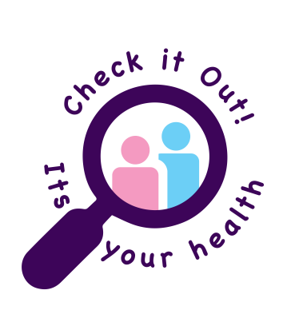
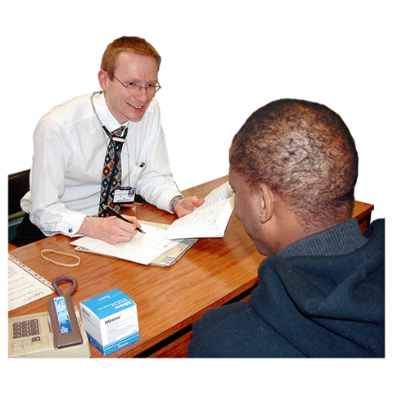
ARE YOU 14 OR OLDER?

Then you can ask reception for an

Annual Health Check

The health check helps to makes sure you are well and check for any problems.
Some Illness’ hide so it is important to
Check It Out and Stay Alive!

