DO YOU HAVE A LEARNING DISABILITY?
You can have a FREE Flu Vaccine
Ask at Reception

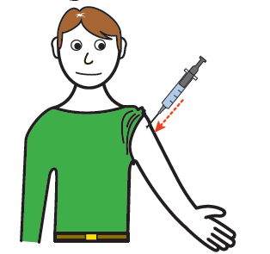
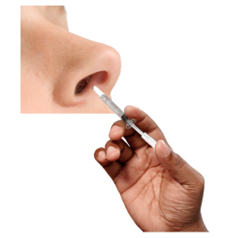
Flu can make you very ill and the vaccine will
help protect you from getting flu. It is given as
an injection but if you won’t have injections it
can be given as a spray in your nose

