THE NEW 2023 PURPLE FOLDER IS OUT

DO YOU HAVE A LEARNING DISABILITY? ARE YOU 18 OR OLDER?

If you live in Hertfordshire or your GP is in Hertfordshire, you can have a
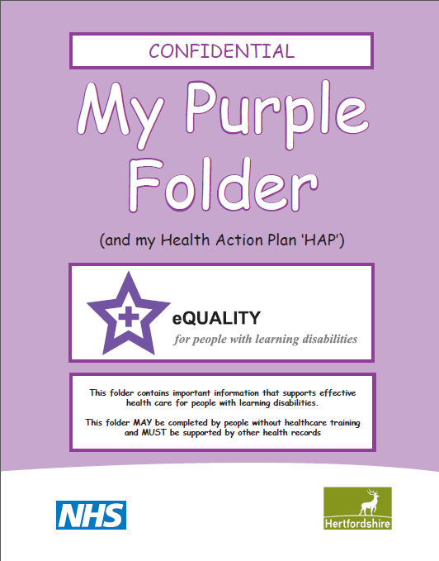
Purple Folder – The NEW Version
This is a folder for storing information about you and your health needs.
You take it to all health appointments to help health staff understand your health needs and what reasonable adjustments they need to make to help you.

If you go out and about on your own then you can also ask for a Purple Card

To get a Purple Folder or Card email
PurpleFolder@hertfordshire.gov.uk
Or call 01438 843848

