**Getting system One to download the health check action plan**

There is a national clinical template and care plan provided by SystemOne. The care plan title is **LD-Learning Disability Health Plan (Oct 2017)** and it is a system wide Word document located as shown in the screenshot below. It is in the Setup – Referrals & Letters – ‘New’ Word Letter Templates area.

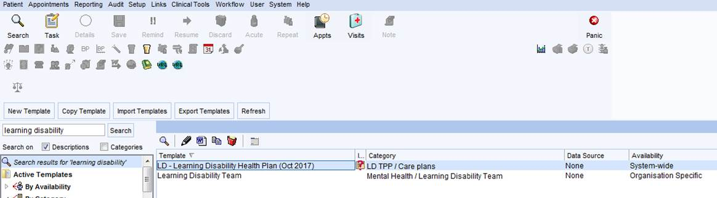

If the GP / Nurse at the surgery requires some training on how to use these items, the practice manager should contact the training team at HBLICT who provide SystemOne support across Hertfordshire.

Watch a video guide re Ardens and System one

https://ardens.freshdesk.com/support/solutions/articles/31000147192-learning-disabilities