**Here are some cards you may want to use.**

**Cut them out and put them in to your travel wallet**

**This guide tells you**

* **About the travel wallet**
* **How to get** a travel wallet
* **How to use** your travel wallet

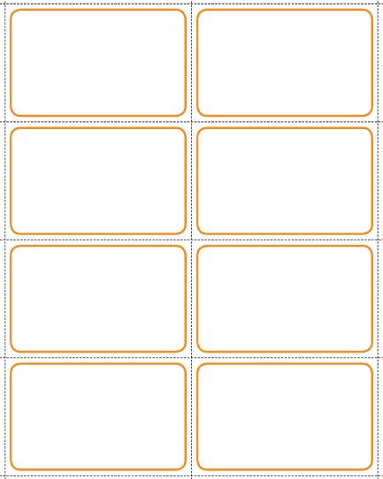

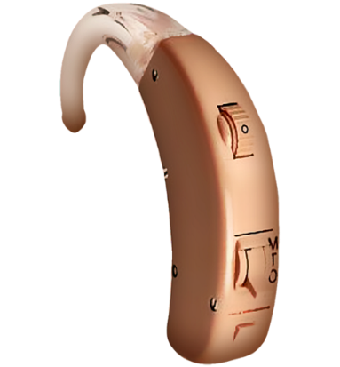

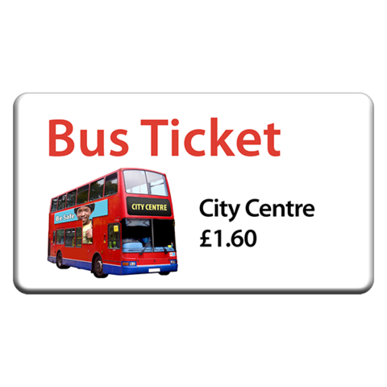

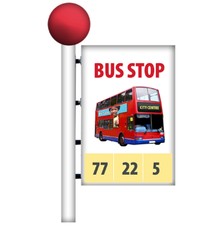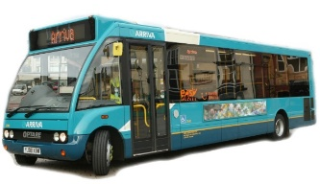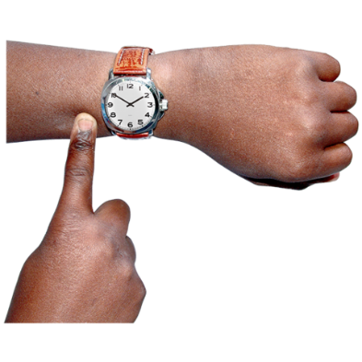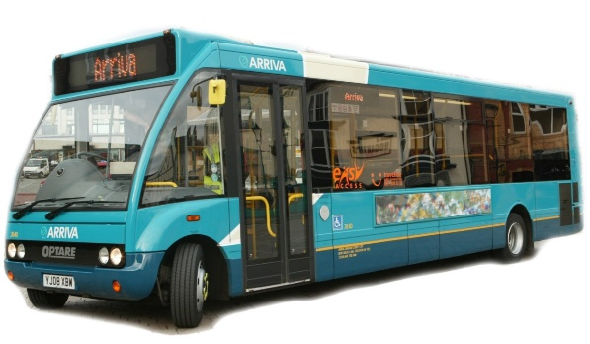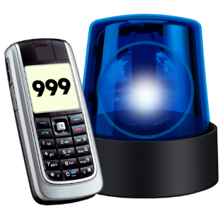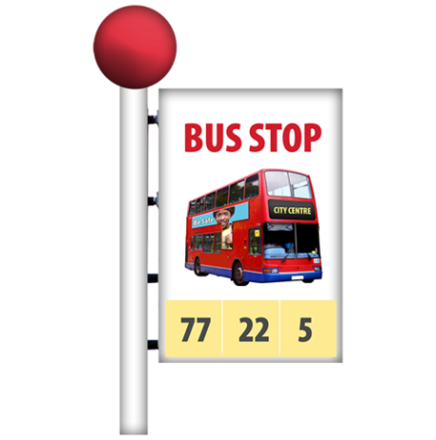

**Please call 999,**

**it is an emergency**

**Where do I get the bus back from please?**

**Please tell me when I get to my stop**

**What number bus do I need to get?**

**I use a hearing aid, please look at me when you speak**

**What time is my bus back?**

**Can I have a ticket please**



**I need help, please call this number:**

……………….……….**.**

**Add your own words and pictures to these cards.**

**Cut them out and put them in to your travel wallet**

