**Learning Disability Annual Health Check**

The learning disability files are downloaded and managed from **Download Web Files**.

1. Log into Vision, right click on the Vision+ icon in the Windows Notification area and select **Download Web Files** from the menu.

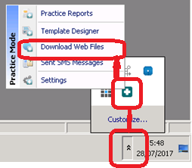

**Note** - To access Download Web Files, you must not have a patient selected in Consultation Manager.

**2.** A list of files available to download and files already downloaded is displayed.

**3.** Find **Learning disability annual health check** in the list and tick the **Download** box.

**4.** Next select the **Download** button.

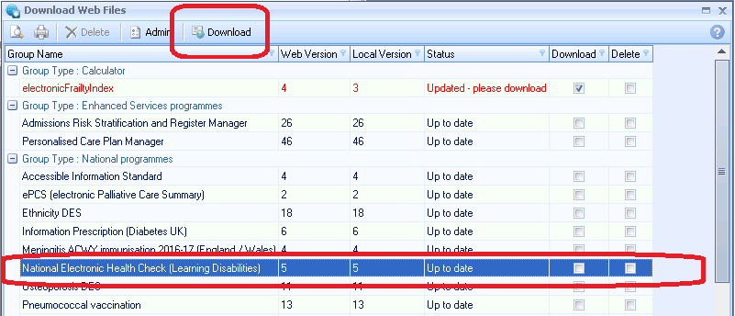**5.** A progress bar displays at the bottom of the screen showing the progress of the download. Once complete the Learning disabilities file is displayed in the web file list.

**Note** - Downloaded templates are available to all users in your practice.

**6.** Close the Download Web Files screen to exit.