Version B1

Hertfordshire County Council

East of England Permit Scheme

Year 9 Evaluation

Document Content

1 Introduction 6

1.1 The network management duty 6

1.2 The role of a permit scheme 6

1.3 Regulatory requirement for a permit scheme evaluation 7

2 Executive summary 8

3 Analysis of works 12

3.1 Applications for work 12

3.2 Application lead time 12

3.3 Work undertaken 14

3.4 Work category 15

3.5 Work activity type 17

3.6 Work duration 18

3.7 Analysis of duration 19

3.8 Work exceeding planned duration 20

3.9 Use of traffic management 21

4 Analysis of work coordination 23

4.1 Responses to permit applications 23

4.2 Collaborative works 24

4.3 Changes during the life of a permit 27

4.3.4 Permit condition changes 27

4.3.6 Duration changes 28

4.3.9 Traffic management changes 30

4.4 Variations to permits 31

4.4.3 Requests for work duration extensions 32

4.4.10 Other variations from Promoters 33

4.4.11 Variations issued by the Council 34

5 Analysis of permit conditions 36

5.1 Use of permit conditions 36

5.2 Conditions for Date & Time Constraints 37

5.3 Conditions for Material and Plant Storage 38

5.4 Conditions for Road Occupation 39

5.5 Conditions for Portable Traffic Signals 41

5.6 Conditions for Traffic Management Changes 42

5.7 Conditions for Work Methodology 44

5.8 Conditions for Consultation and Publicity 45

5.9 Conditions for the Environment (Noise) 46

5.10 Local Conditions 46

6 Analysis of permit compliance 47

6.1 Permit compliance inspections 47

6.2 Offences for working without a valid permit or breach of condition 48

7 Analysis of parity treatment 50

8 Analysis of cost and benefit 54

1.1 Scale and characteristics of works 54

1.2 Impact of works 54

1.3 Quantification of scheme benefit 55

1.4 Scheme Operating Costs 56

1.5 Appraisal results 56

1.6 Emissions savings 57

9 Annex A: Evaluation methodology 59

9.1 Source data for analysis 59

9.2 Work phases 59

9.3 Duration analysis and adjustment 59

9.4 Economic cost-benefit analysis 60

9.5 Period of analysis 61

9.6 Defining Promoters 61

10 Annex B: Glossary and common terms 62

11 Annex C: HAUC Performance Indicators 64

11.1 TPI 1 Works Phases Started (Base Data) 64

11.2 TPI2 Works Phases Completed (Base Data) 64

11.3 TPI3 Days of Occupancy Phases Completed 64

11.4 TPI4 Average Duration of Works 65

11.5 TPI5 Phases Completed involving Overrun 65

11.6 TPI6 Number of deemed permit applications 66

11.7 TPI7 Number of Phase One Permanent Registrations 66

12 Annex D: References 68

Foreword

Hertfordshire County Council is now 9 years into full operation of a Permit Scheme which meets a milestone for a full and detailed report into the efficiency and effectiveness of managing all works and events on the highway and minimising disruption to traffic through using such a scheme.

The emphasis on ‘traffic’ has changed in those 9 years, Hertfordshire’s values have shifted to promote modal shift from the private motor vehicle to more sustainable modes of transport including buses, cycles, and walking, as well as improving resident’s lives and ensuring equality.

The permit scheme has evolved and developed over time to support Hertfordshire’s values and, as this report demonstrates, is still needed to effectively manage the highway network to perform its primary function of the movement of people and goods whilst still allowing adequate access for statutory undertaker’s plant, highway maintenance and other events. Indeed, it will need to continue to develop and evolve to reflect the Growth, Climate and Sustainability Agendas. The use of conditions has been of great benefit to supporting local needs where works are taking place. We hope to see a Lane Rental Scheme in operation on the busiest sections of the highway network withing the next couple of years.

Proactive early coordination of works and events helps works promoters and the travelling public alike. It can be a struggle to satisfy every individual’s needs or to benefit from collaboration however many incentives are offered, but within Hertfordshire it is heart-warming to see how well the coordination and permitting teams have worked with works promoters over the 9 years, despite things like COVID, Brexit, staffing issues and other crises to keep traffic moving, utility supplies connected, Broadband rolled out, and events coordinated.

The detail is in the report that follows.

Jon Prince

Group Manager

Network Management Strategy and Compliance

Hertfordshire County Council

Key findings of the evaluation

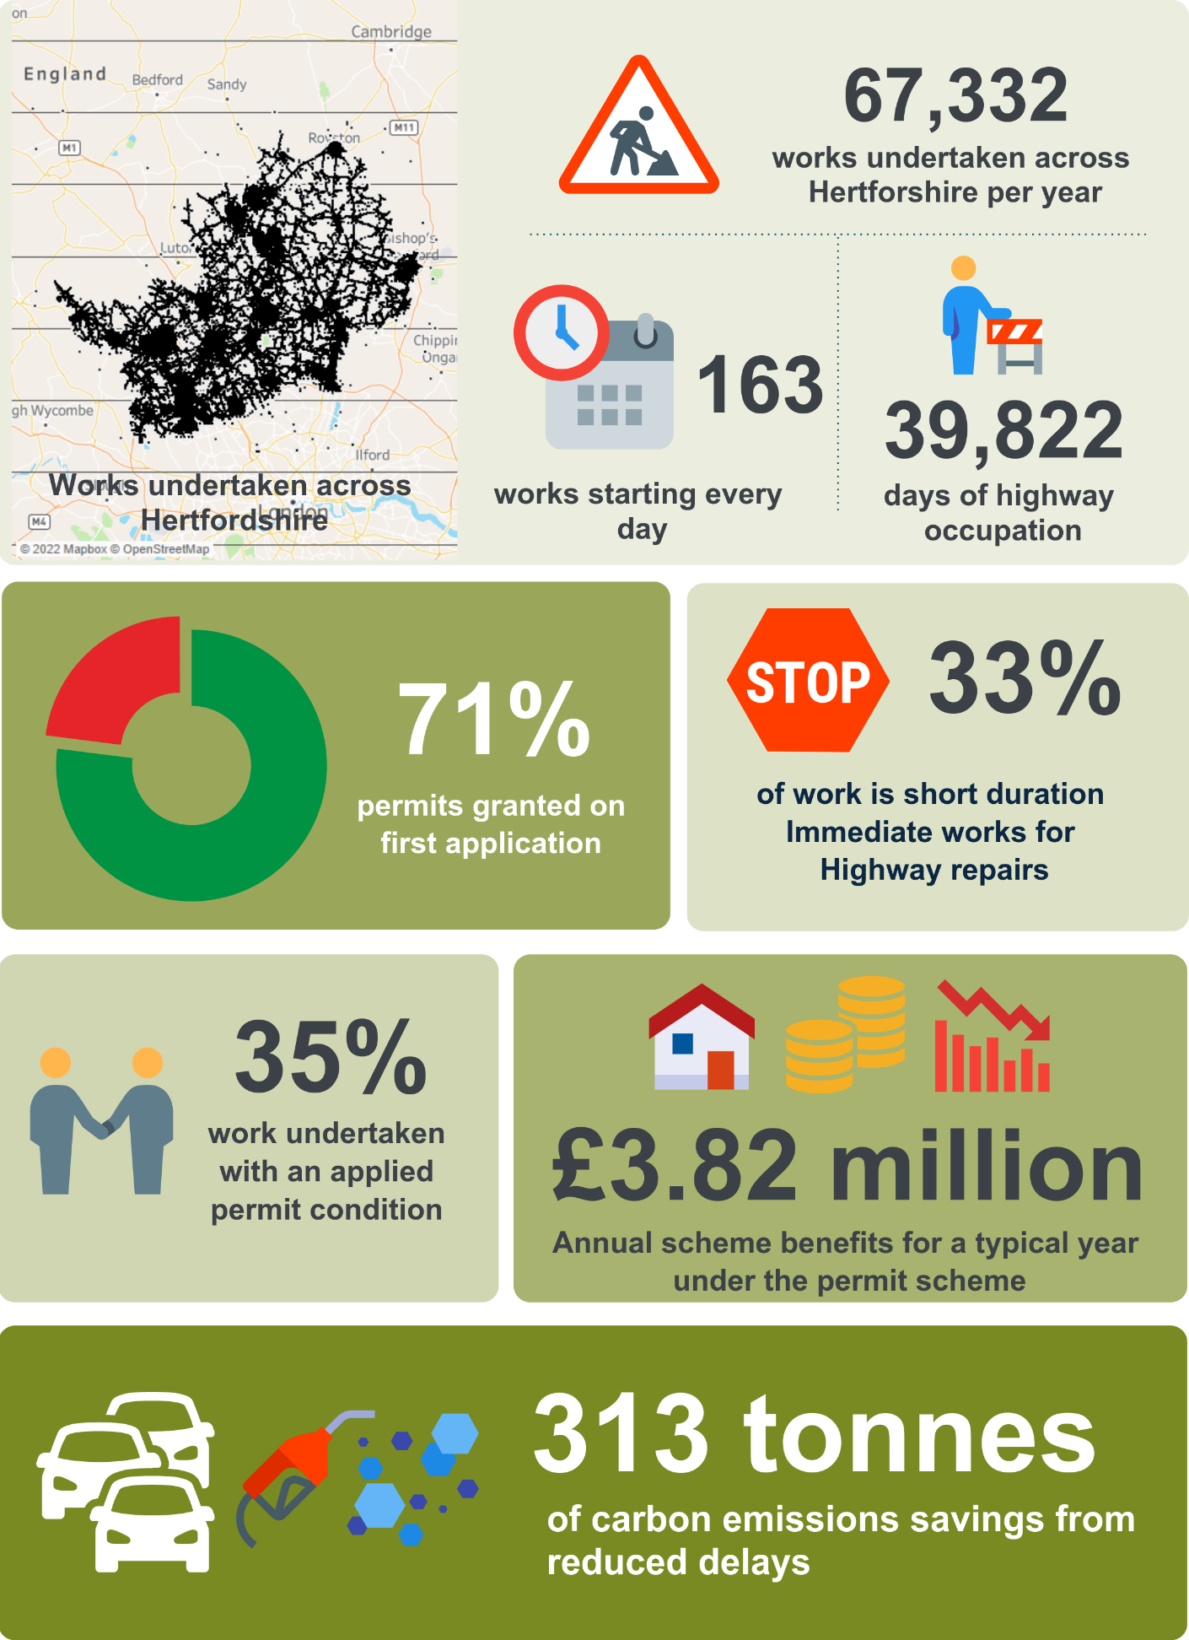

Figures quoted are based on the permit scheme operational years one to nine unless otherwise stated.

1. Introduction
   1. The network management duty
      * 1. In 1991 the New Roads and Street Works Act (NRSWA) placed a duty on the Council, as a highway authority, to coordinate activities (works) of all kinds on the highway under the control of that Authority.
        2. In 2004 the Traffic Management Act (TMA) and associated secondary legislation widened the NRSWA coordination duty. The scope of this increased duty has the following main considerations and Part 3 of the TMA allows for an Authority [Council] to introduce a permit scheme to support the delivery of this duty.

* manage the road space for all users.
* identify current and future causes of congestion, and to plan and act accordingly.
* take a proactive approach to the coordination of works on the road, including unplanned emergency works.
* gather and publish accurate information about planned works and events.
* manage unforeseen incidents and events on the network.
* establish and implement contingency plans for incidents and issues; and
* manage cross-border network travel and demands.
  1. The role of a permit scheme
     + 1. The fundamental objective of a permit scheme is to create a common procedure to control activities on the highway. It is essential that all activities in the highway are effectively coordinated and managed to ensure that traffic disruption and inconvenience is minimised whilst allowing the Promoters of those activities, such as utility companies or the Council, the necessary time and space to complete their work.
       2. Under NRSWA, organisations intending to carry out work on the highway notify the Council of their intention to carry out these works. The Council has powers to provide direction to these works and apply penalties for non-compliance, such as for instances where the works are not carried out according to the notice served.
       3. The powers under a permit scheme enable the Council to take a more active involvement in the planning and coordination of works, from the initial planning stages through to completion. This includes:
* organisations book occupation for work instead of giving notice, essentially obtaining a permit for their works.
* any variation to the work needs to be agreed, before and after works have started, including extensions to the duration.
* the Council can apply conditions to work to impose constraints; and
* sanctions with fixed penalty notices for working without a permit or in breach of conditions (of the permit).
  + - 1. In November 2012 the Council introduced the **East of England Permit Scheme**. The scheme was brought into legal effect through an Order under the provisions of the Traffic Management Permit Scheme (England) Regulations.
  1. Regulatory requirement for a permit scheme evaluation
     + 1. An amendment to the 2007 Permit Scheme Regulations saw the introduction of a new regulation (16A) which makes a provision for the content and timing of permit scheme evaluations
       2. This regulation states that permit schemes [should] be evaluated following the first, second and third anniversary of the scheme’s commencement and then following every third anniversary. The regulation further states that, in its evaluation, the Permit Authority [Council] shall include consideration of:
* whether the fee structure needs to be changed in light of any surplus or deficit.
* the costs and benefits (whether or not financial) of operating the scheme; and
* whether the permit scheme is meeting key performance indicators where these are set out in the Guidance.
  + - 1. This report has been developed by the Council to provide an evaluation for year one of the Permit Scheme and includes the provisions set out within the regulations.
      2. The regulations reference key performance indicators set out in the Guidance – where the Guidance is the Statutory Guidance for Highway Authority Permit Schemes (July 2020 latest edition). The Guidance reiterates the requirement from the regulations, adding each scheme evaluation must be made available to stakeholders (those consulted at the scheme development stage, as set out in Regulation 3) within three months of the date on which the evaluation was due.
      3. In addition, Annex A of the Guidance contains a list of Key Performance Indicators, as outlined below:
* TPI 1 Works Phases Started (Base Data)
* TPI2 Works Phases Completed (Base Data)
* TPI3 Days of Occupancy Phases Completed
* TPI4 Average Duration of Works
* TPI5 Phases Completed involving Overrun
* TPI6 Number of deemed permit applications
* TPI7 Number of Phase One Permanent Registrations
  + - 1. Annex C of this report contains the performance indicator results for each permit scheme year (as available).

1. Executive summary
   * + 1. When Hertfordshire introduced the East of England Permit Scheme (the Scheme) in November 2012 there was an expectation that the role of the Scheme, *primarily to reduce the impact of works across the network*, would gradually reduce. Compliance with the Scheme should naturally lead to improved coordination and control of works across the network by Promoters. Year 9 (2020/21) demonstrates that the role of the scheme has not diminished and continues to need input and resource from the Council.
       2. The volume of works, and associated applications, has remained broadly similar over the life of the scheme, with 54,164 work phases undertaken in Year 9. Works by sector have seen minor changes, mostly in water and highway authority work, which are attributed to changes in working practices, COVID19 and specific projects, *such as broadband rollout for the telecoms sector.*
       3. From the start of the Scheme there has been a noticeable increase in the average lead time for permit applications, which is the key requirement for effective coordination. The number of works with a shorter application period, thereby requiring an *early start,* has remained similar of the nine years (c. 1 out of every 10 applications) with 75% of these being granted by the Council.
       4. The introduction of a new digital system by the DfT in July 2020 saw several improvements in the information being provided by Promoters. One of these included an activity type, which provides more insight into the works being undertaken across the County:

* 42% of works are for highway repair and maintenance
* 32% of works are for utility repair and maintenance
* 16% of works are for highway and utility asset installation or improvement
* 4.4% of works are for remedial activities by utility companies to repair their damage to the highway
  + - 1. In a typical year, most of the work is undertaken by Council (33% of all work duration) and water sector (24% of all work duration). Planned work accounts for 57% of the total work duration, whilst the unplanned Immediate (urgent or emergency) work accounts for the remaining 43% of work duration. Due to the unplanned nature of Immediate work, these can have the greatest potential for disruption and inconvenience and require a lot of resource to coordination effectively.
      2. Many variations in work characteristics and limitations to data make it difficult to analyse work duration effectively, although analysis shows that average duration for work categories has reduced or remained similar over the nine years of the Scheme. Work exceeding the planned duration has remained low (c.2% of all work) with requests for a duration extension by Promoters typically granted on average 9 out of every 10 applications.
  1. Coordination
     + 1. The Council have used the permit scheme controls for effective coordination well since the start of the Scheme. The level of permit applications being granted in first application steadily dropped from Year 2 to a low in Year 6 (55% of all applications) and since then has been steadily increasing to a national standard of 75% (of all applications).
       2. Analysis shows that the main reason for refusal includes:
* Missing information.
* Missing permit conditions.
* Incorrect or missing traffic management details.
* Clash of other planned or active work; or
* Potential collaboration opportunities.
  + - 1. Whilst analysis demonstrates that these rejections lead to a change in the planning and undertaking of work, opportunities for collaboration is an area with the most challenge for change. In Year 9 178 works (475 days) involved a form of collaboration which is a very low proportion of the total work undertaken across the network in that year.
  1. Permit conditions
     + 1. The use of permit conditions can deliver the key benefits of a permit scheme. Some conditions are **implied** on all permits, *such as the working duration and display of permit number on site*, whilst others are **applied** either by the Promoter on their application or by the Council through the rejection of an application.
       2. In Year 9, 43% of work undertaken had an applied condition, which was the highest proportion of all scheme years. Analysis of the conditions applied in Year 9 shows the predominant use of conditions is to:

• limit the days and times of work.

• remove of signals when not in use.

• limit and control the use of traffic management; and

• provide advance publicity of work.

* + - 1. Many conditions are being applied during the initial planning stage, *after application and before work start*, thereby demonstrating proactive coordination and control by the Council.
  1. Use of traffic control
     + 1. There are noticeable changes in the use of traffic control over the life of the Scheme, with a decrease in work under *some carriageway incursion* and an increase in work under a more defined for of traffic control – passive, positive or no carriageway incursion.
       2. Analysis shows that the Council do reject applications because of insufficient or inappropriate traffic management details, and as such thousands of works have a traffic management change during the initial application stage (before work start).
       3. Overall, it is a fair assumption that working the Scheme enables the Council to ensure work complies with the relevant safety codes of practice, *keeping workers and road users safe*, whilst minimising any impact on traffic because of these controls.
  2. Promoter compliance to the Scheme
     + 1. Over the nine years of the Scheme the Council has operated a very effective permit compliance inspection regime. Dedicated onsite inspectors check that work is undertaken with a valid permit and in accordance with permit conditions. As such there is a high level of compliance inspections undertaken per year - 5,140 undertaken in Year 9. On average 85% of inspections result in a pass, with others failing for:
* Not having a valid permit.
* Not displaying the permit number on site (mandatory condition).
* Not working to permit times.
* Not advising the Council for changes in traffic management arrangements; or
* Not controlling the traffic management as per the permit condition.
  + - 1. As a result of these inspections, in Year 9 the Council issued 327 offences for working without a valid permit and 1,266 offences for breach of a permit condition. Each offence is subject to a fixed penalty notice issued by the Council to Promoters.
  1. Parity treatment
     + 1. Operating the permit scheme without discrimination between Promoters is a regulatory obligation the Council needs to demonstrate. Whilst accepting that different operating procedures and Promoter organisations would naturally require different approaches by the Council, analysis shows a general level of parity amongst the treatment of Promoters. Any anomalies for treatment of a specific Promoter sector can be explained and justified.
  2. Cost and benefits of the scheme
     + 1. The Council needs to demonstrate that the Scheme is not only being operated efficiently and effectively, but that it provides *value for money*. A cost-benefit-analysis would determine this through the analysis of work, the costed impact of these works on society, *such as for queuing traffic or diversion routes*, and the cost to administer the Scheme, for the Council and additionally for Promoters to comply with the Scheme.
       2. The annual benefit of the permit scheme in Hertfordshire is estimated at £3.82 million per year with an overall benefit-cost-ratio of 2.5. This means the scheme is delivering greater benefit than it costs and is classified as *high value for money*.
  3. Summary of recommendations
     + 1. This report contains several recommendations from the analysis and review undertake for the evaluation. These are summarised in the table below.

|  |  |  |
| --- | --- | --- |
| **Subject Area** | **Recommendation** | **Reference** |
| Work Category and Work Duration | Create framework to be used when the coordination team are considering duration of works. | 3.4.5  3.6.3 |
| Work Activity Type | Review and analysis of the use of activity types. | 3.5.3 |
| Responses to Permit Applications | Analysis of the use of RC10, RC11 and RC50 to identify any misuse or improvement opportunities | 3.10.7 |
| Collaborative Working | Consider further use of RC33 to at least demonstrate the challenges and limitations that exist across the industry. | 3.11.6 |

|  |  |  |
| --- | --- | --- |
| **Subject Area** | **Recommendation** | **Reference** |
| Collaborative Working | Undertake analysis of potential collaboration opportunities. | 3.11.7 |
| Work Duration Extensions | introduce a process of challenging duration requests for non-emergency works. | 3.13.9 |
| Permit variations issued by the Council | Review text used in HA variations to ensure correct response codes are used | 3.13.16 |
| Conditions for Consultation and Publicity | Review of data to ensure the correct application of condition NCT11b | 4.8.3 |

* 1. Conclusion
     + 1. The Year 9 evaluation clearly demonstrates that the permit scheme has evolved in many ways over the nine years of operation. Whilst being operated efficiently and effectively, the need for the Scheme has not diminished. In fact, the evaluation demonstrates that the role and need for the Scheme has increased. This is clearly evidenced in several areas, such as:
* Rejection of applications for better information or changes to the planned work.
* High levels of requests to vary permits, including extensions to the original planned duration of work.
* Continued addition of permit conditions missing from initial applications.
* Non-compliance to the permit scheme and permit conditions; and
* Changes in the planned traffic control.
  + - 1. Looking ahead, the Council are considering ways to improve the operation of the Scheme, including several recommendations (as above). They are also considering other regulatory controls, such as a lane rental scheme, to complement the permit scheme. Whilst conditions and coordination have a positive impact to work outside of traffic-sensitive times and collaboration between Promoters, a lane rental scheme could potentially bring additional benefits the Council are unable to achieve under a well operated permit scheme. Evaluation is already underway to determine the potential benefits of a lane rental scheme and whether the Council should consider this is a viable option for network management.

1. Analysis of works
   1. Applications for work
      * 1. All **registerable works** require an application to the Council to obtain a permit. Prior to the introduction of the permit scheme, the Council was notified of these works.
        2. Throughout this evaluation the term **application** refers to both the initial notice for a work and the application for a permit unless stated otherwise. Non-statutory forward planning notices are not included in this evaluation.

The chart below shows the volume of permit applications received for each Year with an average across all nine years.

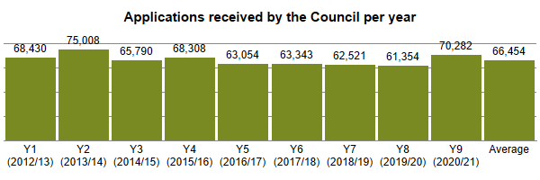

* + - 1. Applications have remained broadly consistent throughout the period of the scheme operation. The decrease in year 8, and subsequent increase in year 9, can be attributed to the reduction of works during the COVID-19 pandemic and subsequent catch up. Additionally, there has been an increase in works from the Telecoms sector due to the national broadband network roll-out and the number of works descriptions that were associated with new developments rose from 186-year 8 306 year 9. This reflects the high level of growth within the County.
  1. Application lead time
     + 1. For the Council to effectively carry out the coordination of works, including the advanced publicity of works, it is essential that applications are submitted with sufficient lead time based on the work category, as set out within primary legislation.
* Major work requires a 3-month advanced notice, which becomes a provisional advanced authorisation under a permit scheme.
* Major and Standard work requires an application lead time of 10 working days prior to the proposed work start date.
* Minor works require 3 working days lead time.
* Immediate works can be submitted after works start and must be received within 2 hours of works start or by 10:00 on the next working day if work started outside of non-working hours.
  + - 1. To reduce any anomalies the analysis only included applications with a lead time between 1 and 100 days for permits and 1 to 250 days for PAAs. The charts below show aggregate average application lead times across the nine years with a linear trend model which computed from a natural log of lead time for each of the observed 112 points (months).
      2. This analysis only includes applications that were submitted within the correct lead time – applications not submitted within the correct lead time are analysed further in this section.

The charts below show a trend line based on the average application lead time, per month, for the period between Year 1 and 9. The charts are delineated into work category and for PAA applications, and permit applications for Major work. Applications not submitted in time have been removed from this analysis to provide a more accurate representation of lead time.

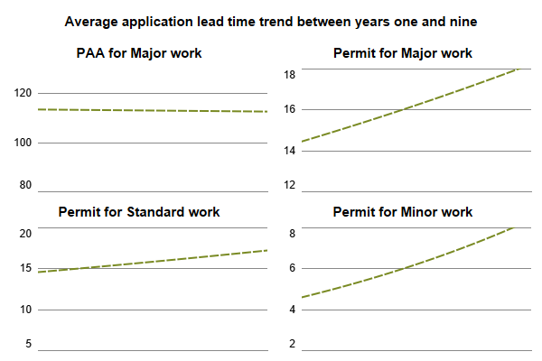

* + - 1. Apart from the lead time for PAAs which has remained broadly consistent, there has been an increase in the lead time for all other works. The greatest possible lead time is critical to enable the Council to effectively review and coordinate applications. The increase in lead time is a positive outcome. The Council are seeing an increase in early consultation on major schemes from both internal and external Promoters. This has enabled the Council to actively promote and remind works undertakers of required lead times.

The chartbelow shows the proportion of applications received in time (of total received) for planned work (excluding Immediate work category), in accordance with the minimum lead time, across Years 1 to 9

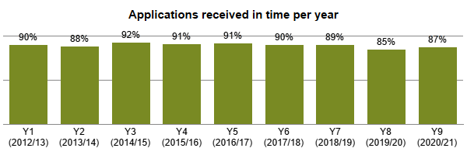

The chart below shows the proportion of requests for an early start granted by the Council (as a % of total received) in Years 1 to 9. Any instances of an application being superseded, cancelled, or auto granted (deemed) have been removed, leaving any remaining as either granted or rejected.

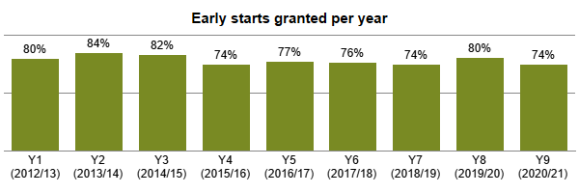

* + - 1. The % of applications received in time has reduced for years 7 to 9. The process for handling early starts changed with the introduction of Street Manager. The process now allows Promoters to submit applications for the required dates – regardless of the minimum lead time – and if the dates are acceptable to the Council, there is no requirement for a formal early start agreement. Where applicable, the Council always agrees the early starts before Promoters submit applications, to save double handling.
      2. For years 8 and 9, the covid-19 pandemic delayed multiple schemes which has resulted in a backlog of works. As a result, the Council are coordinating works where road space allows outside of lead times to maximise road space availability. In addition, early starts are being utilised to promote collaborative working.
  1. Work undertaken
     + 1. Works are only treated as ‘undertaken’ when they have reached a stage of ‘in progress’, *i.e., work has started.* Not all applications for work or where a permit has been obtained (granted) result in work undertaken. On average across the nine years of the permit scheme 85% of applications result in work undertaken.

The chart below shows the total volume of work undertaken per year, where the year is defined by the date of the initial application not the actual start date of work.

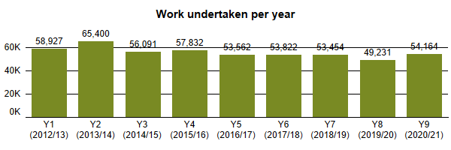

The chart below shows the total volume of work undertaken per year, where the year is defined by the date of the initial application, for each of the main utility types (colour legend).

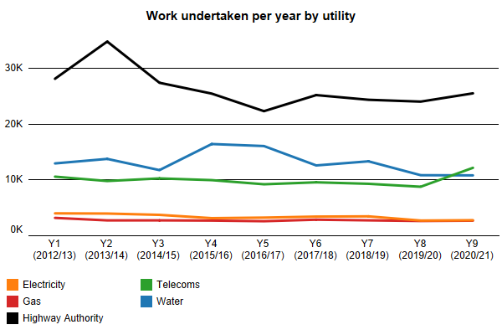

* + - 1. The lower volume of works undertaken in year 8 reflects the impact of the COVID19 pandemic. Approximately 23% of works in year 9 did not reach the stage of “in progress”. This increase is due to the transition to Street Manager from EToN where some works were cancelled in EToN and re-entered into Street Manager

The amount of works undertaken each year broadly reflect the applications shown in section 3.1. The increase in of works in the Telecoms sector for year 9 is attributed to the national broadband roll out programme. The increase in Highway Authority works in year 2 was due to the start of the new term contracts.

* 1. Work category

The tables below show the proportion of work and duration (total days) of work undertaken in Year 9 delineated by work category and utility type. The colour gradient (white to red) depicts the value (lower to higher).

Table % of work in year 9 by work category and utility type

5% of work duration days  by work category and utility type

The chart below shows work undertaken in Year 9 by total duration (days) and total number of works, delineated by the utility type and work category.

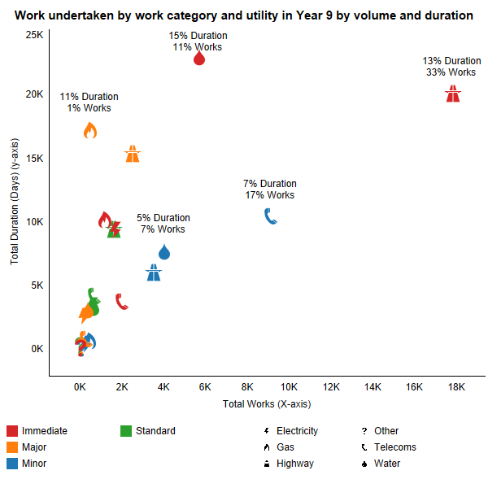

* + - 1. Works from the Highway and Water sectors make up most immediate works undertaken in year 9. The current process is to grant immediate applications unless there is significant information to suggest the works are not legitimate immediate works.
      2. Analysis of Highway immediate works shows that 85% are for carriageway or footway repairs. These are generally in response to fault reporting and are not cause for further investigation.
      3. Analysis of immediate works from the water sector shows a high % of works where no reference is made to “repair”, “loss of service”, “emergency”, “urgent”, “leak”, “flood” or “blockage”.
      4. It is recommended that the Council create a framework to be used when the coordination team are considering work categories and duration of works. This will refer to various sources including the HAUC guidance and average durations of completed works for different utility sectors and activities and work categories. The Council can use this framework to challenge work categories with more confidence.
  1. Work activity type
     + 1. Since the introduction of Street Manager in July 2020 Promoters have been able to provide an activity type on their permit, identifying the type of work being undertaken, *e.g., utility repair and maintenance works or disconnection or alteration of supply.*

The table below shows the proportion of work undertaken (% of total) in Year by activity type for each utility sector. The Total shows the % of all work for that activity.

Table of Activity type by utility sector

* + - 1. On the assumption that Year 9 shows a typical year of work, the following has been derived from analysis of the work activity types and the associated works descriptions:
* There were 421 works that were for traffic management only but only 191 (45%) had the activity type of “Optional Permit (no fee)”.
* There were 1,893 works that included “new service” or “new connection” in the works description but only 512 (27%) had the activity type of “new service connection”.
* There were 555 uses of the activity type “Optional Permit (no fee)”. The Statutory Guidance suggests the following are included in activity type “Optional Permit (no fee)”
  + placement of portable traffic signals or other traffic control,
  + placement of site welfare facilities,
  + placement of site compound or material storage,
  + placement of spoil compound for the works.
    - 1. It is recommended that the Council undertake a comprehensive analysis of the use of activity types and subsequently engagement with Promoters to ensure the correct activity type is being used.
  1. Work duration
     + 1. Analysis of work duration is based on works undertaken only. Durations are typically calculated in whole calendar days, however in reality a work, *such as an asset inspection or pothole repair*, may only take a few minutes or hours.
       2. Since the introduction of the DfT’s digital service, Street Manager, and associated regulatory changes in July 2020 it is possible to determine the timings more accurately and reliably from the works data. This means a work duration can be calculated by minutes instead of whole days. As such, analysis using Street Manager derived data provides a more realistic insight and result.

The chart below shows duration calculated by a whole calendar day and the duration calculated by the times provided in the work start and work stop notices in Street Manager. The period shown covers June 2021 (partway through year eight) to end October 2021 (whole of Year 9).

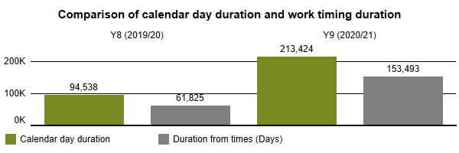

* + - 1. It is recommended that the Council create a framework to be used when the coordination team are considering work categories and duration of works. This will refer to various sources including the HAUC guidance and average durations of completed works for different utility sectors and activities and work categories. The Council can use this framework to challenge work categories with more confidence.
  1. Analysis of duration
     + 1. Analysis of duration considers trend over time, with work delineated into their ‘work category’, which is typically based on a duration banding, *i.e., a minor is work within 2-3 days*. Analysis of durations by works category include charts that show **average duration**, per month with a trend line that shows a linear trend model which is computed for each average duration (observation) per month.

The charts below show an average duration trend for the four work categories across Years 1 to 9 for work undertaken.

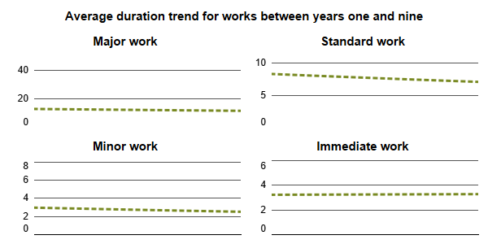

* + - 1. The most notable observation is the decrease in the average duration of Standard and Minor works. There have been agreements between the Council and some Promoters that instead of regularly submitting extensions to minor permits that they apply for standard permits instead.
      2. Immediate works have shown little or no change. This is because the extent and duration of works are unknown until on-site operation begins.
  1. Work exceeding planned duration
     + 1. Works being undertaken on a very busy and often congested road network that exceed their agreed reasonable period of duration can create significant coordination issues. In turn, these works can apply a ‘domino effect’ on work programmes and the potential need to reschedule or revoke other active or planned works that may clash with adjacent over running works.
       2. For this evaluation a work exceeding the planned duration is identifiedwhen a work’s **planned duration** at the start of work is exceeded by the **actual duration** at the end of the work. The duration of the unplanned duration is measured in **calendar days**.

The chart below shows the total number of works undertaken where the actual duration exceeds the planned duration per year (top chart); the additional duration (days) where the work has exceeded the planned duration (middle chart) and the proportion of all works undertaken (% of total) that exceeded the planned duration (bottom chart).

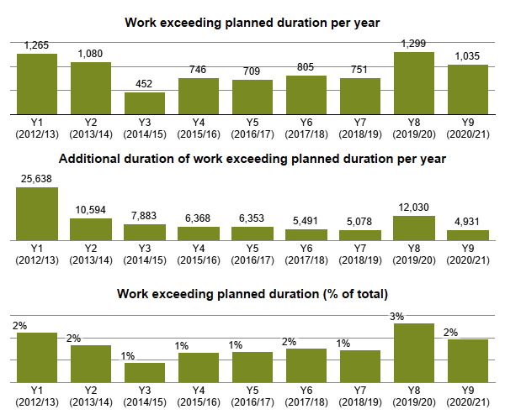

* + - 1. There has been a significant increase in the number of works exceeding planned duration in years 8 and 9, although the additional duration of work for year 9 is the lowest for all years of the scheme operation. Additionally, the % of works exceeding the planned duration for years 8 and 9 is equal to, or higher than, any previous year.
      2. Analysis of the Promoters exceeding planned duration in year 8 shows that Highways (49%) and Gas (21%) are the 2 highest Promoter types.
      3. Analysis of the Promoters exceeding planned duration in year 9 shows that Highways (46%) and Gas (26%) are the 2 highest Promoter types.
      4. Analysis of the works descriptions shows the vast majority were Immediate works for carriageway and footway repairs (Highways Works) and fixing gas escapes. As the extent and duration of immediate works are unknown until on-site operation begins, the Council has limited opportunity to restrict these durations.
  1. Use of traffic management
     + 1. All works must be undertaken using an appropriate form of traffic management (control) to ensure work is undertaken safely - for those undertaking the works as well as the road user, *including pedestrians, cyclists and in particular the needs of disabled people and vulnerable groups.* Different forms of traffic management have varying impacts to the network, *especially the use of portable traffic signals, lane closures and road closures,* so the need to undertake works safely whilst also controlling the impact of works needs to be balanced carefully.
       2. The **Code of Practice: Safety at Street Works and Road Works** sets out the proper arrangements for the signing, lighting, and guarding of works – this must be followed by all Promoters undertaking works on the highway.

The chart below shows traffic management (legend) for all works undertaken within Years 1 to 9 as a proportion of the total works.

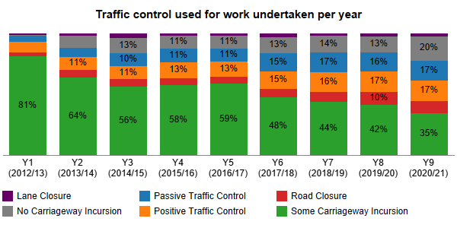

* + - 1. As shown within the chart, the predominate form of traffic control used on the network for work is some carriageway incursion. Positive traffic control, lane and road closure accounted for approximately 29% of the work undertaken in Year 9 which is comparable to years 7 and 8.
      2. Changes in the use of traffic management over the period of operating the permit scheme can be attributed to several different factors, including:
* Changes made by the Council during the initial planning stages (refer to section 4.6)
* Changes to the naming of traffic control across industry wide systems.
* Changes in the work being undertaking and the traffic control required; and
* Discussion between the Council and Promoters prior to an application submitted e.g., site meeting.

Analysis of work coordination

* 1. Responses to permit applications
     + 1. For a permit scheme to be effective the Council must process and respond to each application. Where the Council accept an application, this is granted. Where the Council do not accept an application, or want to make changes to the proposed work, it is refused, and a response code (based on a set of national codes) **must** be provided.

The charts below show the PAA applications and permit applications granted by the Council as a proportion of the total received in Years 1 to 9. PAAs and permits that were cancelled or superseded before a response was given have been removed from this analysis.

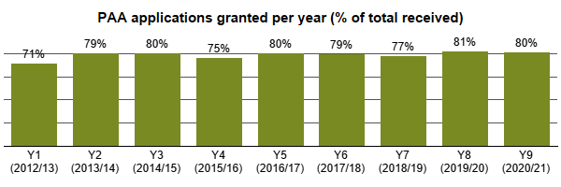

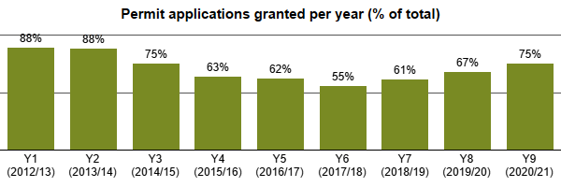

* + - 1. As shown in the charts, the % of PAAs granted remains broadly similar across the years but there are significant variations for the % of permit applications granted each year.
      2. Reasons for the variations in the % granted include:
* If a permit modification request is issued to request the addition of conditions, the response may be received too late, and the dates would need amending.
* Possible clashes with emergency works could also see a permit be refused.
  + - 1. It is clear, even after 9 years of operating the permit scheme, the highest reason for refusing an application is RC11 – missing conditions. This results in additional administrative work for both the Council and the Promoters. Whilst the correct application of conditions on *all* permit applications will never be achieved, works promoters should focus on getting applications right first time.

The chart below shows the total response codes used on rejected applications issued via permit modification request, permit refused and PAA refused for Years 7 to 9. A refusal can contain more than one reason and therefore code.

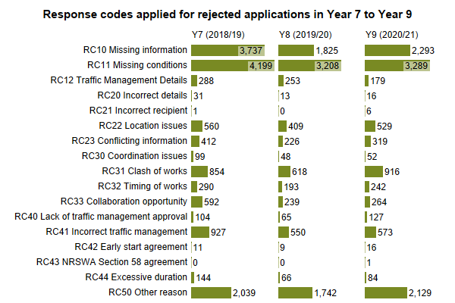

* + - 1. As part of the Councils’ existing Permit Scheme performance management framework, the Council has already commenced work to analyse and identify which Promoters are consistently not adding conditions, or adding wrong conditions, to their initial applications and this will be communicated via monthly performance meetings with the Promoters.
      2. It is recommended that further analysis is undertaken for the use of RC10, RC11 and RC50 to determine a) any trends that can be identified to reduce the need to use RC10 and RC11 and b) to ensure RC 50 is correctly used and reasons for refusal are not included in other RC codes. If necessary, the findings will be discussed with Promoters at monthly performance meetings.
      3. The Council will be undertaking additional training for the Network Coordination team to ensure the correct use of response codes. Additionally, the Council are currently working on simplifying information used by the team ahead of the planned changes to conditions.
  1. Collaborative works
     + 1. One of the most effective methods for the Council to reduce the potential disruption is for Promoters to collaborate their works, thereby undertaking work on the same section of the highway at the same time, under the same form of traffic management, or contiguous working where work methodology does not allow for works in close proximity.
       2. Collaboration between Promoters is recognised as an industrywide challenge, with limited opportunities and practical limitations within work delivery constraints, resource schedules and methodology. As shown in the section above, the refusal for applications is rarely for a collaboration opportunity.

The chart below shows the total number of works undertaken, and the duration of these works (days), where a form of collaboration was used in Year 9.

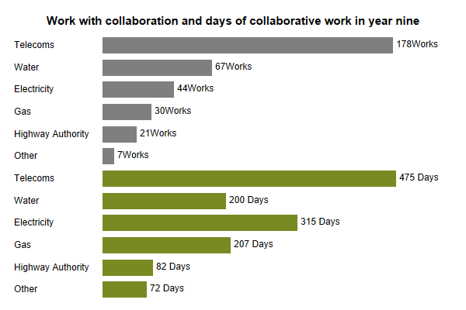

The chart below shows the total number of collaborative works (y-axis) and the total duration of these works (x-axis) by utility and work category in Year 9.

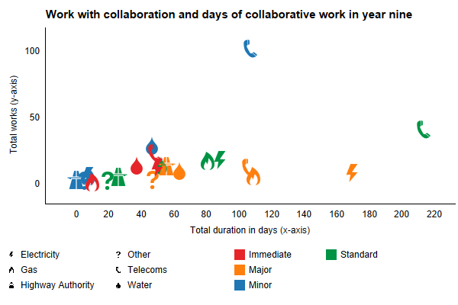

* + - 1. As shown in the chart above, collaborative works were undertaken in Year 9, although these are very low levels compared with the total number of works and duration. Most collaborative works were minor works by the water utility sector, whilst the largest duration of collaboration was for highways major work.
      2. The Council should continue to actively explore collaboration opportunities wherever possible, even if the likelihood of the collaboration occurring is perceived to be low. The Council should record all work with a collaboration opportunity, using the relevant response code, to at least demonstrate the challenges and limitations that exist across the industry.
      3. The Council encourages Promoters to submit forward work plans, although, only a few Promoters do this. Promoters have the means to identify collaborative working opportunities via Street Manager but only some Promoters have done so.
      4. The data does not include communication between the Council and Promoters prior to the submission of permit applications. These communications suggest collaborative working but rarely result in collaborative works being undertaken. The Council will consider further use of RC33 to at least demonstrate the challenges and limitations that exist across the industry.
      5. It is recommended that further analysis of collaboration opportunities is carried out and the analysis will consider if opportunities were realised or not.
  1. Changes during the life of a permit
     + 1. Processing permit applications provides an opportunity for the Council to undertake their network management duty, with an aim to reduce the potential disruption of the work. The sections below show analysis of changes to permits during the planning stage - between the initial application and work start - based on the content of the notices received and issued.
       2. The analysis considers (1) where a change to the permit content, *such as a condition*, can be identified and (2) where a change has been made whether a permit was refused by the Council with a relevant response (code). The latter analysis is limited to when response codes were introduced and applied, and therefore covers the period of Years 4 to 9 only.
       3. This analysis demonstrates the proactive power of the Scheme for coordination, through changes being made to a permit and those at the request of the Council by refusing the initial application(s). The analysis considers changes to three key areas of the work - permit conditions, duration, and traffic management
     1. Permit condition changes
        1. The steady increase in both the works with a condition change and after the use of RC11 demonstrates how the Councils’ coordination team have matured the operation of the permit scheme. As described in section 3.10.7, work continues to analyse and identify areas where applications could be submitted right first time to reduce the need of condition changes and/or additions. This could potentially save both the Council and the Promoters a significant amount of administrative time.

The charts below show the number of instances where a change was made to a permit condition during the application stage of work undertaken (top); and the number of instances where a condition was changed on a permit (for work undertaken) during the planning stage with the code RC11 Missing conditions (% of total) (bottom). The difference in the total are works where conditions were changed, but RC11 was not used.

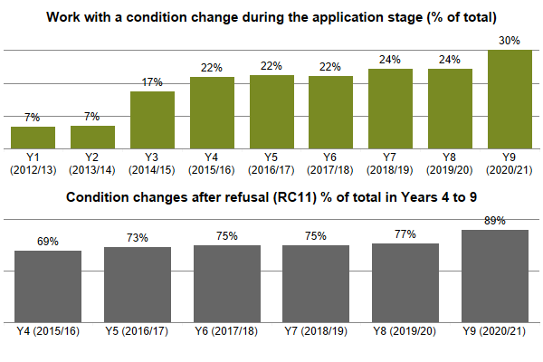

* + 1. Duration changes

The charts below show the proportion of work undertaken (% of total) where there has been a planned duration decrease in Years 4 to 9; and the total duration (days) of the planned duration decrease (bottom).

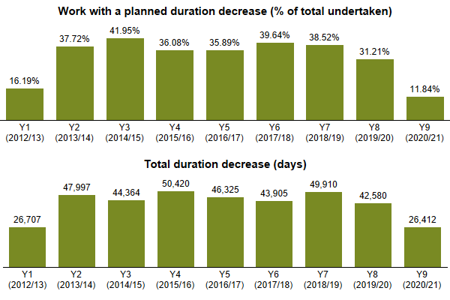

The charts below show the number of refusals issued with the reason excessive duration (code RC44) in Years 4 to 9 (top); and the changes to the planned duration after the use of RC44 (bottom)

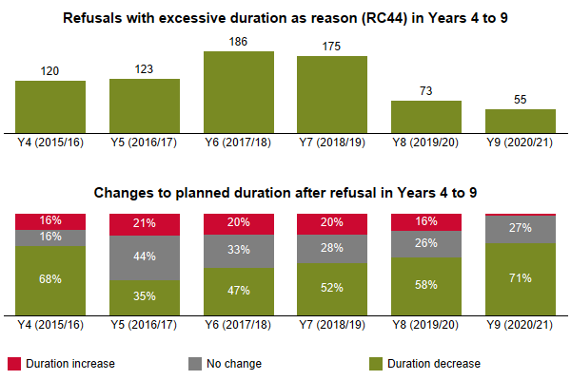

* + - 1. The reduction in the use of RC44 in years 8 and 9 is reflected in the % and days of work with a duration decrease. Discussions prior to the submission of permit applications have reduced the need to use RC44.
      2. The use of RC44 will be monitored as part of the recommendation to create a framework to be used when the coordination team are considering work categories and duration of works (section 3.6.3)
    1. Traffic management changes

The chart below shows the number of instances where a change was made to the traffic management during the application stage for work undertaken in Years 1 to 9.

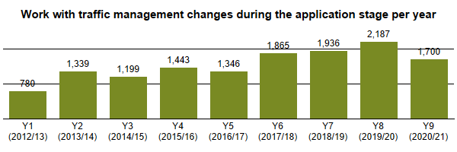

The table below shows the number of refusals issued by the Council, with a relevant reason code, where there was a change to the traffic management during the application stage in Years 4 to 9. The table includes the proportion of changes with a refusal (% of total).

Table of Traffic management changes with refusal during application

The chart below shows works with changes to traffic management during the application stage in Year 9 with the % of total work (with a change) for each type. Any changes below 1% of total have been excluded from the chart for presentation.

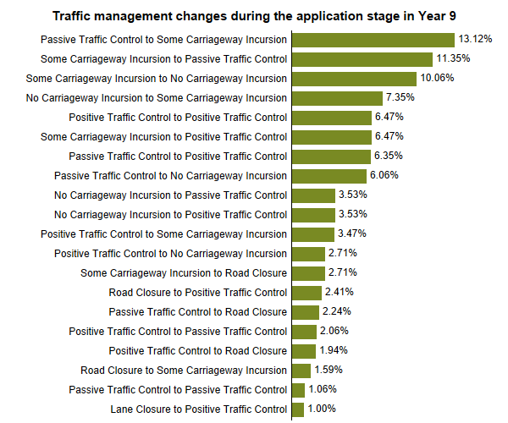

* + - 1. The charts above clearly demonstrate the proactive coordination work undertaken by the Council which subsequently benefits the users of the highway. Examples of this, during year 9, include 13% of changes attributed to passive traffic control to some carriageway incursion and 34% instances of changes being attributed to the use of RC41.
      2. In total, 39% of all changes led to a lesser impact type of traffic control being used. It’s likely that these are due to permits being refused for clash of works. This leads to Promoters reviewing their works methodology.
  1. Variations to permits
     + 1. Both regulations and the Scheme includes a provision for the Council to vary or revoke a permit Therefore, a permit variation (*change request or alteration as named in Street Manager)* can be issued either by the Promoter for the Council to grant or refuse, or by the Council to the Promoter as an imposed change. There are many reasons why variations are issued, which include:
* Changes for planned work dates, because of lack of resources, *such as a contractor or work gang availability*.
* Changes to work details, *such as a change in traffic control or work methodology once a work has been started*.
* Requests to extend the planned duration of the work, because of plant breakdown or other factors, *such as bad weather,* preventing or limiting work.
* Other unplanned activities on the network *such as emergency diversion route caused by an accident or other emergency work.*
  + - 1. The types of permit variation fall within one of four different categories:
* **Highway Authority imposed change** where the Council want to make a change to the permit, either before or after work has commenced.
* **Permit modification** where a Promoter is responding to a permit modification request (refusal) from the Council during the application stage.
* **Promoters change request** where a permit has been granted and the Promoter wants to vary the permit.
* **Promoter imposed change** where a Promoter wants to vary a permit that is still in the application stage and has not been granted.
* **Work extension** where a Promoter wants to change the proposed end date of work (typically increasing the duration) once a work has commenced.
  + 1. Requests for work duration extensions
       1. There has been a marked decline in the number of duration extension requests in years 8 and 9, with year 9 being the lowest of all years. However, the number of additional days of work has increased for both years 8 and 9.
       2. Analysis of these works shows that 28% are from the Water sector and 21% are Highway Authority works. After removing works for make safe, emergencies, blockages, gas escapes, faults etc 55% remain.
       3. The average length of work duration extensions is 2.8 days in year 9. Just 23 works accounts for 23% of the total additional workdays. These works are immediate emergency works and, as such, the Council are limited in the restrictions to duration that they can make.
       4. There have been agreements between the Council and some Promoters that instead of regularly submitting extensions to minor permits that they apply for standard permits instead.
       5. It is recommended that the Council introduce a process of challenging duration requests for non-emergency works. The framework described in 3.6.3 will assist with this.

The charts below show requests by Promoters for work duration extensions (top); the proportion granted of the total received (middle) with applications cancelled or superseded removed; and the total duration (whole calendar days) of additional duration of the total work with a duration extension.

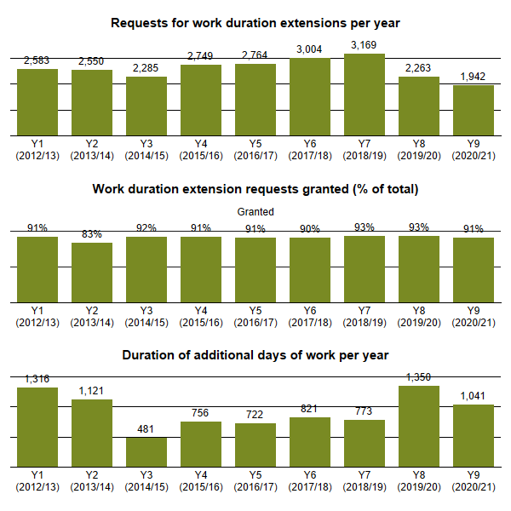

* + 1. Other variations from Promoters

The chart below shows permit variations (excluding those for duration extension) issued by Promoter in Years 1 to 9.

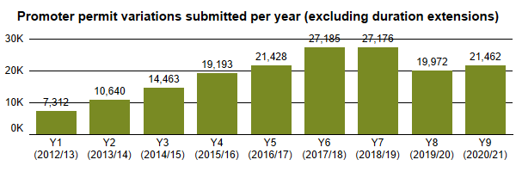

The chart below shows the proportion of Promoter variations (excluding those for extension requests) granted (% of total). Applications that were cancelled or superseded before a response was given have been removed from this analysis.

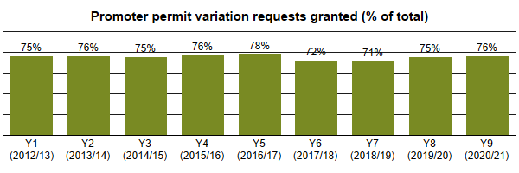

* + - 1. Analysis of variations submitted by Promoters shows an increase in volume up to years 6 and 7 with a decrease for years 8 and 9. Approximately 25% of variation requests are refused but it is not possible to capture the reasons for refusal. the Council can only grant or refuse a variation, there is no option to respond with a modification request.
    1. Variations issued by the Council
       1. Variations issued by the Council are predominantly for Immediate work, to request changes to a permit without refusing a permit and therefore by default making the Promoter *work without a valid permit*.

The chart below shows the volume of authority-imposed variations issued by the Council to Promoters in Years 1 to 9.

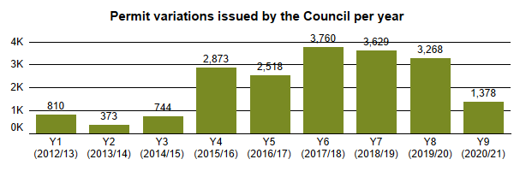

* + - 1. The process for the Council issuing an imposed change is split into two depending on the change(s) required:
* Conditions – the “Impose a Change” option is used and reasons for the request(s) are added as free text.
* For all other changes, the Council must issue a comment within the imposed variation category.
  + - 1. Of the 1,378 variations issued by the Council in year 9, 815 were for condition changes. Of the remaining 563 the main reasons for the imposed variations are for Traffic Management changes, requesting TTRN applications and information on pedestrian management.
      2. 72% of Imposed Variation comments have a reference to an RC code. It is recommended that the Council review the text used in both condition changes and imposed variation comments to ensure the relevant, and correct, RC codes are used.

1. Analysis of permit conditions
   1. Use of permit conditions
      * 1. Applying a condition to a permit is one of the primary methods for achieving the objectives of a permit scheme. The process of a Promoter applying for a permit allows the Council to make changes to the work and where necessary apply conditions, within pre-defined categories, to control and minimise the impact of the works, sometimes even before work starts, *for example advanced publicity of a road closure.*
        2. The sub-sections below outline the conditions available to the Council. These are based on the categories defined in the Statutory Guidance for Permit Conditions. This Guidance sets out the conditions that can be applied to permits and the potential parameters that can be associated to these conditions. Analysis only considers years four to nine as these apply the national condition text codes.
        3. Analysis and evaluation for the use of conditions can be difficult to undertake as there are many variables for a work that need to be taken into consideration, *such as the work methodology, location, use of materials or plant, timing of the work.*
        4. It can be impracticable to determine the criteria for a work and whether a condition could, or should, have been applied or not. In addition, it is not always possible to determine the effect of the condition or an outcome that can be quantified. This analysis does not include conditions that apply to all permits, *such as displaying a permit number on a site board*, but only those that can be applied to a permit.
        5. The sections below show conditions applied by each type for permit scheme years 4 to 9. Further analysis shows if the condition is added during the initial planning stage, between application and work start, instead of being included on the initial application. Typically, a condition applied after application is at the request of the Council following a permit refusal.

The chart below shows the proportion of work undertaken, per year, with any permit condition applied (% of total) excluding those conditions that apply to all permits without having to be added to a permit.

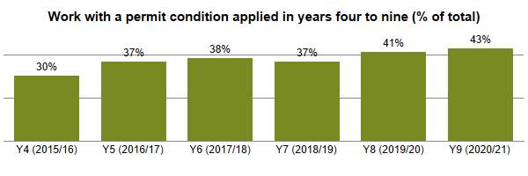

* + - 1. During years 4 to 9 of the permit scheme, on average 38% of work undertaken had a specific permit condition applied. Analysis of the conditions applied in Year 9 (refer to chart below) shows the predominant conditions applied are:
* To limit the days and times of work.
* For the removal of signals when not in use.
* To limit and control the use of traffic management; and
* To provide advance publicity of work.
  + - 1. As can be seen from the charts in sections 5.2 to 5.9, the % of instances where the Council has requested the addition of conditions during the planning stage, clearly demonstrates the role of the Council in the review and coordination of activities.

The chart below shows the total conditions, by their type, applied to work undertaken in Year 9.

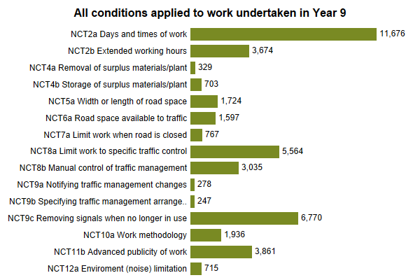

* 1. Conditions for Date & Time Constraints
     + 1. There are two date constraint conditions applied to permits, NCT1a and NCT1b. These conditions limit the flexibility of when works can be started within a timeframe defined by the road category. These conditions are implied and do not need to be applied.
       2. There are two further time constraint conditions which can be applied to permits:
* NCT2a –to limit the days and times of day; and
* NCT2b – to specify extended working hours.
  + - 1. The existing permit scheme performance management framework has focused on the application of NCT2a, and this is reflected in both the volume of works with this condition and the % added during the planning stage for year 9.
      2. Specific actions have included dialogue with the Promoters to facilitate the correct application of the condition, ensuring times associated with the condition are accurate and the consideration to the times of works on the most congested parts of the network. The results of these actions will be monitored for improvements and/or further action.

The charts below show the number of works undertaken with the specified condition (top) and the % of those conditions that were added during the planning stage for Years 4 to 9 (bottom).

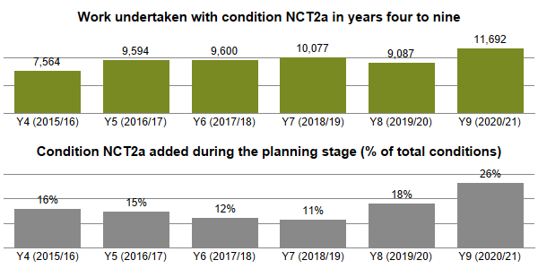

The charts below show the number of works undertaken with the specified condition (top) and the % of those conditions that were added during the planning stage for Years 4 to 9 (bottom).

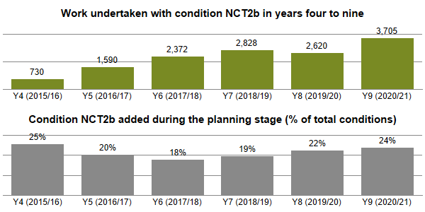

* 1. Conditions for Material and Plant Storage
     + 1. There are two conditions for the removal and storage of materials and/or plant during works:
* NCT4a -removal of surplus materials and/or plant; and
* NCT4b – the storage of surplus materials and/or plant.

The charts below show the number of works undertaken with the specified condition (top) and the % of those conditions that were added during the planning stage for Years 4 to 9 (bottom).

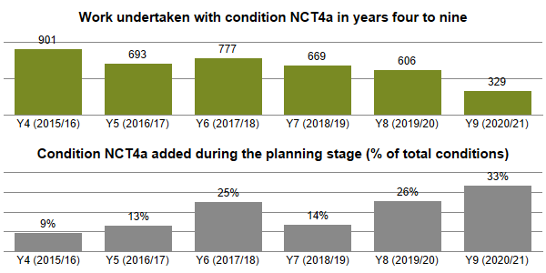

The charts below show the number of works undertaken with the specified condition (top) and the % of those conditions that were added during the planning stage for Years 4 to 9 (bottom).

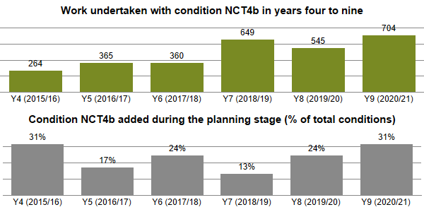

* + - 1. The volume of works with NCT4a applied has been declining and this is due to the increase in the application of condition NCT2a. Condition NCT2a applies to the whole activity, whereas NCT4a just applies to the removal of surplus materials and/or plant.
  1. Conditions for Road Occupation
     + 1. There are three conditions related to road occupation and traffic space dimension conditions, including a road closure:
* NCT5a – specifying the width and/or length of road space that can be occupied; and
* NCT6a – specifying the road space to be available to traffic (including pedestrians) at certain times of the day; and
* NCT7a – limiting activities when the specified road is closed to traffic.
  + - 1. The reduction in the use of condition NCT5a is attributed to the large amount of mains replacement works undertaken in year 8 where the length of road space to be occupied was specified at 100 meters.
      2. The reduction in the use of condition NCT6a is due to the addition of the “Footway Closure” tick box within Street Manager. This negates the need to specify the road space available to traffic (including pedestrians).
      3. The increase in the addition of condition NCT7a in year 9 is driven by the Promoters adding the condition and not as a result of requests from the Council.

The charts below show the number of works undertaken with the specified condition (top) and the % of those conditions that were added during the planning stage for Years 4 to 9 (bottom).

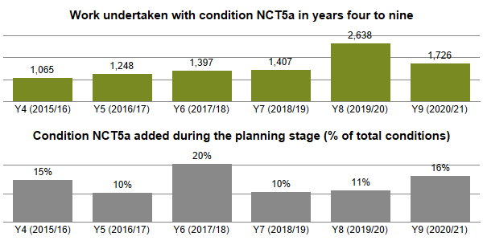

The charts below show the number of works undertaken with the specified condition (top) and the % of those conditions that were added during the planning stage for Years 4 to 9 (bottom).

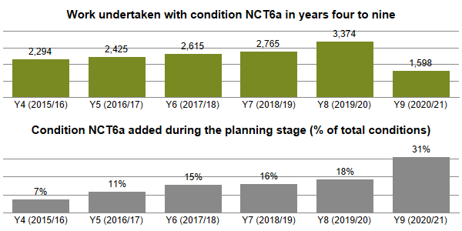

The charts below show the number of works undertaken with the specified condition (top) and the % of those conditions that were added during the planning stage for Years 4 to 9 (bottom).

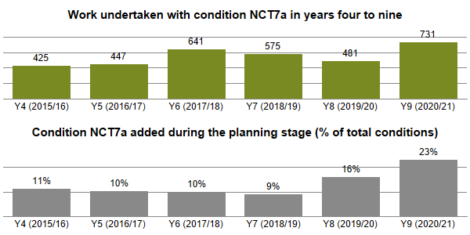

* 1. Conditions for Portable Traffic Signals
     + 1. There are two conditions related to works using specific forms of traffic control:
* NCT8a – limiting activities to the deployment of specified temporary traffic control; and
* NCT8b – specifying the manual control of traffic management at specified times.
  + - 1. Analysis of the application of this condition is limited to works that have a relevant traffic management category, *i.e., two-way lights.*

The charts below show the number of works undertaken with the specified condition (top) and the % of those conditions that were added during the planning stage for Years 4 to 9 (bottom).

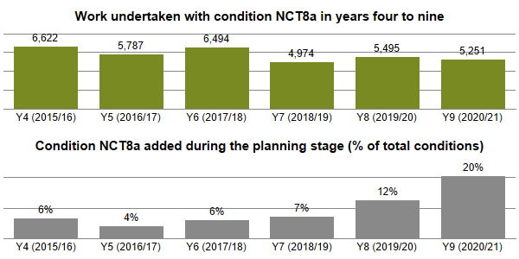

The charts below show the number of works undertaken with the specified condition (top) and the % of those conditions that were added during the planning stage for Years 4 to 9 (bottom).

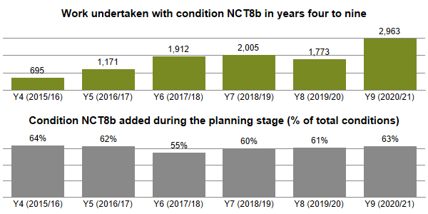

* + - 1. The Councils’ existing permit scheme performance management framework has focused on the application of NCT8a and NCT8b and this is reflected in both the volume of works with this condition and the % added during the planning stage.
      2. Specific actions have included dialogue with promoters to facilitate correct application of the condition, ensuring times associated with the condition are accurate and the consideration to the times of works on the most congested parts of the network. The results of these actions will be monitored for improvements and/or further action.
  1. Conditions for Traffic Management Changes
     + 1. There are three conditions related to traffic management changes during works:
* NCT9a – notifying the Authority when traffic management changes during works.
* NCT9b – specifying the traffic management arrangements to be in place before activities can commence; and
* NCT9c – removing portable traffic signals from operation when no longer in use.
  + - 1. The Council will always ask for the addition of NCT9a and NCT9c, if required, and not added by the Statutory Undertaker as part of the application.
      2. The increase in the volume of NCT9b reflects the increase in the way traffic management changes are managed within permits. Condition NCT9b will describe the different types of traffic management to be used and the Promoters will submit a variation to change the traffic management as the works progress.
      3. Additionally, the following processes are used for managing traffic management changes:
* Promoters will submit a PAA with a follow up permit for the first type of traffic management. This permit will then be closed, and a further permit issued for the next type of traffic management and repeat for each further traffic management change required; or
* Promoters will submit a PAA with a follow up permit for the first type of traffic management. This will then be closed and a new PAA, with follow up permit will be submitted for each subsequent change of traffic management.

The charts below show the number of works undertaken with the specified condition (top) and the % of those conditions that were added during the planning stage for Years 4 to 9 (bottom).

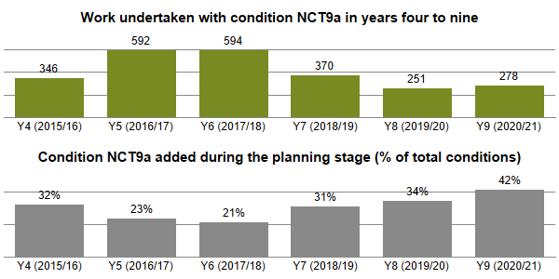

The charts below show the number of works undertaken with the specified condition (top) and the % of those conditions that were added during the planning stage for Years 4 to 9 (bottom).

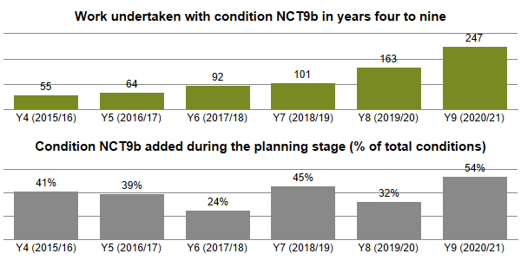

The charts below show the number of works undertaken with the specified condition (top) and the % of those conditions that were added during the planning stage for Years 4 to 9 (bottom).

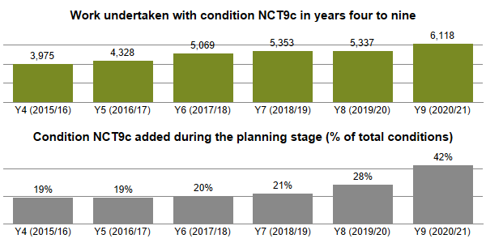

* 1. Conditions for Work Methodology
     + 1. There is one condition related to work methodology: NCT10a – specifying the work methodology to be used for the proposed activities.

The charts below show the number of works undertaken with the specified condition (top) and the % of those conditions that were added during the planning stage for Years 4 to 9 (bottom).

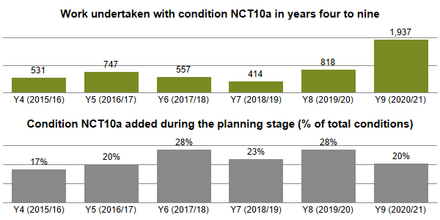

* + - 1. The increase between years 8 and 9 in the use of condition NCT10a is wholly attributable to one Promoter from the Telecoms sector. Analysis of the data shows that additional information for the permit is being added via condition NCT10a. The Council will raise this with the relevant Promoter although it is not sufficient reason to refuse the application.
  1. Conditions for Consultation and Publicity
     + 1. Displaying a permit number on a site information board during the entire duration of the works is a condition that is implied on all permits (NCT11a) and therefore does not need to be specified within a permit. There is an additional condition (NCT11b) specifying the advanced publicity of works that can be applied to work.

The charts below show the number of works undertaken with the specified condition (top) and the % of those conditions that were added during the planning stage for Years 4 to 9 (bottom).

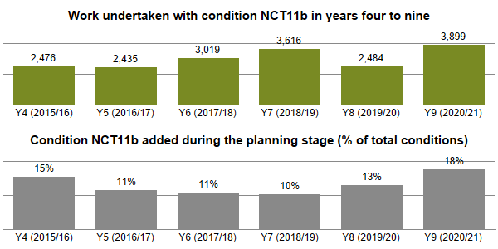

* + - 1. For year 9, approximately 96% of planned works with a road closure did have NCT11b applied. This demonstrates improved consultation & publicity with businesses and residents that facilitates informed choices for travel plans.
      2. The Council will review the 4% of works that did not have NCT11b applied and provide additional training to the coordination team where applicable.
  1. Conditions for the Environment (Noise)
     + 1. There is a condition that can be applied to works for an environmental (noise) control: NCT12a – limiting the timing of certain activities for the environment.

The charts below show the number of works undertaken with the specified condition (top) and the % of those conditions that were added during the planning stage for Years 4 to 9 (bottom).

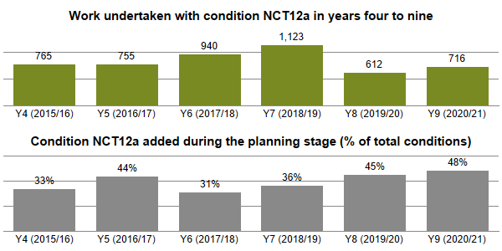

* + - 1. The relatively high percentage of condition NCT12a being added by the Authority demonstrates the continued need for the review of permit applications. Analysis of the data shows that NCT12a is predominantly applied to ensure no noisy works before 9am where Sunday working is scheduled.
  1. Local Conditions
     + 1. The Statutory Guidance for Permit Conditions allows for a non-defined condition to be agreed between the Council and a works promoter – this is called a local condition. No local conditions have been applied by the Council.

1. Analysis of permit compliance
   1. Permit compliance inspections
      * 1. Under a permit scheme the Council can undertake additional inspections during work for permit compliance to ensure that (a) work is being undertaken with a valid permit and (b) in accordance with the stated conditions (as applicable).
        2. The volume of Permit Condition Inspections, and the pass rate, remain broadly consistent. A detailed breakdown of the data is unavailable.
        3. This data is useful in confirming that the Council are operating a consistent inspection regime with regards to Permit Compliance. The failure rate also shows that there is a consistent level of failure, which in itself has not reached a level that would require significant intervention nor cause large concern across the 9-year period.
        4. However, it is recognised that the failure rate has, broadly speaking, stayed the same, and further intervention to drive an improvement in this area is something the Council could target in future years.

The charts below show the number of permit condition inspections carried out per year (top) and the % of inspections (of total carried out) with a recorded pass (bottom).

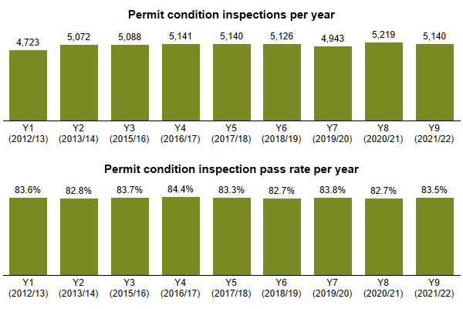

The chart below shows the reason for permit condition failure (non-compliance) recorded in Year 9. An inspection can fail for more than one permit condition.

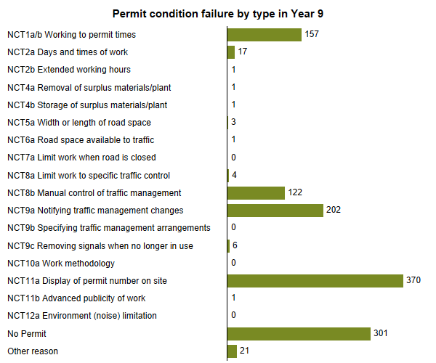

* 1. Offences for working without a valid permit or breach of condition
     + 1. A permit scheme introduced two new offences, with financial penalties for statutory undertakers, where there is a failure to comply with either of these. The chart **Offences for working without a valid permit by utility** shows the number of offences issued by the Council for working without a permit by utility.
       2. Data is only available from when Street Manager was introduced (July 2020).
       3. Analysis of the year 9 offences for working without a valid permit shows the Water sector (38%) and the Telecoms sector (29%) are the highest offenders.
       4. Analysis of the offences for breach of permit conditions shows that the Gas sector (31%) and the Water sector (26%) are the highest offenders.
       5. This data is useful in enabling the Council to spot trends of poor performance although it is noted that there is minimal year on year data at this point; it is expected that the headline figures reducing in future years, but this will need to be closely monitored from a Compliance perspective.
       6. It may be useful to further analyse these areas to see who the worst offenders are based on number of works and number of offences. For example, the Water Sector is responsible for the most offences but how do others with a smaller footprint compare. This data could assist the Council in further targeting inspections and managing performance.

The table below shows the number of permit scheme offences, by their type, issued in Years 8 to 9.

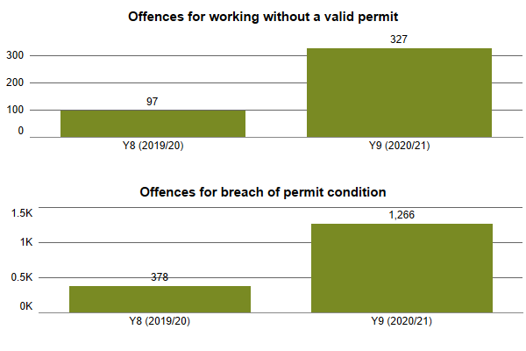

1. Analysis of parity treatment
   * + 1. Section 40: Non-discrimination of the Permit Scheme Regulation state that the Council must apply the regulations (Parts 5 and 6) *without any discrimination between different classes of application for permits or for provisional* advanced *authorisation*. Statutory Guidance defines this further a **parity treatment** with *each permit application received are treated equally regardless of the works’ promoter* .... and [Highway] *works will be treated in the same way as any undertaker (except that they are not liable for the fees or sanctions).*
       2. Parity treatment will be analysed using the following specific measures, show for each utility sector:

* Response to PAA and permit applications.
* Permit applications deemed (granted).
* Response to Promoter permit variations.
* Variations issued by the Council.
* Conditions applied to permits; and
* Permit Compliance Inspections undertaken.
  + - 1. *The charts below show the PAA or permit applications granted within Years 1 to 9 (as a % of total received) by utility sector. The charts do not include those applications that were deemed (granted), superseded or cancelled before a response was given.*

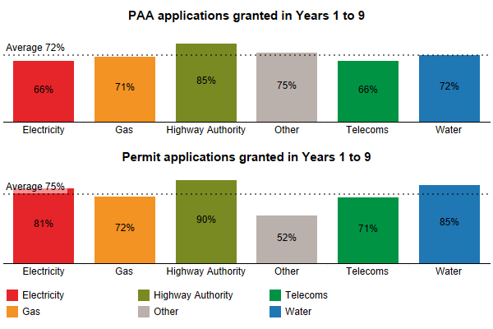

* + - 1. Highway Authority works have the highest grant % due to the high volume of pre-application discussions with the Network Management Team. A level of discussion with external Promoters does exist but this is limited. Highways Works Promoters are much more proactive in engaging with the Councils’ Network Management Team.
      2. Works Promoters have been urged to engage in pre-application discussions via the quarterly coordination meetings, but this has not proved successful. There is a move to monthly performance meetings with individual Promoters and it is hoped this will improve the level of pre-application discussions.
      3. *The chart below shows the % of PAA and permit applications (of total) that were deemed (granted) within Years 1 to 9. The charts do not include those applications that were superseded or cancelled before a response could be given.*

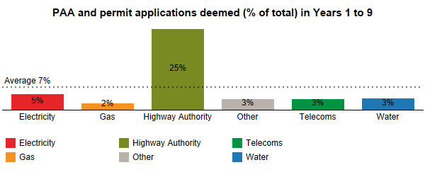

* + - 1. The relatively high % of deemed applications for Highways gives a false reading. This is due to the high volume of works that are completed before the Council has the opportunity to review the application.
      2. As shown in the chart below, analysis of Year 9 shows that when you remove the auto-grant in Year 9 the % of deemed drops to 0%, therefore it can be assumed previous year’s show volume of works that were auto-granted.

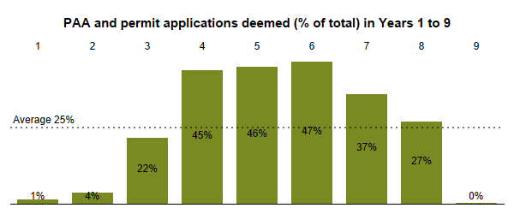

* + - 1. The volume of deemed applications represent 0.5% of all works undertaken in year 9 and parity is therefore demonstrated. Reductions in the volume of deemed items are attributed to improved working practices, team skills and knowledge matured over the operation of the scheme.
      2. *The charts below show the permit variation applications granted within Years 1 to 9 (as a % of total received) by utility sector. The variations are delineated by requests for extensions and other variations. The charts do not include those applications that were deemed (granted), superseded or cancelled before a response was given.*

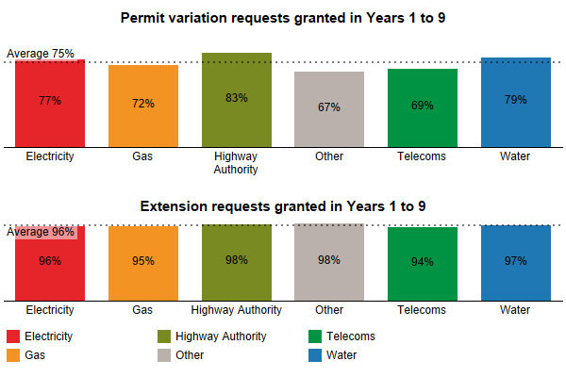

* + - 1. Parity is demonstrated for both the % permit variations granted, and extension requests granted.
      2. *The chart below shows the number of variations issued to Promoters by the Council in Years 1 to 9.*

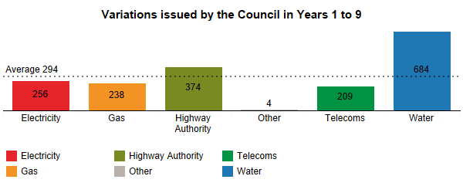

* + - 1. The volumes of variations issued by the Council - by utility sector - are reflective of the proportionate volume of works undertaken by utility sector and therefore parity is demonstrated i.e., Highway Authority and Water works represent the highest volumes of works undertaken.
      2. *The chart below shows the % of planned works undertaken with a permit condition, as a % of total works, by utility sector within Years 1 to 9. Unplanned Immediate works have been removed from this analysis.*

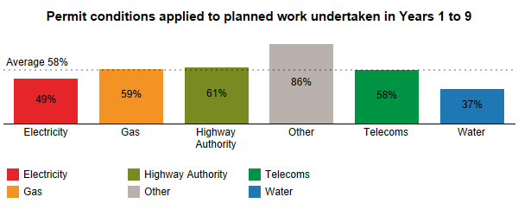

* + - 1. The % of permit conditions applied to works undertaken demonstrate parity. The high % for other works is not cause for concern as the number of works are very low.

The chart below shows the proportion of passes from permit compliance inspections per year for Highway and Utility work. Due to a limitation in the historic data, it is not possible to delineate this measure by utility type.

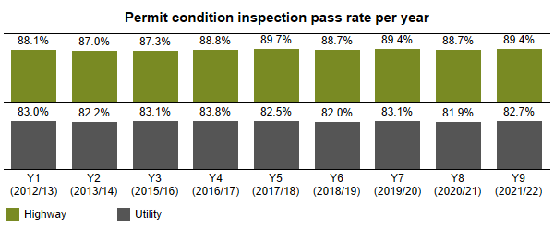

* + - 1. This data shows that failure rates have been broadly consistent in this area across the 9-year period and are not at a rate that causes significant concern.
      2. However, it may be worthwhile the Council renewing the emphasis of these inspections to try and improve performance. It is noted that Highway works broadly perform at a higher level than SU works, and this may be something to focus on.
      3. Finally, it would be beneficial for these figures to be broken down further in future years to enable the Council to target appropriately, as some poorer performers may be escaping focus as other good performers could skew the overall headline figures.

1. Analysis of cost and benefit
   1. Scale and characteristics of works
      * 1. Works data is available for a twelve-year period covering both pre and post scheme implementation. This data has been analysed to produce estimates of historical impact of works in Hertfordshire.
        2. The introduction of Street Manager and associated regulatory changes in 2020 provided a more detailed source of data for actual timings of works, which in turn provides a more precise estimate of the actual impact that works have had on motorists. The estimated impact cost can now be derived from both a duration based on minutes, and not whole days, and the time of day the work is undertaken, *i.e., at peak times or off-peak*. The estimated impact using Street Manager data is therefore not directly comparable to estimates from previous years and evaluations.
        3. To ensure the most rigorous analysis for the CBA, data from the most recent complete year - Year 9 (2020/21) has been used as the basis for estimating work impact cost and permit scheme benefits.
   2. Impact of works
      * 1. The estimated impact of the works has been estimated using **QUeues and Delays and ROadworks** (QUADRO) models. QUADRO was originally developed for the DfT and designed to assess and monetize the impact of delays due to works. Whilst no longer hosted by the DfT, the QUADRO model continues to be maintained, under the responsibility of National Highways (formerly Highways England) and is considered nationally the most appropriate tool to quantifying the impact of works for this evaluation.
        2. These impact estimates include the following elements:

* Road user travel time (delay caused to consumer and business as a result of works)
* Road user vehicle operating costs (the impact of delay and diversion on vehicle operating costs for consumers and business)
* Accident costs
* Emissions costs (resulting from congested conditions and diversion)
* Indirect tax revenue (increased tax revenue to the exchequer because of higher fuel consumption)
  + - 1. Whilst QUADRO covers most of the standard monetised elements of work impact, an off-model adjustment was made to account for reliability impacts. DfT guidance recommends that this be captured through application of an uplift to journey time costs/benefits. The recommended uplift factor is 10-20%. A factor of 15% has been adopted for this evaluation to be consistent with this recommendation.
      2. For the CBA work is disaggregated into several characteristics, including traffic management, which has important implication on the scale of impact. QUADRO only considers impact to traffic on the carriageway, therefore work involving *no carriageway incursion* are assumed to have no impact to the road users. It should be noted that the overall scheme impact based on QUADRO is a conservative assumption as non-carriageway work is also likely to cause impact to the road user or wider society.
      3. Having developed QUADRO models for Hertfordshire’s Road network, an impact cost is calculated for each work within the data according to its characteristics and duration – based on actual work timings from Street Manager. This provides highly granular results, especially when compared with the typical aggregated CBA approach adopted in other scheme evaluations. This calculated impact forms the basis of the benefits calculation.

The table below shows the total works, duration, estimated impact cost and the average cost per day for work undertaken by traffic management type in Year 9. The figures contained in this table may not directly correspond with other analysis within this evaluation due to adjustment in work being analysed and when the data was extracted for analysis.

The table below shows the total works, duration, estimated impact cost and the average cost per day for work undertaken by traffic management type in Year 9. The figures contained in this table may not directly correspond with other analysis within this evaluation due to adjustment in work being analysed and when the data was extracted for analysis. 

The annual impact of roadworks undertaken in Hertfordshire in 2020/21 are estimated to be £66.9million (2010 prices [1]).

The average cost impact per day of works is £429.

* 1. Quantification of scheme benefit
     + 1. The benefits of the permit scheme are expected through more efficient and better managed works. Relating observed changes directly to the scheme is complicated by the range of factors which influence work and how they are planned and undertaken. For the CBA, the comparative scenario is one in which the permit scheme had not been introduced and is therefore by its very nature hypothetical and unobservable.
       2. A national evaluation of permit scheme was commissioned by the DfT in 2017 [2]. This study adopted a rigorous cross region evaluation of the observed pattern of roadworks under local highway authorities with and without permit schemes. The study concluded that the impact of work was typically 5.4% lower in areas with a permit scheme, which aligned closely with the default assumption of 5% impact reduction adopted in historic assessments[3].
       3. To ensure the most rigorous assessment of the impact of the Scheme in Hertfordshire, the national evaluation estimate of a 5.4% reduction in impact under a permit scheme has been assumed and applied to the most recent and accurate impact cost estimate for 2020/21.
       4. The CBA requires that benefits are appraised against costs over a given period, which is recommended as 25 years within DFT guidance. Consequently, values are projected forward over this period with impacts and benefits increasing in real terms to reflect growth in values of time, vehicle operating costs, accident savings and emissions costs.

The annual benefit of the Scheme in Hertfordshire is £3.82million (2010 prices)[4]

The table below shows the calculated annual permit scheme benefits based on the Year 9 values.

The table below shows the calculated annual permit scheme benefits based on the Year 9 values.

* 1. Scheme Operating Costs
     + 1. Scheme benefits must be set against scheme costs to determine value for money. These costs include setup costs; operating costs, *such as staff, consultants, maintenance/running costs*; and capital costs, *such as IT equipment, software.*
       2. Importantly, the permit scheme costs included within the appraisal are the additional costs of operating the permit scheme above those incurred previously to administer a *noticing regime*. By considering the incremental costs, this fairly compares a ‘with permit scheme’ scenario to a ‘without permit scheme’ scenario.
       3. Whilst the scheme has now been running for nine years, the appraisal focuses on the projected costs of operation over future years, to align with the benefit estimate, based on the most recent full year of operation.
       4. The annual incremental operating costs are estimated at £4million per annum (2020 prices). Rebasing these costs to 2010 prices to align with the price base of the benefits results in an operating cost of £3.24million per annum (2010 prices).
       5. In addition to the costs of operating the permit scheme, it is important to recognise that there are costs borne by Promoters to operate under the permit scheme. These will include:
* Permit fee costs which represent a business cost to the Promoter.
* Additional administration costs in complying with the permit scheme; and
* Costs related to changes in working practices, *such as greater use of traffic management, or additional resources to comply with permit conditions.* 
  + - 1. Within the CBA permit fee costs are treated as a business cost to the Promoter, netted from overall scheme benefits. However, the transaction is effectively a transfer payment between Promoter and the Council, so the payment is treated as a revenue and is subtracted from scheme operating costs.
      2. Detailed Promoter costs related to changes in working practices has been sought numerous times for national evaluations, without any results. Therefore, an estimate based on 20% of the Councils operating costs has been assumed. This aligns to evidence gathered from other evaluations, including assumptions adopted for the DfT’s national evaluation.
  1. Appraisal results
     + 1. The CBA takes the benefits and costs established from the most recent year of operation and projects these over the 25-year appraisal period. The future costs and benefits are discounted using the standard discount rate of 3.5%, meaning that near term costs and benefits are valued more highly than those occurring later in the appraisal period.

The table below shows the results of the appraisal and values.

The table below shows the results of the appraisal and values. 

* + - 1. The benefit to cost ratio (BCR) is a measure of value-for-money exhibited by a scheme.

With a BCR of 2.5 the permit scheme can be defined as delivering greater benefit than it costs and classified as *High Value for Money*.

The table below provides the full monetised costs and benefits from the appraisal.

This table includes costs and benefits which are regularly or occasionally presented in monetised form in transport appraisals, together with some where monetisation is in prospect. There may also be other significant costs and benefits, some of which cannot be presented in monetised form.  Where this is the case, the analysis presented above does NOT provide a good measure of value for money and should not be used as the sole basis for decisions.  

This table includes costs and benefits which are regularly or occasionally presented in monetised form in transport appraisals, together with some where monetisation is in prospect. There may also be other significant costs and benefits, some of which cannot be presented in monetised form. Where this is the case, the analysis presented above does NOT provide a good measure of value for money and should not be used as the sole basis for decisions.

* 1. Emissions savings
     + 1. A component to the costed benefits in the appraisal is a reduction in carbon emissions. These emissions savings are driven by more efficient vehicle movements and the avoidance of the ‘stop-start’ movements associated with works. QUADRO places a monetary value on emissions savings by applying a ‘cost of carbon’ to the amount of carbon generated because of works, *for example additional fuel due to idling, or diversions around road closures.*
       2. In the most recent year of the scheme (2020/21), the carbon emission generated by works within the Hertfordshire area, as calculated within QUADRO, were valued at £4.01million (2010 prices), which represents around 6% of overall work impact cost.
       3. The implied carbon emissions attributable to works amounts to 66,077 tonnes for Year 9 equivalent to 4.7% of overall highway related carbon emissions produced within Hertfordshire.
       4. The improved efficiency of works under the permit scheme means that the carbon emissions generated because of works should be lower than they would have been without the scheme in operation.
       5. In line with the broader assumptions about permit scheme impacts, on the basis that emissions resulting from works are 94.6% of the level they would have been in the absence of the scheme would lead to estimated annual carbon emissions savings.

Estimated annual carbon emission savings of 313 tonnes CO2 from reduced delays.

* + - 1. To set this emission saving in context, using typical emissions of new cars sold in the UK currently, this reduction can be associated to an equivalent saving of annual car kilometres CO2 reduced.

Over 3.5 million annual car kilometres CO2 reduced.

1. Annex A: Evaluation methodology
   1. Source data for analysis
      * 1. This evaluation uses data collected from both Street Manager and the Council’s system to process and record works. The data collected contains the content of notifications sent between Promoters undertaking work, such as utility companies, and the Council.
        2. Analysis of these notifications enables the Council to produce metrics for performance indicators and further measures. For some measures aggregating data for analysis does not provide an accurate picture of the results, for example for the analysis of all work durations can provide a falsely inflated picture of changes over time. This evaluation therefore delineates many of the measures into sub-categories, such as works category, to provide a more accurate result and trend.
        3. Many of the measure contained in this evaluation were analysed with sub-categories to ensure accuracy in the results. These have not all been included within this evaluation report; however, it should be accepted than any findings presented have been tested for certainty and any anomalies investigated and defined.
   2. Work phases
      * 1. In this evaluation work is analysed in logical phases. A work is typically identified by a work reference number, which often applies to multiple phases of work, for example a work reference number may contain the following individual phases:

* work with a temporary reinstatement.
* follow-up work changing the temporary reinstatement to a permanent reinstatement.
* defect work to rectify a fault with the permanent reinstatement.
  + - 1. To logically delineate work phases, a phase is identified from the initial application through to work completion notices within the same work reference. Therefore, the analysis shown for work in this evaluation is for a work phase, *i.e., the total works undertaken are the total work phases undertaken*.
  1. Duration analysis and adjustment
     + 1. Analysis of works duration is calculated using the dates provided within the work start and work stop notifications, inclusive of these dates. As a result of incorrect dates on notices from Promoters spurious durations can be found within the extracted data, such as work with a negative duration, created where the supplied end date is before the start date, or work with a significantly high duration.
       2. Analysis of work duration is essential for this evaluation, for both an assessment of changes in work duration and to calculate a work impact cost (impact to society). Therefore, a process to cleanse duration involving the following 3 steps is undertaken. If the actual duration does not meet the criteria below, then the duration is not revised.
* Where an actual duration is a negative value, then this is replaced with the planned duration.
* In the case of 1. if a planned duration is also a negative value, then a default value for the works category is used; and
* Where the actual duration is more than 50% greater than the planned duration and the difference is more than a set value, based on the work category, then the duration is revised using the planned duration.
  + - 1. Since the introduction of the DfT’s digital service for the management of roadworks (Street Manager) and associated regulatory changes from 1st July 2020, information related to the timing of works, *i.e., start time, and stop time,* has improved. As such since the introduction of Street Manager it is possible to measure and analyse durations closer to actual time than to a day period.
      2. Analysis of total duration based on the notice dates (whole calendar day) and notice times shows that there can be noticeable differences between these two types of measure.

The charts Comparison of calendar day duration and work timing duration by utility and Comparison of calendar day duration and work timing duration by work category show the differences between a calculated total work duration using the dates (calendar day) and times contained in the work start and work stop notices (legend). The charts show each comparison either by utility (top) or work category (bottom).

* + - 1. For this evaluation, analysis of work duration and trend is predominantly based on dates of the work notices, not timings, as the pre-scheme historic data does not contain accurate timings. Future evaluations may contain analysis based on timing once the data range has increased over time. In addition, the use of activity type also introduced by Street Manager can be useful to consider the durations of specific activity and whether these are changing over time or remaining within accepted tolerances.
      2. This report contains analysis of duration based on time wherever possible, however for a complete analysis of operational year one and to analyse results compared to previous years it is not possible to effectively use this. It is anticipated that future operating years will use analysis of duration based on work timings time, across far more effectively.
  1. Economic cost-benefit analysis
     + 1. A cost-benefit analysis (CBA) provides a framework to measure and compare the benefits of a scheme, from an estimated reduction in the impact of works to the road user, against the cost of setting up and operating a scheme.
       2. The approach to the CBA is as follows:
* Use data and established impact models to assess the scale of societal impact of works to the residents and local economy.
* Estimate the reduction in impact resulting from the permit scheme and quantify the social benefit of this reduction.
* Quantify the costs of operating the permit scheme; and
* Undertake the cost benefit analysis to determine a benefit to cost ratio and net present value delivered by the scheme.
  + - 1. Annual evaluation of a permit scheme CBA provides opportunity to review the value of the scheme with the benefit of the outturn scheme operating costs and revenues, updated estimates of the societal impact of work and to compare this to a scenario of *not operating a permit scheme*.
      2. The societal impact of each work is estimated based on impact calculations derived from the **QUeues and Delays at ROadworks** (QUADRO) model. QUADRO was originally developed for the DfT and designed to assess and monetize the impact of delays due to works. QUADRO is currently maintained by Highways England.
      3. QUADRO captures loss of time to travellers, increased vehicle operating costs because of idling in queues and/or diversion, vehicle emissions and accident impacts. Impact modelling is based on local traffic flow data (within the Council’s boundary), disaggregated by road type, to provide locally relevant impact values.
  1. Period of analysis
     + 1. Throughout this evaluation there is a reference to Years. These years are based on the permit scheme years, where year one is between 5th November 2012 and 4th November 2013. Operating years before the scheme came into legal effect are show as negative years, i.e., Y-1 covers the period 5th November 2011 to 4th November 2012
  2. Defining Promoters
     + 1. Within this evaluation Promoters can be defined by their utility type, e.g., water. The Promoter type Highway Authority is included in this definition, as works for road purposes. The utility type Other includes other organisations who need to undertake work on the highway, such as Network Rail who account for 78% of work within this type.

1. Annex B: Glossary and common terms
2. GlossaryAnnex C: HAUC Performance Indicators
   1. TPI 1 Works Phases Started (Base Data)
   2. Table no of worksTPI2 Works Phases Completed (Base Data)
   3. Table works completedTPI3 Days of Occupancy Phases Completed
      * 1. The data shown for this performance indicator includes analysis using either the work start, and work stop notice dates or times (from June 2020). Year 8 only contains part year (July 2020 to October 2020) for duration based on time and is therefore excluded.
   4. Table Days of Occupancy Phases Completed TPI4 Average Duration of Works
      * 1. This data is only show for years eight and nine as the accuracy of the information provided by the Promoters since the start of Street Manager was improved significantly. Prior to this the work start and work stop information is insufficient to provide an accurate and comparable average duration.
        2. To provide meaningful information the data has been delineated into work category and the duration is show in days, rounded to the nearest one decimal place.
   5. Average Duration of Works TPI5 Phases Completed involving Overrun
      * 1. The table below shows the results of the data analysis, however as explained within this report these figures should be treated with caution as the accuracy of information provided from the Promoter prior to the introduction of Street Manager in July 2020 seems low.
   6. Over running works TPI6 Number of deemed permit applications
      * 1. This data does not include permits that are auto granted by Street Manager, but only those where a response was not provided to a permit within the specified timescale. The data is delineated by three different events, PAA, permit and permit-variation.

Number of deemed permit applications

* 1. TPI7 Number of Phase One Permanent Registrations

Permanent registrations

1. Annex D: References

1. The QUADRO model calculates impacts in line with the DfT’s appraisal guidance WEBTAG. Within this guidance the DfT specified base year prices are specified as 2010, enabling comparison between appraisal results for different schemes on a like for like basis.
2. https://assets.publishing.service.gov.uk/government/uploads/system/uploads/attachment_data/file/700502/permit-schemes-evaluation-report.pdf
3. DfT Permit Scheme Evaluation Guidance, 2016
4. Excl. reliability benefits which are added into the appraisal at a later stage