**Croxley Green Library Visual Story**

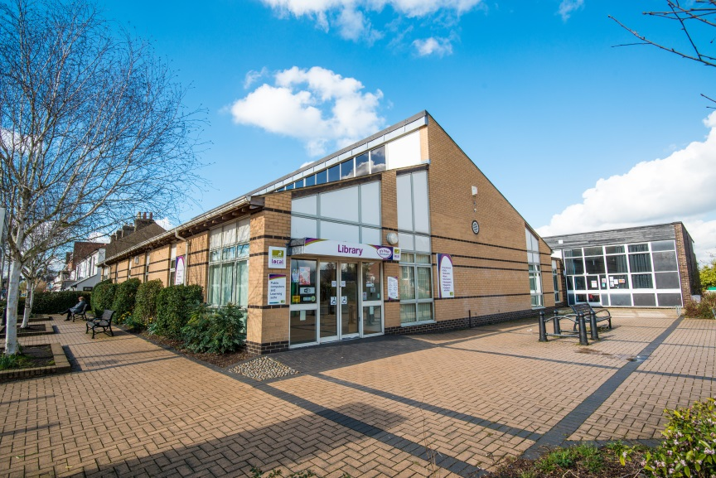

**Croxley Green Library, Barton Way, Croxley Green, WD3 3HB**

**Opening Hours:**

|  |  |  |  |  |
| --- | --- | --- | --- | --- |
|  |  | Staff on site |  |  |
|  | Open+ | Start | Finish | Open+ |
| Monday | 7.00am | 2.00pm | 6.00pm | 8.00pm |
| Tuesday | 7.00am | 9.30am | 6.00pm | - |
| Wednesday | 7.00am | 9.30am | 6.00pm | - |
| Thursday | 7.00am | - | - | 8.00pm |
| Friday |  7.00am | 9.30am | 6.00pm | 8.00pm |
| Saturday |  7.00am | 9.30am | 6.00pm | 8.00pm |
| Sunday | Closed |  |  |  |

This is a simple guide to help people visiting Croxley Green Library for the first time, if you have any questions please ask the staff.

|  |  |
| --- | --- |
| outside view of the library | This is Croxley Green Library   |
| a woman is sitting behind a desk looking at a computer screen | Please ask for help at the Enquiry Desk.  If we are busy you may have to wait.   |
| a lady smiling showing her staff badge | Library staff are here to help. All library staff wear a badge like this.   |
| library cards front and back | This is a library card, you will get one when you become a library member.    You need a library card to borrow books and to use the computers.  To get a library card, ask the staff at the help desk. |
| **headphones** | Sometimes we have noisy times in the library and you may wish to visit at a quieter time.    Or you can bring some ear defenders to wear. |
| cid:736f88d7-f4a0-4941-8e1f-41528b3ce097@Hertfordshire.gov.uk | This is a kiosk. You can borrow and return books here.    Follow the instructions on the screen. Ask the library staff if you need help.  If it is busy you may need to queue. |
| a man is outside the library, holding a card under a black box. above the box is a sign with opening hours | Croxley Green Library is available during extended, unstaffed hours.    You can borrow, return and renew books, use the computer and Wi-Fi, read newspapers and magazines.  To find out more about Open+, please visit Croxley Green Library during normal staffed opening hours to apply for Open+ membership. |
| children library with shleves of books in hte back, a sofa and tub chairs on the sides, a colourful carpet in the middle and wooden boxes full of picture books at the front | This is the children’s area.   |
| small area with book shelves on the left and comfortable chairs on the right | This is the teenage area.   |
| large area with long computer desk against the back wall and 2 square table with chairs around them | This is the IT Suite where you can use a computer or study.    Library members can use the computers for free for two hours a day.  There is free Wi-Fi in the library. wifi logo |
| shelves of books | There are lots of books you can borrow.   |
| shelves with magazines on display | There are magazines which you can borrow.   |
| toilet sign with stylised pictures of a woman, a man, and a person in a wheelchair | There is no toilet in the library. |
| cid:e43681d1-e20f-4615-8f86-7795d43b3938@Hertfordshire.gov.uk | When you are ready to leave the library, take the items that you want to borrow to the kiosk and follow the instructions on the screen.    Ask the library staff if you need help.  If it is busy you may need to queue. |
| cid:4c311b1f-8343-42b0-8ecf-9e181c4cca5d@Hertfordshire.gov.uk | You can take the items you have borrowed home. Print a receipt so you know when you need to bring them back to the library.    Remember to return or renew your items on time to avoid charges.  You can renew your items at the kiosk or:   * ask at the desk * online at [www.hertfordshire.gov.uk/libraries](http://www.hertfordshire.gov.uk/libraries) * Telephone: 0300 123 4049 * Textphone: 0300 123 4041 |
| cid:38b11f0d-3e1d-4975-99eb-d73f8a421c04@Hertfordshire.gov.uk | We hope you enjoyed the story.  If you need any extra help or information please ask a member of staff.     For more information on the library please visit our website:  [www.hertfordshire.gov.uk/croxleygreenlibrary](https://www.hertfordshire.gov.uk/croxleygreenlibrary)  Please come back soon. ☺ |