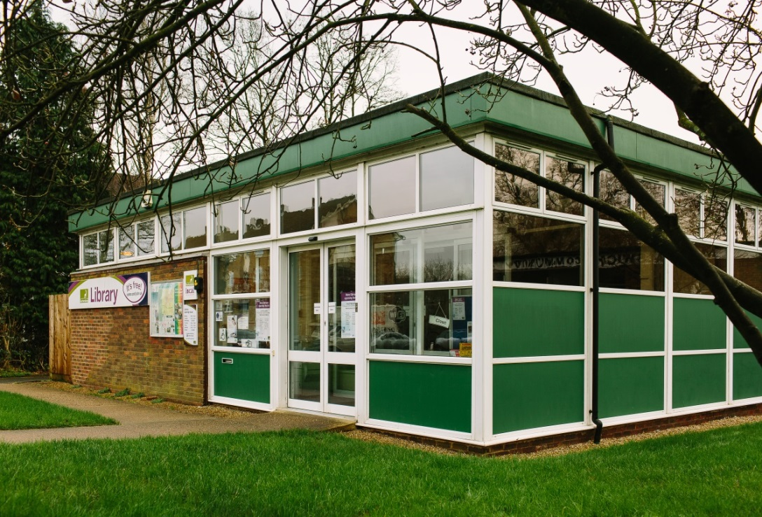

**Marshalswick Library Visual Story**

**Marshalswick Library, The Ridgeway,**

**St Albans, AL4 9TU**

**Opening Hours:**

|  |  |  |  |
| --- | --- | --- | --- |
| Monday | 10.00am | - | 6.00pm |
| Tuesday | •1.00pm | - | 6.00pm |
| Wednesday | Closed |  |  |
| Thursday | 10.00am | - | 6.00pm |
| Friday | •1.00pm | - | 6.00pm |
| Saturday | 10.00am | - | 5.00pm |
| Sunday | Closed |  |  |

This is a simple guide to help people visiting Marshalswick Library for the first time, if you have any questions, please ask the Library staff.

|  |  |
| --- | --- |
| **outside view of square building with glass doors and a large sign saying library** | This is Marshalswick Library.   |
| A person sitting behind a desk | This is the help desk. Ask here if you need help or have any questions.    You may have to wait if we are busy. |
| a woman smiling showing her staff badge | Library staff are here to help. All library staff wear a badge like this.   |
| library cards front and back | This is a library card; you will get one when you become a library member.    You need a library card to borrow books, use our online services and to use the computers.  To get a library card, ask the Library staff at the help desk. |
| **headphones** | Sometimes we have noisy times in the library; you may wish to visit at a quieter time.    Or you can bring some ear defenders to wear. |
| pink self service kiosk | This is a kiosk. You can borrow and return books here.    Follow the instructions on the screen. Ask the Library staff if you need help.  If it is busy you may need to queue. |
| **small area with book shelves on the walls and wooden boxes with picture books in the middle** | This is the children’s area.   |
| **shelves with books** | There are lots of books you can borrow.    You can reserve books if we do not have what you are looking for.  Speak to one of the team to help you. |
| shelves with magazines on display | There are magazines to borrow.    We also have daily newspapers to read. |
| toilet sign with stylised pictures of a woman, a man, a person changing a baby and a person in a wheelchair | There is **not** a toilet in the library.    But Library staff can tell you where to find one nearby. |
| computer desk with screens, keyboard and a scanner | These are some of our computers which you can use.    Library members can use them for free for two hours a day.  If the computers are busy you may need to book. Ask the Library staff if you need help. |
| table with 4 chairs around it | This is the study area. It is sometimes busy and may not be quiet.  There is free Wi-Fi in the library.   wifi logo  Ask Library staff for login details. |
| cid:e43681d1-e20f-4615-8f86-7795d43b3938@Hertfordshire.gov.uk | When you are ready to leave the library, take the things that you want to borrow to the kiosk and follow the instructions on the screen.    Ask the Library staff if you need help.  If it is busy you may need to queue. |
| cid:4c311b1f-8343-42b0-8ecf-9e181c4cca5d@Hertfordshire.gov.uk | You can take the things you have borrowed home. Print a receipt so you know when you need to bring them back to the library.    Remember to return or renew your items on time to avoid charges.  You can renew your items at the kiosk or:   * ask at the desk * Access your account on the Library App * online at [www.hertfordshire.gov.uk/libraries](http://www.hertfordshire.gov.uk/libraries) * Telephone: 0300 123 4049 * Textphone: 0300 123 4041 |
| cid:38b11f0d-3e1d-4975-99eb-d73f8a421c04@Hertfordshire.gov.uk | We hope you enjoyed the story.  If you need any extra help or information, please ask a member of Library staff.     For more information on the library please visit our website:  [www.hertfordshire.gov.uk/marshalswicklibrary](https://www.hertfordshire.gov.uk/marshalswicklibrary)  Please come back soon. ☺ |