**North Watford Library Visual Story**

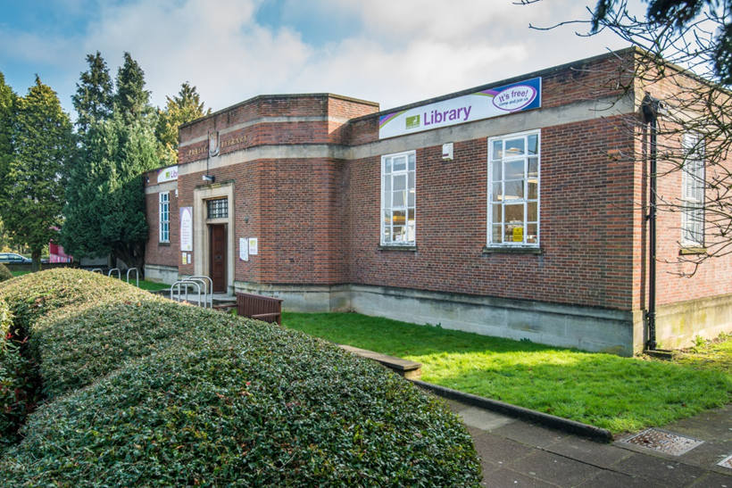

**North Watford Library, St Albans Road, Watford, WD24 7RW**

**Opening Hours:**

|  |  |  |  |
| --- | --- | --- | --- |
| Monday | 9.30am | - | 6.00pm |
| Tuesday | 9.30am | - | 6.00pm |
| Wednesday | 9.30am | - | 6.00pm |
| Thursday | Closed |  |  |
| Friday | •1.00pm | - | 6.00pm |
| Saturday | 9.30am | - | 4.00pm |
| Sunday | Closed |  |  |

This is a simple guide to help people visiting North Watford Library for the first time. If you have any questions, please ask the staff.

|  |  |
| --- | --- |
| **brick building with library sign** | This is North Watford Library.   |
| **brick building with front entrance open** | This is where you enter the library.   |
| **a woman is sitting behind a desk and looking at a computer screen** | This is the help desk.    Ask here if you need help or have any questions.  If it is busy you may need to queue. |
| **a woman is sitting in a chair, holding her staff badge** | Library staff are here to help.  All library staff wear a badge like this.   |

|  |  |
| --- | --- |
| **headphones** | Sometimes we have noisy times in the library and you may wish to visit at a quieter time.    Or you can bring with you some ear defenders to wear. |

|  |  |  |
| --- | --- | --- |
| library card | This is a library card. You will get one when you become a library member.    You need a library card to borrow books and to use the computers.  To get a library card, ask the staff at the help desk.  You can borrow up to 30 items at a time with your card. | |
| **two touchscreen self service kiosks** | These are the kiosks. You can borrow and return books here.    Follow the instructions on the screen. Ask the library staff if you need help.  If it is busy you may need to queue. | |
| **a large space with 2 sofas on the left, book shelves along the back and right wall, three children's tables and chairs and a carpet** | This is the children’s area.   | |
| three round tables with chairs | This is the quiet study area.   wifi logo  Ask staff for login details.  Desks with power sockets are available.  You can charge your own device here. | |
| **inside the library with a book display unit at the front and rows of bookshelves behind** | There are lots of books you can borrow.    If you cannot find a book you are looking for, you can ask the library staff to help. | |
| magazines in a display standrows of shelves with talking books | You can also borrow magazines and books you can listen to on CD.   | |
| comfortable seating area with 4 chairs around a low round table | There are plenty of places to sit and read around the library.   | |
| two public computers | These are the computers. They are downstairs. Library members can use them for free for two hours a day.    If the computers are busy you may need to book.  Ask the library staff if you need help. | |
| a book in the self service kiosk with a hand scanning a library card | When you are ready to leave the library, take the things that you want to borrow to the kiosk and follow the instructions on the screen. Ask the library staff if you need help.  If it is busy you may need to queue.   | |
| receipt coming out of self service kiosk | You can take the things you have borrowed home. Print a receipt so you know when you need to bring them back to the library.    Remember to return or renew your items on time to avoid charges.  You can renew your items at the kiosk or:   * ask at the desk * online at [www.hertfordshire.gov.uk/libraries](http://www.hertfordshire.gov.uk/libraries) * Telephone: 0300 123 4049 * Textphone: 0300 123 4041 | |
| lady putting books in bag | | We hope you enjoyed the story.  If you need any extra help or information please ask a member of staff.     For more information on the library please visit our website:  [www.hertfordshire.gov.uk/northwatfordlibrary](https://www.hertfordshire.gov.uk/northwatfordlibrary)  Please come back soon. ☺ |