**Royston Library Visual Story**

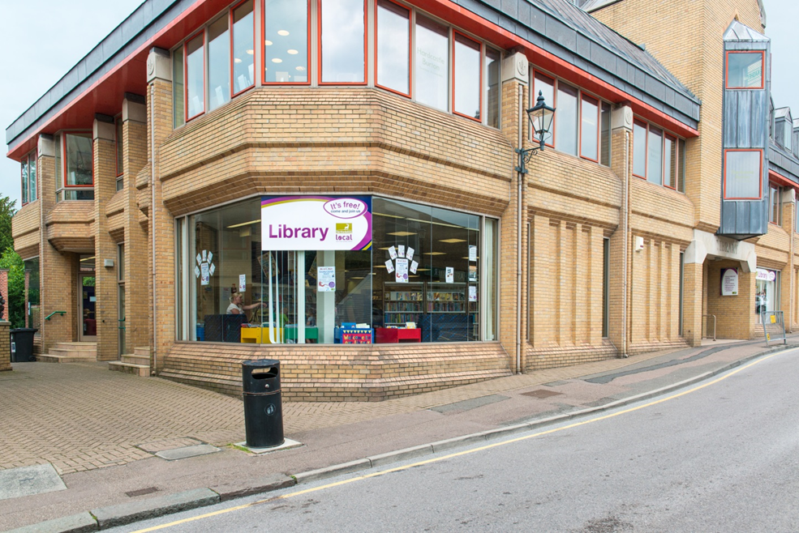

**Royston Library, Market Hill, Royston, SG8 9JN**

**Opening Hours:**

|  |  |  |  |
| --- | --- | --- | --- |
| Monday | 10.00am | - | 5.30pm |
| Tuesday | 10.00am | - | 5.30pm |
| Wednesday | 10.00am | - | 5.30pm |
| Thursday | 10.00am | - | •1.00pm |
| Friday | 10.00am | - | 5.30pm |
| Saturday | 9.00am | - | 4.00pm |
| Sunday | Closed |  |  |

This is a simple guide to help people visiting Royston Library for the first time, if you have any questions, please ask the staff.

|  |  |
| --- | --- |
| **outside view of brick building on a street corner with large glass windows and a sign saying library** | This is Royston Library   |
| **a woman is sitting behind a desk, smiling at the camera** | This is the help desk.    Ask here if you need help or have any questions.  If it is busy you may need to queue. |

|  |  |
| --- | --- |
| **a woman smiling showing her staff badge** | Library staff are here to help.  All library staff wear a badge like this.   |
| **headphones** | Sometimes we have noisy times in the library and you may wish to visit at a quieter time.    Or you can bring with you some ear defenders to wear. |

|  |  |
| --- | --- |
| **library cards front and back** | This is a library card, you will get one when you become a library member.    You need a library card to borrow books and to use the computers.  To get a library card, ask the staff at the help desk. |
| pink self service kiosk | This is a kiosk. You can borrow and return books here.    Follow the instructions on the screen. Ask the library staff if you need help.  If it is busy you may need to queue. |
| **children's library there are shelves with books on the left, wooden boxes full of picture books on the floor and a sofa at the back** | This is the children’s area.   |
| **shelves of books** | There are lots of books you can borrow.    If you cannot find a book you are looking for, you can ask the library staff to help. |
| shelves with magazines on display | You can also borrow magazines   |
| five computers on an oval table with bookshelves in the background | These are the computers. Library members can use them for free for one hour a day.    If the computers are busy you may need to book.  Ask the library staff if you need help. |
| table with chairs and bookshelves on the back wall | This is the quiet study area. There is free Wi-Fi in the library.   wifi logo  Ask staff for login details.  Desks with power sockets are available.  You can charge your own device here. |

|  |  |
| --- | --- |
| two low tables with newspapers, 2 tub chairs and leaflet display in the background | This is Royston Information Centre.    You can find out here about all the tourist sites in Royston. |

|  |  |
| --- | --- |
| cid:e43681d1-e20f-4615-8f86-7795d43b3938@Hertfordshire.gov.uk | When you are ready to leave the library, take the things that you want to borrow to the kiosk and follow the instructions on the screen. Ask the library staff if you need help.  If it is busy you may need to queue.   |

|  |  |
| --- | --- |
| cid:4c311b1f-8343-42b0-8ecf-9e181c4cca5d@Hertfordshire.gov.uk | You can take the things you have borrowed home. Print a receipt so you know when you need to bring them back to the library.    Remember to return or renew your items on time to avoid charges.  You can renew your items at the kiosk or:   * ask at the desk * online at [www.hertfordshire.gov.uk/libraries](http://www.hertfordshire.gov.uk/libraries) * Telephone: 0300 123 4049 * Textphone: 0300 123 4041 |
| cid:38b11f0d-3e1d-4975-99eb-d73f8a421c04@Hertfordshire.gov.uk | We hope you enjoyed the story.  If you need any extra help or information please ask a member of staff.     For more information on the library please visit our website:  [www.hertfordshire.gov.uk/roystonlibrary](https://www.hertfordshire.gov.uk/roystonlibrary)  Please come back soon. ☺ |