**Brookmans Park Community Library Visual Story**

**A Library run in partnership with Brookmans Park Library Community Volunteers**

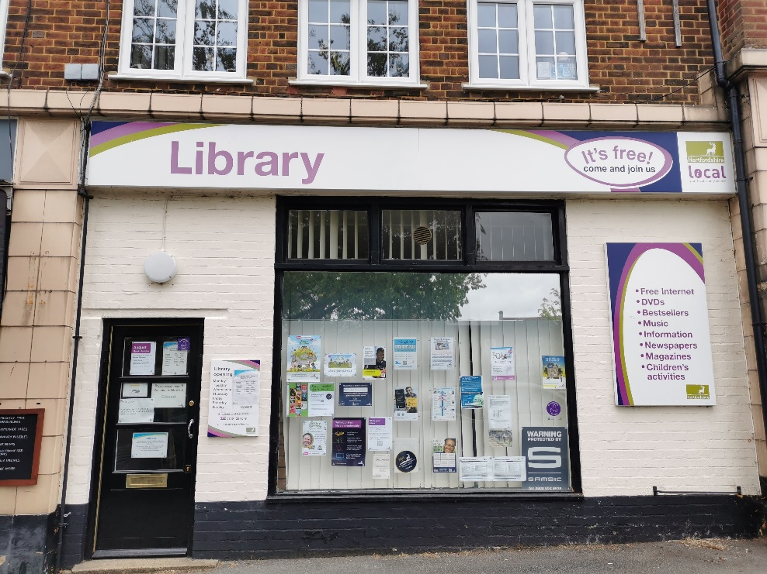

**Brookmans Park Community Library, 31 Bradmore Green, Brookmans Park, Hertfordshire, AL9 7QR**

**Opening Hours:**

|  |  |  |  |
| --- | --- | --- | --- |
| Monday | 🕑2.00pm | - | 🕠5.30pm |
| Tuesday | 🕑2.00pm | - | 🕠5.30pm |
| Wednesday | Closed |  |  |
| Thursday | 🕑2.00pm | - | 🕠5.30pm |
| Friday | 🕑2.00pm | - | 🕠5.30pm |
| Saturday | 🕤9.30am | - | 🕕12.30pm |
| Sunday | Closed |  |  |

A library run in partnership with Brookmans Park Library

Community Volunteers

This is a simple guide to help people visiting Brookmans Park Community Library for the first time, if you have any questions please ask library volunteers.

|  |  |
| --- | --- |
| **outside view of entrance of the library with a large window in the centre, the main door on the left and a big sign saying library across the top** | This is Brookmans Park Community Library   |
| **outside view of the front door** | This is the front door of the library.   |
| a library volunteer badge on a green lanyard | Library volunteers are here to help. All library volunteers wear a badge like this.   |
| A tablet on a stand | The Library Link can be used to contact Libraries Information who can provide information on library services. |
| **headphones** | Sometimes we have noisy times in the library, and you may wish to visit at a quieter time.    Or you can bring some ear defenders to wear. |

|  |  |
| --- | --- |
| A library card showing the front and back, with mini keyring versions next to them. The front has a blank space for a name, and the back has a barcode on. | This is a library card, you will get one when you become a library member.    You need a library card to borrow books and magazines and to use the computers.  To get a library card, ask the volunteers at the help desk. |
| Library membership forms for an adult and a child. | We can help you write down your name and where you live on one of these forms. We need to know this before we can give you a library card.    Or you can take it home with you and ask your family or support worker to help you. |

|  |  |
| --- | --- |
| a self service kiosk | This is a kiosk. You can borrow and return books here.    Follow the instructions on the screen. Ask the library volunteers if you need help. |
| inside the library with colourful rugs on the floor, bookshelves at the back and small boxes with children's books on the right | This is the children’s area.   |
| bookshelves filled with books | There are lots of books you can borrow.   |
| spinner displaying magazines | You can also borrow magazines   |

|  |  |
| --- | --- |
| desk with office chair and computer | This is the computer. Library members can use it for free for two hours a day.    If the computer is busy you may need to book. Ask the library volunteers if you need help.  wifi logoThere is free Wi-Fi in the library.  Ask volunteers for login details. |
| book in self service kiosk with hand scanning library card | When you are ready to leave the library, take the items that you want to borrow to the kiosk and follow the instructions on the screen. Ask the library volunteers if you need help.    If it is busy you may need to queue. |
| receipt coming out of self service kiosk | You can take the items you have borrowed home. Print a receipt so you know when you need to bring them back to the library.  Remember to return or renew your items on time to avoid charges.  You can renew your items at the kiosk or:   * ask library volunteers at the desk * online at [www.hertfordshire.gov.uk/libraries](http://www.hertfordshire.gov.uk/libraries) * Telephone: 0300 123 4049 * Textphone: 0300 123 4041 |
| lady putting books in bag | We hope you enjoyed this story.  If you need any extra help or information, please ask library volunteers.     For more information on the library please visit our website: [www.hertfordshire.gov.uk/brookmansparklibrary](http://www.hertfordshire.gov.uk/brookmansparklibrary)  Please come back soon. ☺ |