**Harpenden Library Visual Story**

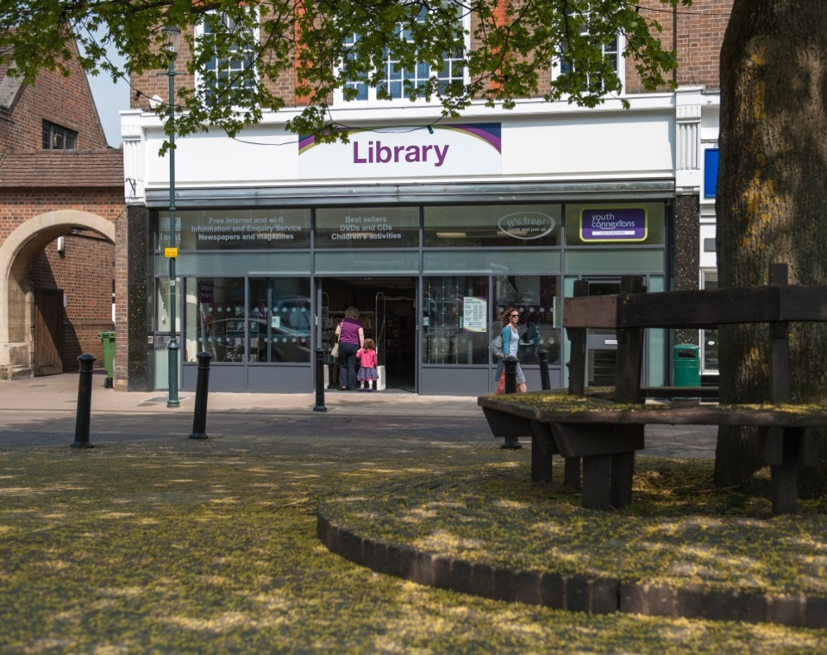

**Harpenden Library, 27 High Street, Harpenden AL5 2RU**

**Opening Hours:**

|  |  |  |  |
| --- | --- | --- | --- |
| Monday | 9.00am | - | 6.00pm |
| Tuesday  ***Self-service***  ***Full service*** | 9.00am  •1.00pm | -  - | •1.00pm  6.00pm |
| Wednesday  ***Self-service***  ***Volunteer Self-service*** | 9.00am  •1.00pm | -  - | •1.00pm  7.00pm |
| Thursday | 9.00am | - | 7.00pm |
| Friday  ***Self-service***  ***Full service*** | 9.00am  •1.00pm | -  - | •1.00pm  6.00pm |
| Saturday | 9.00am | - | 5.00pm |
| Sunday | Closed |  |  |

This is a simple guide to help people visiting Harpenden Library for the first time, if you have any questions please ask the staff.

|  |  |
| --- | --- |
| outside front of the library | This is Harpenden Library   |
| a woman sitting behind a desk | This is the help desk please ask for help here.    You may have to wait if we are busy. |
| a woman holding a staff badge | Library staff are here to help. All library staff wear a badge like this.   |
| front and back of library card | This is a library card, you will get one when you become a library member.    You need a library card to borrow books and DVDs and to use the computers.  To get a library card, ask the staff at the help desk. |
| **headphones** | Sometimes we have noisy times in the library and you may wish to visit at a quieter time.    Or you can bring some ear defenders to wear. |
| a selection of fidget toys | You can borrow fidgets and ear defenders to use while you are in the library.    Just ask a member of staff.  If all the fidgets and ear defenders are being used by other people, you may have to wait. |
| a person giving a fidget toy back to another person in the library | Before you leave the library give the fidgets and ear defenders back.   |
| a self service kiosk | This is a kiosk. You can borrow and return books here.    Follow the instructions on the screen. Ask the library staff if you need help.  If it is busy you may need to queue. |
| inside a library with bookshelves on the sdie and a self service kiosk in the middle | This is the library Self-service area which is open at set times when the main library is closed.    There are some things that you cannot do during our Self-service hours, remember to check our opening times before you visit.  If you want extra help from staff please visit during normal opening hours. |
| a woman standing in front of a computer screen | During library Self-service times, when the main building is closed, you can borrow and return items and use our computers and printers.   |
| 2 women talking next to a printer | Some days there are volunteers who can help you to use the library Assisted Self-service area.   |

|  |  |
| --- | --- |
| inside children's library with small table and chairs at the front bookshelves at the back and boxes of books in the middle | This is the children’s area.   |
| shelves of books | There are lots of books you can borrow.   |
| shelves with magazines | There are magazines which you can borrow.   |
| desk with three office chairs | This is the quiet study area. There is free Wi-Fi in the library.  wifi logo    Ask staff for login details. |
| long desk with computers | These are some of our computers which you can use.    Library members can use them for free for one hour a day.  If the computers are busy you may need to book. Ask the library staff if you need help. |
| toilet sign | There is a toilet in the library.    If it is busy you may need to queue. |
| large lift door open | This is the lift. This lift is to help borrowers who cannot use the stairs.    You can use this lift if you have booked one of our meeting rooms upstairs |
| hand scanning a library card on self service kiosk | When you are ready to leave the library, take the things that you want to borrow to the kiosk and follow the instructions on the screen.    Ask the library staff if you need help.  If it is busy you may need to queue. |
| hand taking receipt from kiosk | You can take the things you have borrowed home. Print a receipt so you know when you need to bring them back to the library.  Remember to return or renew your items on time to avoid charges.  You can renew your items at the kiosk or:   * ask at the desk * online at [www.hertfordshire.gov.uk/libraries](http://www.hertfordshire.gov.uk/libraries) * Telephone: 0300 123 4049 * Textphone: 0300 123 4041 |

|  |  |
| --- | --- |
| person putting books in a bag | We hope you enjoyed the story.  If you need any extra help or information please ask a member of staff.     For more information on the library please visit our website: [www.hertfordshire.gov.uk/harpendenlibrary](http://www.hertfordshire.gov.uk/harpendenlibrary)  Please come back soon. ☺ |