**PURPLE PLEDGE OF PRINCIPLES FOR COMMUNITY HEALTH SERVICES**

**HANDBOOK**

This handbook is designed to accompany the Purple Principles and Pledges for health professional’s training videos, which can be located here:

[Purple Principle and Pledges for health professionals](https://www.youtube.com/playlist?list=PLBSjtUxPa6TWk1PIwhfOSW0Ah0OPbh3pn)

**The National Mandatory Learning Disability and Autism Training [Sometimes delivered as Oliver McGowan Training] Provides you with the foundation of understanding – The Purple Principles aims to help you to embed this in your services practice**

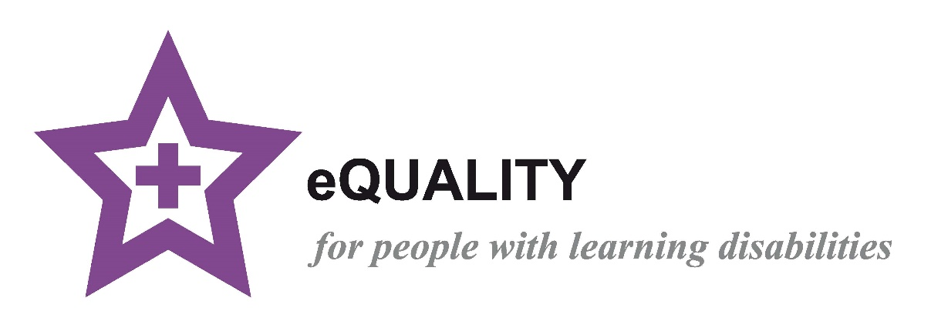

Improving health outcomes for people with learning disabilities

|  |  |
| --- | --- |
| PAGE | INDEX |
| 3 | Hertfordshire Services |
| 5 | The Purple Star Strategy |
| 6 | How does the purple pledge of principles work for your service? |
| 8 | Video links |
| 10 | **Principle 1 - What is a learning Disability, learning Difficulty and Autism?** |
| 14 | What causes a learning disability? |
| 15 | Inclusion Tool |
| 18 | What is Autism? |
| 22 | **Principle 2 – Why are there health inequalities?** |
| 27 | **Principle 3 – Adapting your service** |
| 32 | **Principle 4 – Time** |
| 35 | **Principle 5 - Environment** |
| 38 | **Principle 6 – Attitude** |
| 41 | **Principle 7 – Communication** |
| 46 | **Principle 8 - Help** |
| 47 | Mental capacity and Best Interest decisions |
| 50 | LD nursing Service Help |
| 51 | Purple Folder / Purple Cards and Purple All Stars |
| 54 | The Purple All Stars |
| 55 | DNA CPR – HELP to get it right |
| 56 | Safeguarding – every small thing may be a piece of a much bigger picture |
| 59 | Principle 8 pledge page |
| 60 | **RECORD OF TEAM /SERVICE TRAINING FORM** |
| 61 | **RECORD OF SERVICE PLEDGES DOCUMENT** |
| 62 | Useful websites |
|  |  |

**Hertfordshire Services**

**Purple Star Strategy Team 01438 844 681**

[**purplestarstrategy@hertfordshire.gov.uk**](mailto:purplestarstrategy@hertfordshire.gov.uk)

If you have any queries throughout your Purple Star Accreditation or Monitoring Process, please don’t hesitate to get in touch with the team on the above number or email address.

**Health Professionals can find information on our service and tools at -** [**www.hertfordshire.gov.uk/LDprofessionals**](http://www.hertfordshire.gov.uk/LDprofessionals)

**People with learning disabilities and their carers can also find information about our services and keeping healthy at –**

[**www.hertfordshire.gov.uk/LDMyHealth**](http://www.hertfordshire.gov.uk/LDMyHealth)

**Health Liaison Team 01438 845 372**

[**healthliaisonteam.referrals@hertfordshire.gov.uk**](mailto:healthliaisonteam.referrals@hertfordshire.gov.uk)

The nurses in this team support people with a learning disability in accessing secondary health care. If you refer someone to secondary health and have concerns about how their health needs will be met, then contact this team. Leave a message and they will call back. This service is available Monday-Friday 9am-5pm.

**Purple Folder 01438 843 848**

[purplefolder@hertfordshire.gov.uk](mailto:purplefolder@hertfordshire.gov.uk)

For adults who are registered as having a learning disability, please visit our website for details on our new 2023 version purple folder [The Purple Folder | Hertfordshire County Council](https://www.hertfordshire.gov.uk/services/adult-social-services/disability/learning-disabilities/my-health/my-purple-folder.aspx)

**GP Link Nurses**

Every GP surgery has a Community Learning Disability team. You can contact them for non-urgent discussions via their team email address.

[Watfordthreerivers.adt@Hertfordshire.gov.uk](mailto:Watfordthreerivers.adt@Hertfordshire.gov.uk) 01442 454 343

[StAlbans.adt@Hertfordshire.gov.uk](mailto:StAlbans.adt@Hertfordshire.gov.uk) 01438 843 166

[Dacorum.adt@Hertfordshire.gov.uk](mailto:Dacorum.adt@Hertfordshire.gov.uk) 01442 454 444

[Hertsmere.adt@hertfordshire.gov.uk](mailto:Hertsmere.adt@hertfordshire.gov.uk) 01442 454 242

[WelwynHatfield.adt@Hertfordshire.gov.uk](mailto:WelwynHatfield.adt@Hertfordshire.gov.uk) 01438 843 600

[NorthHerts.adt@Hertfordshire.gov.uk](mailto:NorthHerts.adt@Hertfordshire.gov.uk) 01438 845 629

[Stevenage.adt@Hertfordshire.gov.uk](mailto:Stevenage.adt@Hertfordshire.gov.uk) 01438 845 529

[Eastherts.adt@Hertfordshire.gov.uk](mailto:Eastherts.adt@Hertfordshire.gov.uk) 01438 843 111

[Broxbourne.adt@Hertfordshire.gov.uk](mailto:Broxbourne.adt@Hertfordshire.gov.uk) 01438 843 400

[0-25_Central@Hertfordshire.gov.uk](mailto:0-25_Central@Hertfordshire.gov.uk) 01438 845 258

**Health and Social Care Service - 0300 123 4042**

**Monday - Friday 9-5 service**

If you feel someone may need some help from a Community Learning Disability Nurse or Social Worker.

This may be due to concerns you have about:

* Family circumstances
* Care Support
* Low level mental health anxiety concerns
* Meeting / managing their health needs
* Or anything else – this is your starting point

**Single Point of Access (HPFT) 0300 777 0707**

If someone presents with significant mental health issues, then the best starting point is SPA as they can offer intensive support for people with a mental health and learning disability diagnosis

**beyond a 9-5 Monday-Friday service**

**Herts Help 0300 123 4044**

[**www.hertfordshire.gov.uk/LDhertshelp**](http://www.hertfordshire.gov.uk/LDhertshelp)[info@hertshelp.net](mailto:info@hertshelp.net)This is the generic Hertfordshire help service to support people in finding the right service they need. They know what’s available, including private and voluntary sectors in all aspects of life.

**LEDER**

[**www.hertfordshire.gov.uk/LDleder**](http://www.hertfordshire.gov.uk/LDleder)

To tell LeDeR about the death of someone with a learning disability: **01278 727411**

[Report the death of someone with a learning disability (leder.nhs.uk)](https://leder.nhs.uk/report) <https://leder.nhs.uk/report>

# The Purple Star Strategy

The Purple Star brand was developed in 2014 by the Hertfordshire Community Learning Disability Nursing Services through the Health Liaison Team [Herts County Council] in partnership with people with a learning disability, people who support them and the University of Hertfordshire Business School.

The Purple Star is a Trademark which is accredited to GP Practices in Hertfordshire who demonstrate the delivery of high quality reasonably adjusted services to adults with learning disabilities, in line with the requirements of the Equality Act 2010.

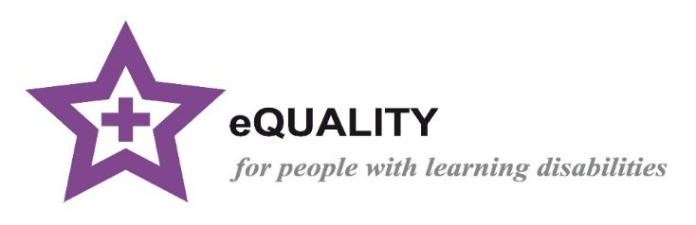Like a "kite mark" the presence of a Purple Star at a health service provider indicates that a defined set of standards, as set out in the Purple Star Promise, have been achieved by that health service provider and are consistently being maintained and monitored via an independent steering committee.

**A new Layer of Purple Star for ALL health care Providers.**

Following the success of the Purple Star Accreditation for GP practices, we wanted to be able to offer similar service improvement enablement to all community, acute and end of life healthcare providers too. People with a learning Disability die an average of around 26 years younger than the rest of the population **(LeDeR 2019)** Delays in diagnosis, due to barriers in communication and capacity to understand their health needs, is a significant issue and we want to be able to support **ALL** health providers to be aware of the role they can play in reducing these risks … and so we have developed the **…**

**PURPLE PLEDGE of PRINCIPLES RECOGNITION**

The new Mandatory Learning Disability and Autism training will help your team have the core understanding of WHY services need to be adapted. This will help your service establish HOW to make those changes and what services are there to help you in Herts.

**How Does the Purple Pledge of Principles work for your service?**

**The Purple Star Team** have developed training videos in 8 chapters for your services to utilise and create a pledge of practice from.

You can use these videos:

* as bitesize training within staff meetings
* as individual staff members – setting targets in professional development for staff to complete
* in small groups
* As part of induction for new staff

This is a handbook to accompany these videos. In this handbook you will find some of the information from the videos in written format and some forms for your service to keep a record of the pledges made as individuals or as a whole service. These pledges can be both to maintain practice that already enables good health outcomes for your patients with a learning disability or Autism **OR** they can be pledges, no matter how small, on how individuals or the whole service will improve their practice.

These Videos and accompanying handbook will:

1. **Give the knowledge to be able to go away and form your own Pledges /action plan for service changes that will enable better access / breakdown barriers for people with a Learning Disability and Autistic people.**
2. **Provide your service with a toolkit of resources to enable better reasonable adjustments – this is to support your services learning disability or vulnerable adults champion to feel confident in ensuring all staff understand how to meet the health needs of people with a learning disability.**
3. **Provide an understanding of the role of the Learning disability nursing service - (Acute liaison and Community LD teams) and links for making referrals.**
4. **Provide you with food for thought / ideas of pledges the service can make and a provide a form to evidence this.**

**We will also:**

1. **Provide ongoing updates and advice, through the Purple Star Team, on new legislation / tools etc that may benefit you in meeting the health needs of people with learning disabilities.**

**Receiving the Purple Pledge of Principles Recognition**

The certificate of recognition is an acknowledgement of your services engagement with the Purple Principles of Reasonable adjustments and your pledges for maintaining current good practice and making improvements.

Your service will provide us with the following information, and this will be presented to the independent Purple Star Steering Committee to receive Purple Pledge of Principles Recognition of your commitment and dedication to improving / maintaining excellent reasonable adjustments.

1. **Evidence how many of the current workforce have watched the 8 training videos and been involved in the pledges of Practice Changes.**
2. **Create a Pledge of Practice changes / action plan / positive current practice you will maintain -** These actions may be tiny changes that an individual practitioner has reflected on and will change in their practice **OR** team/system changes that the whole team will develop and embed within the service. They all need recording on the pledges form.
3. **Notify us of the Internal Governance that will be used to hold you to account for your pledges.** The Pledges will be the responsibility of the organisation to fulfil and will not be monitored by the Health Liaison Team. How well new pledges are embedded into their own processes and their own service governance of this, is totally down to that service and what works within their organisational and line management structure. This could be via their equality and diversity leadership structure, commissioning, or service line management structure.

**It is also good to:**

Build in a feedback process for people with a learning disability and those who support them, that asks questions to help evidence the impact of the pledges in practice.

**What happens if your feedback indicates you are not doing so well?**

We are here to support and not judge!! So, use the Purple Star Team to help you revisit your pledges and help you improve your practice.

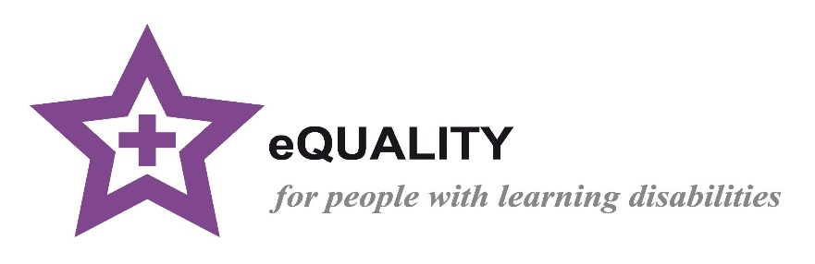

**THE TRAINING VIDEO LINKS**

**Before we start …. Here is a 4-minute Whiteboard created by Herts Community Trust, to help you truly understand the impact of the reasonable adjustments we can make for people with a learning disability and Autistic People**

[CC255 Herts Reasonable Adjustments](https://www.youtube.com/watch?v=gUHHoZZcUTo&feature=emb_title)

**Please now plan how your service will:**

* **Ensure the staff team all watch the videos [as a team or individually]**
* **Establish Who will keep a record of this**
* **Establish Who will keep a log of the individual and service Pledges**
* **Establish Who will be the overarching body of governance to ensure the pledges are achieved within your organisation**
* **Take responsibility in following this up**

**Here are the Video links and you can use the material in the handbook below to accompany each Video**

[Video 1 - definitions](https://youtu.be/UZNKRzQ6ae4)

This is a snippet taken from a training session to help health professionals understand The Difference between Learning Disability, Learning Difficulty and Autism.

[Video 2 - Making reasonable adjustments](https://youtu.be/y0tPn9iZuLk)

This principle focuses on what the health inequalities are that people with a learning disability and autistic people face and why these happen.

[Video 3 - Making reasonable adjustment](https://youtu.be/HrpZQJf3jnw)

This principle focuses on the importance of reviewing and adapting your processes to ensure they are accessible from very first contact through to seeing the clinician. The focus is on the Accessible Information Standard 2016 and how to put this into practice.

[Video 4 - TEACH](https://youtu.be/-xY4PXa04dA)

This principle focuses on reasonable adjustments – In Hertfordshire we break reasonable adjustments into 5 areas and use the acronym TEACH. This principle focuses on the letter T – TIME.

[Video 5 - TEACH](https://youtu.be/18JOV5JlJ4Q)

This principle focuses on reasonable adjustments – In Hertfordshire we break reasonable adjustments into 5 areas and use the acronym TEACH. This principle focuses on the letter E – Environment.

[Video 6 - TEACH](https://youtu.be/tf0Tugnik08)

This principle focuses on reasonable adjustments – In Hertfordshire we break reasonable adjustments into 5 areas and use the acronym TEACH. This principle focuses on the letter A – Attitude.

[Video 7 - TEACH](https://youtu.be/4Nik-aF7i6s)

This principle focuses on reasonable adjustments – In Hertfordshire we break reasonable adjustments into 5 areas and use the acronym TEACH. This principle focuses on the letter C - Communication and how important it is to always assess the persons capacity to understand the risks of refusal of health investigations or treatment and to make best interest decisions where someone can’t understand to avoid delays in diagnosis and treatment.

[Video 8 - TEACH](https://youtu.be/gV_kWE-FoHA)

This principle focuses on reasonable adjustments – In Hertfordshire we break reasonable adjustments into 5 areas and use the acronym TEACH. This principle focuses on the letter H – Help This section also touches on Safeguarding and how we all must work together to identify potential safeguarding risks.

**At the end of each principle, you are invited as a team or individual to consider what you have heard and make a pledge for what you will do to improve equitable health outcomes in your area of health practice.**

PRINCIPLE 1

**What is a learning Disability, learning Difficulty and Autism?**

**A refresher on the definition of a Learning Disability and some core examples to help embed the understanding**

**Please watch this video alongside this section of the handbook:** [Principle 1](https://www.youtube.com/watch?v=q42hupRuDXo&list=PLBSjtUxPa6TWk1PIwhfOSW0Ah0OPbh3pn&index=1)

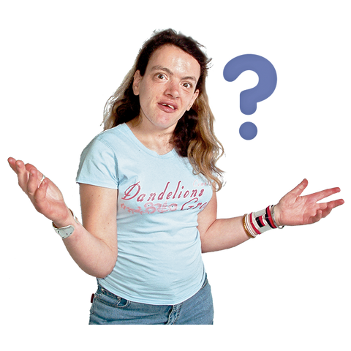

**The definition of a Learning Disability is:**

* **Impaired Intelligence (IQ below 70)** but IQ is rarely tested
* **Reduced ability to understand new or complex information** and impaired ability to learn new skills
* **Impaired Social Functioning**
* **Reduced ability to cope independently**
* **Started in childhood** Before the age of 18
* **Life long**
* **With lasting effect** on development

A learning disability is a reduced intellectual ability and difficulty with everyday activities. For example, household tasks, socialising or managing money – which affects someone for their whole life.

Learning **disability** is often confused with learning **difficulty**. Dyslexia and Dyspraxia are called a “learning difficulty” **NOT** a learning disability because they do not affect a person’s intellect or ability to learn, it just makes it more difficult.

Mental health problems can also present as a learning disability but again, a mental health problem does not affect intellect or the ability to learn but may affect the person’s ability to absorb information at that time.

**These descriptions of a Learning Disability may help:**

**Mild learning disability**

* **Social functioning** – ability to maintain social network independently
* **Education** – likely to have been educated in mainstream school with recognised additional need
* **Dependency** – able to live independently with recognised need for support
* **Communication** – likely to be verbally communicative
* **Understanding** – may appear to have more understanding than they do, likely to have difficulty processing new or complex information unless clearly and fully explained in an understandable way

**Example: ‘Geoff’**

Geoff is 31 years old and lives in his own flat with his girlfriend. He has a part time job at B&Q and is a season ticket holder at the local football club. Geoff is quite chatty and often gives the impression of understanding when he doesn’t. Geoff needs support understanding letters and finances. He went to the local comprehensive school and had some support with reading and writing. He left school with no formal qualifications.

**Moderate learning disability**

* **Social functioning** – likely to need support to maintain social networking
* **Education** – likely to have been educated in specialist or mainstream education with dedicated support
* **Dependency** – likely to need support with daily living
* **Communication** – may or may not have verbal communication therefore reliable communication would need to be facilitated by others who know them well. Likely to benefit from supplementary communication tools such as easy read information, Makaton etc
* **Understanding** – limited understanding beyond clear and straight forward conversation. Likely to have difficulty processing new or complex information

**Example: ‘Charlotte’**

Charlotte is 25 years old and has Down’s syndrome. She received her primary education in a mainstream school with individual support and transferred to a special school for her secondary education. She lives at home with her parents but has aspirations of having her own flat. Charlotte attends college three days a week and a local weekly disco for people with learning disabilities, where she meets her boyfriend. Charlotte can be familiar and very tactile with people she does not know well making her extremely vulnerable. She has a few well-rehearsed sentences that give an impression of a higher level of communication than is the case.

**Severe learning disability**

**(Including those with profound and multiple learning disability)**

* **Social functioning** – likely to be dependent on others to have any social network
* **Education** – likely to have been educated in specialist education
* **Dependency** –dependent on others for daily living. They may or may not have a physical disability
* **Communication** – individualised communication and use of non-verbal techniques including body language and behaviour Communication is likely be very difficult so consultation with others who know them well is important
* **Understanding** – very limited or no obvious understanding, with difficulty processing basic information

**Example: ‘Jenny’**

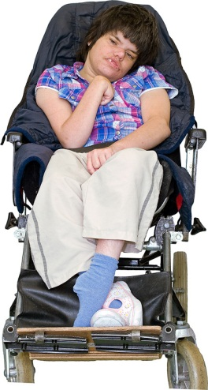

Jenny is16 years old and has both a severe learning disability and some physical disability which means she is unable to walk unaided. She is totally reliant on others to meet her personal care needs. She attends the local special school and will leave when she is 19 years old. She lives with her mother and two younger siblings.

Her social network is through school and short break service. Jenny has no verbal communication and responds best to familiar people. Jenny is more likely to respond to a simple single choice question as she finds it difficult to communicate complex choices or information. When Jenny is in pain or distressed, she usually bites her hands, rocks back and forth and cries.

**What causes a learning disability?**

A learning Disability can be caused by:

* **An inherited condition** – a condition passed down through the parents
* **Chromosomal differences**– Most syndromes can be identified through DNA analysis of chromosomal differences, for example, Downs Syndrome is caused by an additional part on Chromosome 21
* **Complications during birth** – reduced oxygen supply during birth can cause brain damage
* **A very premature birth** – the baby may not develop fully
* **Mother’s illness during pregnancy –** e.g.,Chicken pox in early pregnancy when the foetus may form a pox impacting brain development
* **The mother drinking during pregnancy** – this is called fetal alcohol syndrome
* **A debilitating illness or injury in early childhood** – e.g., a head injury from a car accident, bad fall, or Meningitis
* **Neglect and/or a lack of mental stimulation early in life** – if the brain isn’t given the chance to develop or the baby isn’t fed properly it can cause brain damage

**Some syndromes and conditions have very specific health concerns associated with them…**

For example, people with Downs Syndrome have higher risks of issues with eyesight and hearing, heart disease, dysphagia, GOARD, sleep apnea, mental health problems (25-30% suffer with anxiety and depression), early onset dementia (10-22% get it in their 40s), early menopause, osteoporosis, hypothyroidism (15-37%), diabetes type 1 and type 2, obesity (89-95%), skin conditions and cervical spine issues with degenerative changes (70%)

So as a medical professional it is always important to ascertain if they have syndrome specific additional potential comorbidities (this is the presence of two or more diseases or medical conditions in a patient).

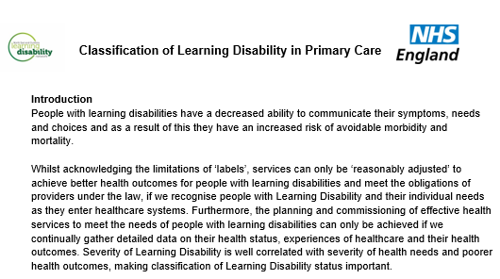**LEARNING DISABILITY – INCLUSION TOOL**

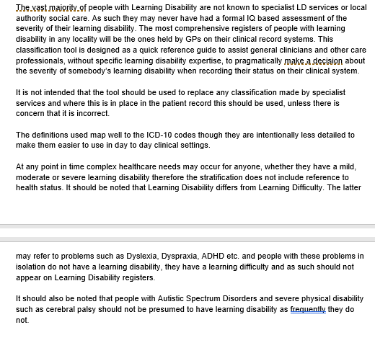

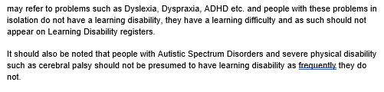

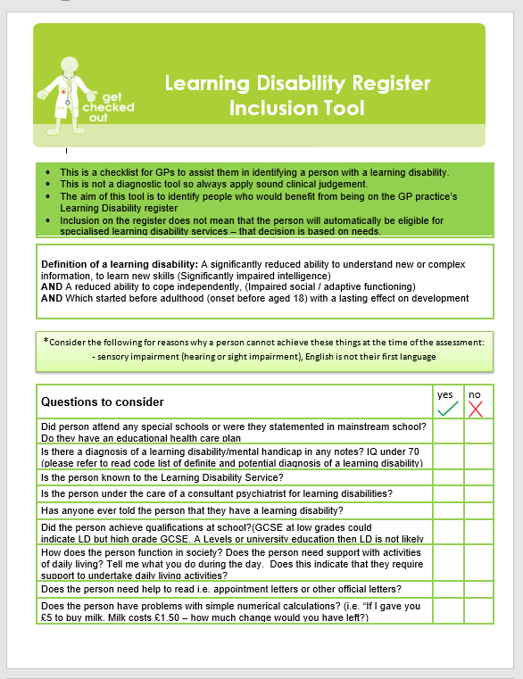

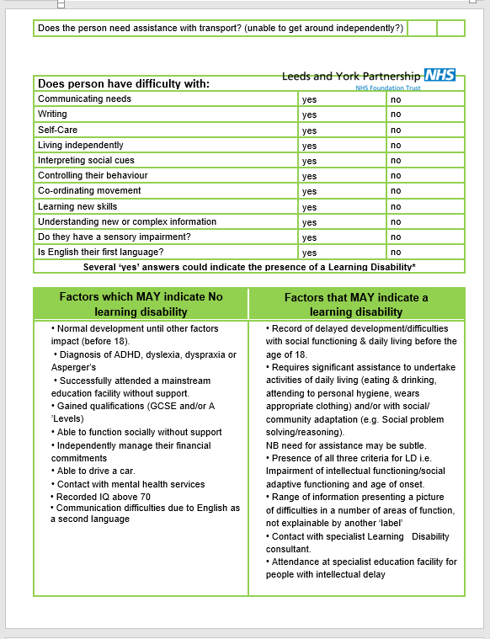

**What is Autism?**

**Autism is not a learning disability.** The person may have full intellectual ability but struggle with understanding societies typical communication cues and styles. Some Autistic people do have an underlying learning disability as well.

Please watch this video on Autism, as this patient group equally need support to overcome health inequalities <https://www.nhs.uk/conditions/autism/what-is-autism/>

**Autism symptoms and behaviours**

Individuals with autism may present a range of symptoms, such as:

* **Reduced eye contact**
* **Differences in body language**
* **Lack of facial expressions**
* **Not engaging in imaginative play**
* **Repeating gestures or sounds**
* **Closely focused interests**
* **Indifference to temperature extremes**

These are just a few examples of the symptoms an individual with autism may experience. Any individual could have some, all, or none of these symptoms. Keep in mind that having these symptoms does not necessarily mean a person has autism. Only a qualified medical professional can diagnose autism spectrum disorder.

Most importantly, an individual with autism is first and foremost an individual. Learning about the symptoms can help you start to understand the behaviours and challenges related to autism, but that’s not the same as getting to know the individual. Each person with autism has their own strengths, likes, dislikes, interests, challenges, and skills, just like you do.

**Comorbidities with autism**

When a person has more than two or more disorders, these conditions are known as comorbidities. Several comorbidities are common in people with autism, these include:

* Anxiety
* Depression
* Epilepsy
* Gastrointestinal and immune function disorders
* Metabolic disorders
* Sleep disorders

Identifying comorbidities can sometimes be a challenge because their symptoms may be mimicked or masked by autism symptoms. However, diagnosing and identifying these conditions can help avoid complications and improve the quality of life for individuals with autism.

**Don’t Assume!**

Don’t assume, based on appearance or behaviour,

that someone does or does not have a learning disability!

Rosie Jones – Comedian

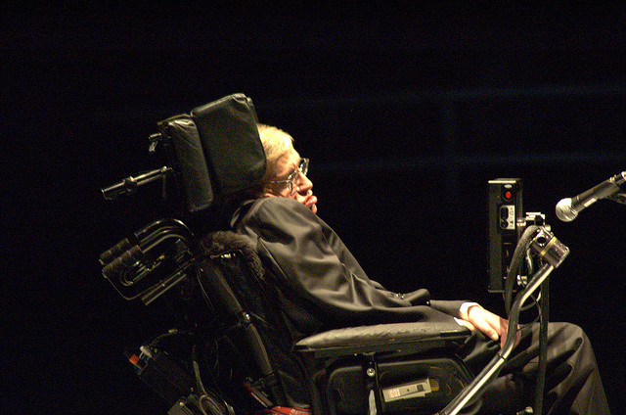Stephen Hawking – Physicist, cosmologist and author

**Time to talk and make a Pledge**

What are your previous experiences and apprehensions of LD?

Did u know and fully understand the differences before today?

Pledge to read the scenarios to feel more confident in recognising a LD

Pledge to watch the autism video

Please transfer your Pledges to the team’s pledge Document at the end of this handbook.

**NOTES:**

|  |
| --- |
|  |

PRINCIPLE 2

Why are there health inequalities?

**Recap of Mandatory training with additional examples to help you reflect on the impact of your practices**

**Please watch this video alongside this section of the handbook** [Principle 2](https://www.youtube.com/watch?v=y0tPn9iZuLk)

**People with Learning Disabilities are dying considerably younger than the general population.**

**Learning Disability Mortality Review (LeDeR 2019)** found that people with Learning Disabilities are dying on average **26 years *younger*** than the general population. 23 years for men, and 29 years for women.

**The Confidential Inquiry into Premature Deaths of People with Learning Disabilities (CIPOLD) (2013)**. The inquiry looked at the deaths of 247 People with Learning Disabilities. The findings showed that nearly **50% of deaths were *avoidable*** compared to 24% in the rest of the population.

**What are the barriers to getting the same health outcomes as any other patient would get?**

**Communication** – if you are unable to tell someone you are in pain you might display behaviour that is misunderstood with nobody realising it relates to a health issue. This can lead to a delay in diagnosis that could be the difference between living and dying avoidably.

**Health Screening** – there is a low attendance rate for health screening among the learning disability population. This may be due to not understanding the importance of going, or family and carers not seeing it as critical, so avoiding it as it would be too challenging. Limited ability to weigh up the risk of not attending versus the dislike of going through the screening, means people may not get screened without understanding the risks this involves. (**Mental Capacity**)

**Accessibility** – access to buildings could be difficult if you have anxiety about going to health settings/new places due to sensory overload. Accessibility can also be impacted by practical things, such as not having someone to support at appointments or not wanting to pay for transport. This, again, may mean the person is ‘making a decision’ not to access health without being able to weigh up the risk of this decision.

**Diagnostic overshadowing** – this is when symptoms are attributed to the persons learning disability for example, if an individual has incontinence – this may be put down to their learning disability rather than another health cause. Or if the individual is being unresponsive, a doctor may assume that this is their ‘normal’ because they have a learning disability and not realising this is a severe decline from their baseline.

**Treatment options** – surgery involving complicated rehabilitation might not be offered if there are concerns the person might not comply with the essential rehabilitation plan. For example, if after surgery they need to be non-weight bearing, but are getting up and down, putting themselves at greater risk.

**Signs and Symptoms** – health problems might be accompanied by unusual signs and symptoms, for example someone with a severe learning disability might demonstrate discomfort by self-injuring or hitting out. The person may not show any signs of pain and not be able to vocalise the changes / pain they are experiencing.

**Understanding their own health needs** – health promotion materials might not be accessible to people with Learning Disabilities or explained in a way they understand, so people accept refusal even though they don’t have capacity to understand the risks of that refusal.

**People with Learning Disabilities may have additional health conditions**

These are some of the conditions that generally people with learning disability have high risk of either suffering or dying from:

* **Cancer** – there is a higher rate of death due to delays in diagnosis because people with learning disabilities are less likely to voice their symptoms early enough, some people have a higher pain threshold, and some people are reluctant to accept treatment
* **Coronary heart disease** – second highest cause of death - at around 18% - may be due to condition, but also exercise, diet and lifestyle
* **Dental issues/oral hygiene –** due to diet and how they are supported. Poor dental care also leads to throat cancers and heart disease
* **Diabetes** – this is linked to obesity, due to poor lifestyle choices
* **Epilepsy** – there is a higher chance of having epilepsy where a brain has an injury or damage, and uncontrolled seizures may cause further damage to the brain
* **Gastro-intestinal problems –** double the rate ofgastro-intestinal cancers such as oesophageal, stomach and gallbladder
* **Mental health problems**
* **Obesity –** very high rate of obesity in people with learning disabilities
* **Respiratory disease** - Highest cause of death at nearly 50% (compared to 15% in general population)
* **Sensory impairments –** 60% of people with learning disabilities need glasses and 40% are hearing impaired
* **Swallowing/feeding problems -** The swallow reflex is really complicated and when it goes wrong this can cause aspirational pneumonia (where food or liquid goes into the lungs and they get an infection) Look out for signs of the swallow reflex changing, such as keeping food in the mouth for a long time and not swallowing, dribbling, or coughing when eating and drinking, they may need a swallow assessment
* **Constipation –** in 2019 there were 12 deaths from constipation on the LeDeR report of people with learning disabilities. Know your **Bristol stool chart** to be able to spot changes

[Bristol stool chart explained](https://www.youtube.com/watch?v=9Wv87x9ho9s)

**MEET SIMON**

Simon lives in a residential care provision in Hertfordshire. He likes trains and cars. He is non-verbal and communicates his happiness by jumping up and down and clapping. When he is unhappy or unwell, he becomes lethargic and won’t get out of bed.

One day, Simon’s behaviour dramatically changed. He started biting his hand, he was jumping about but squealing in a way that indicated he wasn’t happy. If staff approached him, he hit out. He was biting his arm and started throwing furniture.

The care team called the doctors surgery to request a home visit. They said they wanted to rule out stomach pain as he was hitting his stomach too and had not opened his bowels for a week.

The GP came out but could not get into the room with Simon due to his aggressive behaviour towards him. The GP prescribed a sedative and said he would return the next day to examine again.

**Simon’s behaviour escalated even with sedation.**

That day a learning disability nurse visited the home on a separate matter relating to a different resident. She heard the screaming and asked what was happening. When the staff told her what had happened the nurse asked about Simon, what is Simons usual way of behaving? What do you think he could be communicating with this change in behaviour?



The staff then said how Simon is always calm. They said that the only time he had ever been this aggressive before was when he was in excruciating pain and had a total bowel blockage having eaten socks. When asked if they had told the doctor this, they said that they had said they thought he might be blocked but had not given that full picture because ‘they didn’t want to tell the doctor his job and the doctor hadn’t asked…’

When the doctor was called again, with this additional information he was able to weigh up the risk of delaying physical examination by 24hrs and decided that it was in fact in Simons best interest to be taken straight to hospital.

Simon was in theatre that night. He had a total blockage with socks and the surgeon felt he would not have survived until the next day.

**Time to talk and make a Pledge**

**Think about the service you offer:**

Imagine a patient who has no understanding of their health condition and what you are needing to do to help them? What are likely to be the fears and barriers and what can you do to help overcome these?

What aspects will they find challenging?

The next 6 principles will help you develop your ability to overcome these – can you now pledge to watch and complete these in a specific time frame?

Please transfer your Pledges to the team’s pledge Document at the end of this handbook.

**NOTES:**

|  |
| --- |
|  |

PRINCIPLE 3

Adapting your service

How to put accessible information standard into your practice

**Please watch this video alongside this section of the handbook:** [**Principle 3**](https://www.youtube.com/watch?v=HrpZQJf3jnw)

**Accessible Information Standard 2016** 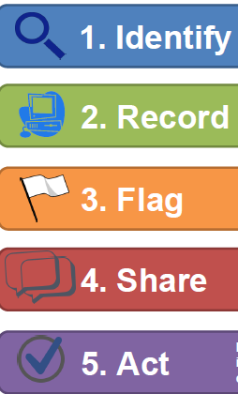

It is a legal requirement for all health and social care providers to identify, meet and share the information and communication needs of people who use their service.

For people with a learning disability - The Accessible Information Standard requirement means all health and social care providers need to:

**IDENTIFY** – Ask all patients and those who support them, how they like to be communicated with. Consider if this would affect how information is sent to them for example, do they prefer phone calls?

**RECORD** – Make sure you tell the patient and get **agreement** from them that this information will be recorded on your system, and on their Summary Care Record Additional Information. The patient (or family/carer) must agree to the exact wording used for this record.

**FLAG** – This information MUST be flagged on your system and on the Summary Care Record Additional Information so ALL professionals KNOW how to communicate with this person and can access this information easily and instantly.

**SHARE** – Whenever referring this person to other professionals or liaising with other professionals you MUST notify them of the persons preferred method of communication, using the agreed wording.

**ACT** – Make sure that you always follow the communication method requested and recorded.

**Accessible Information Standard**

**CIPOLD (2013) found that a large contributing factor to the health inequalities faced by people with learning disabilities is delays or failings to attend health appointments due to not receiving information in an accessible format that the person could understand. By adhering to the Accessible Information Standard, this ensures that professionals are reducing this risk factor for people with learning disabilities.**

**The Reasonable Adjustment Digital Flag 2024**

**This extends the AIS as it is the new Nationally Accessible Record that will indicate where a person needs Reasonable Adjustments, including communication needs, and will have the option to include**

* **Details of their significant impairment**
* **Key Adjustments that should be considered**
* **Underlying conditions**

**ALL organisations under Health and Social Care, by April 2024 were required to prepare for the new digital flag by ensuring they have processes in place on their own systems that:**

* **Identify**
* **Record**
* **Flag**
* **Share**
* **Meet**
* **Review**

**The reasonable adjustments and communication needs of the people known to their service who have a learning disability and / or are Autistic.**

**GAVIN SAYS**

[**Gavin Says - check you know the best way to contact someone**](https://www.youtube.com/watch?v=ZuVjwvOvTzo)

**In the video, Gavin explains how if he used to receive a letter asking him to come for an appointment, he would just put them in the bin. This is because, firstly, he didn’t always understand the letter and secondly, if it looked a bit scary, he didn’t like the idea of going, so he would bin them and not tell anyone he had received them. He would have gone down as a DNA and not had his treatment, so knowing a bit about the person before communication is vital…**

**Think about your website –** do you have easy links to information for your learning disability patients? Remember – if you get it right for people with a learning disability, you get it right for everyone… Everyone likes bitesize simple information.

**Think about your appointment process** – Does it work for people with a learning disability who may not have someone to help them? How complicated is the press 1, press 2, process? Do you have a designated line that bypasses that process for the patients who would find the appointment process a barrier to getting healthcare?

**Think about the initial contact-** Add a sentence to your letters or emails in an easy-read format, say ‘call us if you want to know more’ and make sure the person who takes the calls has the skills to communicate effectively. If making a phone call, ask the person if they have a disability, learning disability or anything else that would mean they need some extra help, this could be the difference between them attending or not attending. Also, try to keep your tone of voice calm and friendly, as a brisk or hurried conversation can be misinterpreted as you are annoyed with them.

**GAVIN SAYS**

[**Gavin Says- Your tone on the phone can make a difference.**](https://teams.microsoft.com/l/message/19:meeting_ZjI5MTI3NDEtZGUyMy00ZjJlLTljNDEtMjJkMTliOWU5YjU5@thread.v2/1740070769343?context=%7B%22contextType%22%3A%22chat%22%7D)

Gavin explained to us that when he makes a call to someone to book an appointment, if that person sounds very rushed and tries to get Gavin off the phone quickly, he interprets that as the person being cross with him and this then puts him off going to the appointment.

**Time to talk and make a Pledge**

What changes can you make at entry point?

Can you change your phone call script to identify additional needs?

Add a line to your letters?

Do better follow ups with DNA’s – go back to the referrer, are there any additional communication needs that have not been shared?

Make sure you understand their AIS and reasonable adjustments before they arrive to make the face to face encounter a successful one.

Please transfer your Pledges to the team’s pledge Document at the end of this handbook.

**NOTES:**

|  |
| --- |
|  |

PRINCIPLE 4

Time

**Please watch this video alongside this section of the handbook:** [**Principle 4**](https://www.youtube.com/watch?v=-xY4PXa04dA)

Under the **Equality Act 2010**, every health provider has a duty to make reasonable adjustments to bridge the health inequalities. In Hertfordshire, the Learning Disability Health Liaison Team developed the acronym **TEACH** to help you consider all the different ways in which you may need to make reasonable adjustments.

Reasonable adjustments need to be made at **ALL** stages of health care delivery from the person being able to make an appointment through to clinicians referring on.

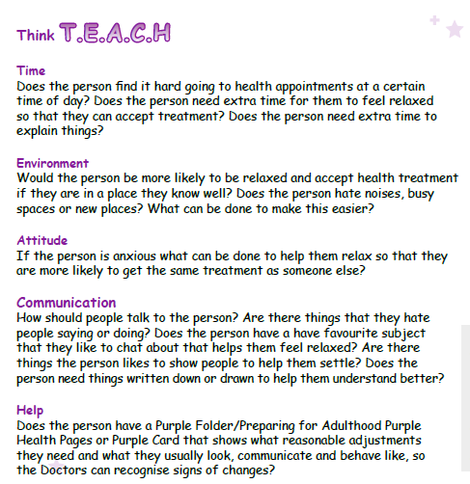

TIME

* 
* **Take time** to find out the needs of the person and gather good background information, share this information with other health professionals.
* **Take time** to go back to the referrer if they have not shown up for an appointment, to see if there is anything else you could do to help them attend.
* **Take time** to make sure they have made an informed decision not to attend the appointment and that they fully understood the implications of not attending.

**GAVIN SAYS**

[**Gavin Says - Think about time of day**](https://www.youtube.com/watch?v=yk2M8Ov1J0I)

Gavin tells us about his friend who could not deviate from his structured day without it causing him distress, he would allocate himself 2 hours a day which he called his ‘free time’ and could only tolerate appointments or extra things in his day within this allocated free time.

* Try to offer different **times** of the day for appointments.
* **Take time** to explain about medications or procedures and make sure the person has understood, maybe ask them to repeat back to you what they need to do.

**Time to talk and make a Pledge**

Make the time to gather background information on your patients

Can you give extra time for appointments where needed?

Can you offer different times of the day for appointments for people who need them?

Please transfer your Pledges to the team’s pledge Document at the end of this handbook.

**NOTES:**

|  |
| --- |
|  |

PRINCIPLE 5

Environment

**Please watch this video alongside this section of the handbook:** [**Principle 5**](https://www.youtube.com/watch?v=18JOV5JlJ4Q&list=PLBSjtUxPa6TWk1PIwhfOSW0Ah0OPbh3pn&index=5)

**The environment is not just the building, it is the people around you, images on the walls or screens, smells, things around you and noises. Some people struggle with sensory overload of a clinical environment…**

**Sensory Overload of the environment.**

Sensory overload is very common in people with a learning disability and autistic people.

Just being able to climb in their shoes and imagine what YOUR environment may feel like for them will help YOU to know how to help them.

Remember that they MAY not be able to filter out things that aren’t relevant to them.

* **ALL** noises may sound excessively loud – they may be sounds so familiar to you that you don’t hear them, like the beep of the appointment machine or the growl of the blood pressure machine
* **ALL** images on the wall may be leaping out at them
* **ALL** equipment and furniture MAY be alarming if its unfamiliar to them
* **ALL** smells will impact their stress levels, especially unfamiliar smells



**Imagine ….**

You have been zapped into the sky and dropped in a room on another planet … imagine how you would be trying to instantly take in everything around you and assess the risk and fear… how would you feel?

Your heart is racing, your eyes are darting around, you are shaking, you start to cry, something totally unfamiliar approaches you … you jump, you scream. They move to touch you … You hit out and run but there is nowhere to go … you start knocking things over in your desperate plea to find a safe place…

**This is Fight or Flight mode …. If someone’s behaviour is challenging … they are probably in fight or flight mode - what are they communicating and what can you do to answer that communication and help them feel in that safe place?**

You could…

* Seek the guidance of those that know the person well to see what they think will help.
* Mirror their actions of reassurance
* Ensure your body language, tone and facial expressions are giving an aura of kindness, caring, and understanding … not fear, frustration and wanting them to go…
* Take time to allow them to come out of fight or flight mode and feel secure in your company
* Remember … it’s not behaviour … its communication

**When someone struggles with your environment,**

**it’s time to think outside the box-here are some examples:**

* A man is always seen in the car outside, this is where he feels safe and will allow first level of investigations to happen. If further things are needed then a best interest decision can be made as to how to progress, but without this stage everything would remain undiagnosed
* A man who hates waiting rooms and noise wears his headphones and waits in the car, he then goes straight into the room when it’s his time
* A lady who brings her dog because she is only calm when her dog is with her. A member of staff waits with her dog outside when she is called in to the appointment
* A lady who likes the waiting room as she likes to look at the fish… but hates it when its noisy, must have appointments very early when it is quiet and has a chair facing the fish tank ready… she will then relax and engage
* Another gentleman loves to ‘high-five’ everyone, when he enters a clinical setting, if everyone ‘high-fives’ him he will accept treatment, if they don’t, he refuses treatment

**GAVIN SAYS…**

[**Gavin Says - Think about whether a change in environment will help**](https://www.youtube.com/watch?v=gvf76225sYA)

When he was in the emergency department for deep vein thrombosis, he was getting very agitated because of all the noise and smells around him. He needed someone to reassure him, but instead the lady got out lots of equipment and Gavin asked what it was all for, she replied it was to check his heart! This increased Gavin’s anxiety and made him want to leave. Luckily, the learning disability nurse could see Gavin was upset, so took him outside for a change of environment, some fresh air and to explain everything that was going on.

**Time to talk and make a Pledge**

What can you do as individuals or a service to adapt your physical environment?

Hide equipment that isn’t needed?

Have a less busy wall?

Provide a quiet space?

Have the option for people to wait outside?

Gain the skills and confidence when someone is anxious, to bring them out of flight or fight mode.

Please transfer your Pledges to the team’s pledge Document at the end of this handbook.

**NOTES:**

PRINCIPLE 6

Attitude

**Please watch this video alongside this section of the handbook:** [**Principle 6**](https://www.youtube.com/watch?v=tf0Tugnik08&list=PLBSjtUxPa6TWk1PIwhfOSW0Ah0OPbh3pn&index=6)

This isn’t just about treating everyone with dignity and respect but is also about valuing everyone’s life equally. If a person isn’t accepting medical treatment or examinations, then the medical practitioner needs to be considering their mental capacity to understand **WHY** the treatment/investigation is being recommended and the possible **RISKS** of not having it.

It’s having the attitude to find solutions to the obstacles that the persons learning disability puts in the way of them receiving an equitable health service. If they don’t have capacity to understand, weigh up the risks of their refusal then a best interest decision must be made, ensuring every step possible has been taken to meet their health needs.

**GAVIN SAYS…**

[**Gavin Says - make sure you explain WHY the person needs the healthcare**](https://www.youtube.com/watch?v=uQ3Vq3Hmpac)

**It is not about being kind and using the ‘Aww bless’ attitude, when he had his fear of needles, often he was told ‘ok, don’t worry about it then’ and did not proceed with the treatment.**

**After one nurse took the time to explain to Gavin why it was so important, in a way he understood, his first thought was ‘didn’t all the other people care about my health then?’ and ‘did they want me to die?’. He describes this as ‘Killing with Kindness’.**

**Gavin also has difficulty maintaining a healthy weight and people would often offer biscuits and sweet treats to him, trying to be nice and kind, but once he learned about the dangers of being obese, he realised this was not the best thing for them to do and they should have been talking to him about the risks of being overweight instead.**



**A Harry Potter Reasonable Adjustment**

**A man with a learning disability who refuses all medical interventions has found a way of accepting them through his love of Harry Potter.**

**With most medical decisions he does not have the capacity to fully understand the risks of his decision to refuse treatment and so Best Interest Decisions must be made.**

**He recently reached a point that his refusal to have his toenails cut was impacting his ability to wear shoes and walk.**

**The GP was weighing up whether it was in his best interest to have a general anaesthetic as his behaviours meant he would not accept any podiatry support whilst awake.**

**The risk of infection and inability to mobilise was a tough decision to weigh up against the risk of anaesthetic.**

**Then, one of our learning disability nurses discovered his passion for Harry Potter and started to think outside the box.**

**With good communication, a bit of creativity, a bit of wizardry attire, a couple of wands and an open-minded podiatrist, they were able to set up his Hogwarts podiatry within his flat and all assumed different Harry Potter characters. It took time, but they worked their ‘magic’ without any need for risky anaesthetic.**

**A great example of least restrictive approaches to best interest decision making.**

**So … when someone asks you to talk about Dogs to help a person remain calm or asks you to see them in the car instead of the consulting room, think of Harry Potter and stick on whatever the metaphorical wizard hat is, that is required to get equitable health outcomes for YOUR patient*.***

**Time to talk and make a Pledge**

**What can you do as a service to ensure your attitude is a solution finding one, that enables someone with a learning disability or autism to get the same health outcomes as anyone else?**

|  |
| --- |
|  |

Please transfer your Pledges to the team’s pledge Document at the end of this handbook.

**NOTES:**

PRINCIPLE 7

Communication

**Please watch this video alongside this section of the handbook:** [**Principle 7**](https://www.youtube.com/watch?v=4Nik-aF7i6s&list=PLBSjtUxPa6TWk1PIwhfOSW0Ah0OPbh3pn&index=7)

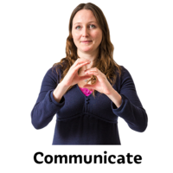

There are no golden rules on how to communicate, as it is different for everyone, but being able to put yourself in the shoes of the person, being empathetic and reading their communication style is a good place to start.

Communication is using accessible information to enable understanding, for example, easy read leaflets, pictures, symbols, or sign language and using the Purple Folder to both read back and record. The purple Folder will enable health professionals to understand the person’s baseline and assess changes in their health that they may not be able to verbalise.

(See page 38 for information about the purple folder)

Only a small percentage of communication is verbal, it is mostly body language. If you don’t give off an aura of safety, warmth, and friendliness, then the person is unlikely to accept any physical examinations from you.

On the next two pages are ten top tips on how to communicate effectively with someone who has a learning disability.

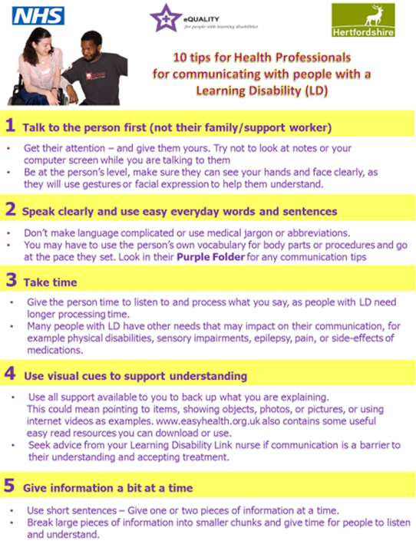

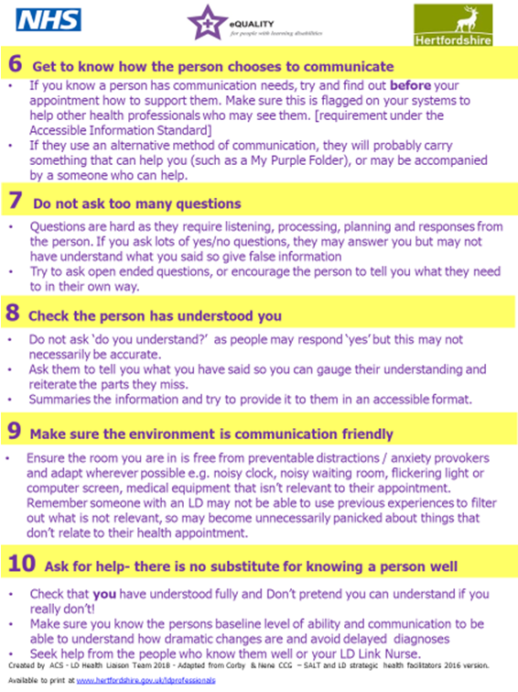

**Communication**

**Complete your background research**

Don’t forget, if you have done your background research you should have all the core knowledge about that person. For example, one gentleman absolutely hated the phrase ‘young man’ and if he was greeted with this on arrival, he would become very agitated, and it would disrupt the service you are trying to provide him. Some things you just need to know about a person and no two people are the same.

**Getting help to communicate**

Remember to involve the carer, support worker, family member or friend… whoever has come along to support the person, because they are the ones who know them best, they will be able to tell if they are communicating well and understanding everything that is being said.

You need to open that door of communication *‘*You are an expert in Simon… please tell me, what is he usually like? What do you think he may be communicating/ may be wrong with him?’

****As someone working within a health setting… from first call through to clinician you ARE the SCARIEST people on the planet.

People are apprehensive about ‘opening up’ to you unless asked.

Diagnosis when there are communication barriers is all about finding the pieces of the diagnostic jigsaw puzzle … you need the help of the people who know the person well to make sure you get enough pieces to build an accurate picture.

**Time to talk and make a Pledge**

What can you do as individuals or a service to improve your communication skills and confidence to ensure they don’t have an impact on equitable health outcomes?

Please transfer your Pledges to the team’s pledge Document at the end of this handbook.

**NOTES:**

|  |
| --- |
|  |

PRINCIPLE 8

Help

**Please watch this video alongside this section of the handbook:** [**Principle 8**](https://www.youtube.com/watch?v=gV_kWE-FoHA&list=PLBSjtUxPa6TWk1PIwhfOSW0Ah0OPbh3pn&index=8)

Getting help means listening to others (carers, parents, people who support the person in society and partners) **THEY** are the experts in the person and may have essential information to help you build the jigsaw puzzle of diagnosis.

Also, **HELP** is about seeking help or advice from specialist services when you have concerns or are unable to find solutions to meeting the persons health needs (for example a community Learning Disability Nurse or Social Worker).

**Mental Capacity and Best Interest**

The **Mental Capacity Act 2005** sets out the law around supporting people with learning disabilities to make decisions. The CIPOLD report found that poor adherence to the Mental Capacity Act led to premature deaths of people with Learning Disabilities. It is vital that everyone involved in providing healthcare to people with a learning disability understands and follows the Mental Capacity Act.

**In This Section we try to help embed an understanding of how Mental Capacity and Best Interest is something you do every day – if you decide NOT to do something for someone who doesn’t have capacity to understand what is needed, you have, in effect, made a Best interest decision … so we want to help you to truly understand this law in everyday practice.**

**ACID Test**

**Always think…**

**If someone without a learning disability came to me with the same ailment/illness/treatment/need, what would I be doing and in what timeframe?**

**If that is not achievable because of barriers due to their learning disability, THEN you need to assess their Capacity to understand what is needed and the risk of not doing it.**

**Then, if they are NOT able to make an informed decision with their refusal – you need to clinically act in the BEST INTEREST using LEAST RESTRICTIVE approaches to get EQUITABLE health outcomes.**

**Five Principles of MCA:**

1. **Never Assume!** Just because someone has a diagnosis of a learning disability does not mean that they lack capacity on every decision.

Simplify the bare minimum information you would expect ANY patient to understand and explain it in those terms.

You MUST assess for each situation and cannot make a blanket statement that someone with a learning disability does not have capacity. The person’s capacity to understand may be altering with each medical decision, and at different points in their life.

2. **Informed Decisions:** You must make practical steps to support someone with a learning disability to understand and make an informed decision. Remember the C in TEACH. If there is minimal risk of delaying treatment and it is felt, with time, they may be able to understand and accept treatment, then give the people who support the EXACT simplified information that you would expect them to understand to be deemed to have capacity.

**THINK CURB**

• **Communicate** – Tell them why you think the investigation/treatment is a good idea and what the risk is if you don’t do it. Get the people who support them to help if necessary. Can the person communicate that they have understood this back to you?

• **Understand** – Check they understand what you have said and again use their person who supports them to help

• **Retain** – This would be via for example, them telling you back what will happen and why in their own words. Not just parroting or saying ‘yes’

• **Balance the decision** - Weigh up the information and choice they have made. This would mean they would need to show that they understand the possible consequences of refusing

**If the person Does NOT have Capacity, it is a MEDICAL best interest decision. Next of Kin and Carers CANNOT consent or refuse consent on behalf of the patient UNLESS they have lasting power of attorney for their health and wellbeing**

3. **Unwise Decisions:** People with Learning Disabilities have the right to make unwise decisions. So, if they can demonstrate that they understand the risk of their decision this is their choice. You can ask people who support them to keep discussing and encouraging them to change their mind, but you cannot make a best interest decision if THEY have capacity in this medical decision.

“I know that the smear test can help make sure I never get cancer there, but I would rather risk dying of cancer than have a smear test’”.

4. **Best Interests:** If a person with a Learning Disability has been found to lack capacity about a decision, then a best interests decision needs to be made.

• If it is a small decision with negligible health risks you can make this there and then with the carer (for example, carrying out a physical examination, taking bloods, flu jab, completing annual health check)

• Bigger decisions with bigger health risks need a multi-disciplinary decision

**You do this every day!** – you weigh up what is the right course of action for the patient, and you tell them. When they don’t understand, you weigh up, with the people who support the person, how achievable that course of action is and what would need to be done to achieve this successfully… **Remember the H in Help. The people in their life are the experts in the person … you are the experts in health … this is Teamwork.**

The Health Professional can take into consideration the next of Kin’s and carers views **BUT** the carer and Next of Kin **CANNOT** make the decision. It is a medical decision as to what is in the best interest of the patient. It is **ONLY** when someone holds **lasting power of attorney for health and welfare** that someone else can make the decision for the person.

5. **Less Restrictive:** Where possible, always use the less restrictive option.

Example: Someone with a learning disability who is needle phobic and requires a blood test in their best interests. Covert approaches and Distraction techniques should be weighed up as these would be less restrictive than a general anaesthetic. If the only approach adds risk itself, then you must weigh up whether the risk of the approach is greater than the risk of not proceeding.

**If you need HELP from the Learning Disability Nursing Service then Here is an outline of the nursing service we offer** Within Learning Disability Nursing in Adult Social Care – we also have a number of specialisms – but again, we all work very closely together so can pass to our approriate nursing colleagues

**Hertfordshire County Council**

**Learning Disability Nursing Service**

Adult Care Service

**Health Liaison Team**

**Countrywide**

* Strategic Liaison Nurse Leads
* Health Improvement & Prevention Team (HIP)
* Epilepsy Specialist Nurses (ESN)
* Acute Liaison Nurses (ALN)
* Training Lead
* Information Quality Officer
* Purple Star Strategy Team
* Creative Practitioner & Purple All-Stars
* Expert by Experience Advisor
* Health Equalities Nurses (HEN)

**East**

Learning Disability Nurses in each Adult Disability Social Care Team working with people aged 25 or over

* East Herts
* Broxbourne
* North Herts
* Stevenage
* Welwyn and Hatfield

**West**

Learning Disability Nurses in each Adult Disability Social Care Team working with people aged 25 or over

* Dacorum
* Watford and Three Rivers
* Hertsmere
* St Albans

**0-25 Together**

**Countrywide**

Learning disability nurses work as part of this service but with people aged 18 – 25 only.

They can use all the additional nursing services under the Health Liaison Team and are also clinically overseen by the learning disability nurses in the Adult Disability Service

To make a referral to the Adult Care nursing service – you need to complete the nursing referral form [referral form](https://www.hertfordshire.gov.uk/media-library/documents/adult-social-services/ld-gp-referral-form.pdf) and it can be returned direct to the relevant team [above]

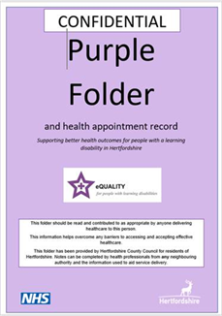**Purple Folder**

The purple folder is a health passport that is offered to adults with learning disabilities living in Hertfordshire. Please click on the link below or visit our website for more detail.

Good use of the Purple Folder can reduce the risk of delays in Diagnosis due to communication barriers or reluctance to accept investigations or treatment. It should be used by ALL health services in Herts when a patient attends an appointment with one. If someone with a learning disability says they do not have one, all health services should encourage them to get one. [The Purple Folder | Hertfordshire County Council](https://www.hertfordshire.gov.uk/services/adult-social-services/disability/learning-disabilities/my-health/my-purple-folder.aspx)

The Purple Folder provides health professionals with a holistic overview of the person’s health and their baseline abilities, recent history of other health professional’s involvement to help build a diagnostic picture, the reasonable adjustments that need to be made, communication needs of the person to ensure they understand and can make informed choices as well as to ensure you, as health professionals, know whether they are communicating pain or ill health *(for example, one lady screams and bites her hand and this indicates she is excited and happy. Another lady screams and bites her hand and this indicates she is in excruciating pain)* the level of support the person needs to enable them to successfully access healthcare services and the support level they would need with personal care, eating and drinking should they be admitted to hospital.

It is a tool that can support you, as a health professional, to confidently communicate and work with an individual in the most appropriate manner for them. It is a requirement under the **Equality Act** to make reasonable adjustments and a requirement under the **Accessible Information** **Standard** to use a person’s preferred means of communication. The purple folder is deemed to be a health document and therefore, if the information is within the Purple Folder and a health service does not utilise it, they could be questioned over their compliance with these two legislations. The Purple Folder is there to help. To order a purple folder, please direct the person with a learning disability (over the age of 18) to email[purplefolder@hertfordshire.gov.uk](mailto:purplefolder@hertfordshire.gov.uk)

**What should you do when someone brings their Purple Folder to your service?**

1. If there are any barriers to you being able to give them the same healthcare you would anyone else, check the reasonable adjustments section and communication section to see if there are things you can try that their carer hasn’t told you.
2. If you discover something that helps the person e.g., if I talk about dogs he calms and then he trusts me and engages with healthcare, then make sure this is added to the reasonable adjustment’s sections so others in the future can use this top tip too.
3. If you are unsure whether they are in pain or of the severity of their illness, read the ‘how I behave when I am well / unwell’ pages to see if they are likely to be non-verbally communicating more extreme symptoms than you can establish. Also, check the baseline measurements that are recorded in the folder to see how far off baseline they are.
4. If the person has come without support, then complete one of the blank pages called ‘The Health Plan after Todays appointment’ and write in clear and simple language.
5. After an Annual Health Check, make sure the Health Check action plan is stored in the annual health check section and you have record on the annual health check record page. If the baseline measurements page hasn’t been updated, then add any that have been taken at the annual heath check and remind the person the annual update of the purple folder is due at annual health check time.
6. Always write a brief summary in the health appointment record.

**The Health Appointment Record**

This should be written on by ALL the health professionals who see the person. It only needs a brief outline of the appointment and actions. This will help gain an overview of all health interventions the person may be currently receiving to aid diagnostic decisions. The records should be kept in chronological order to make this easier for you.

An example of good use of this was a gentleman who started having falls, he became unsteady on his feet, disengaged, slept more, uninterested in the TV and his books. The GP did NOT look at the appointment record pages and went down the pathway of neurology and possible dementia. The neurologist DID look at the record and identified a sudden onset of these changes in February. It was identified he had seen an optician in February and been given a new prescription for glasses… this prescription was completely wrong. All the symptoms related to not being able to see. This would have been identified and resolved a lot earlier had the GP read records.

**Getting a NEW 2023 Version of the purple folder**

Whether someone has never had a Purple Folder or have an old version [Old versions will say MY purple Folder … new ones say Purple Folder] they are all entitled to a new Version.

All pages are available on the website here [www.hertfordshire.gov.uk/purplefolder](http://www.hertfordshire.gov.uk/purplefolder) for the person to complete electronically online and print and add to their folder. To receive folder and inserts they can contact us on01438 845372 or email [purplefolder@hertfordshire.gov.uk](mailto:purplefolder@hertfordshire.gov.uk)

If you think the person does not have a support network to help them complete the Purple Folder, then please let us know and we will support them. We will ask you the key Reasonable Adjustments and Communication approaches that you have established with the person to ensure these are in their folder.

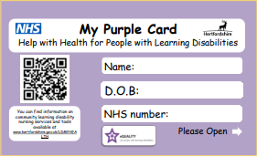**Purple Cards**

We have also created purple cards that can be stored in a person’s wallet and contain the core information on reasonable adjustments, communication needs and help with health. These are a useful addition [not replacement] to the purple folder for people who are more independent and may be out without their purple folder. Do you have patients who would benefit from this? [purplefolder@hertfordshire.gov.uk](mailto:purplefolder@hertfordshire.gov.uk)

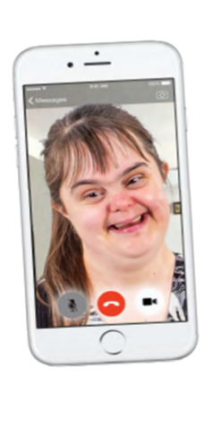

**Me on My Best Day**

We have a campaign to encourage all people with a learning disability to film a 20 second video showing what they look, behave, and communicate like when they are well. This is to help health professionals understand how far off their baseline they are. Can you ask your patients to make sure they have one of these on their phone?.

This video [Me on my best day](https://www.youtube.com/watch?v=oA-RP4JPmz8&list=PLBSjtUxPa6TVIjsjjyndYwos11B8r-MAD&index=2) is a great one for sharing and letting people know it is a good idea to record a video of them on their best day, so health professionals can see any changes in behaviour.

**Our Pledge**

**record your services pledge for what you will change in your practice to ensure better use of the Purple Folder.**

**The Purple All Stars**

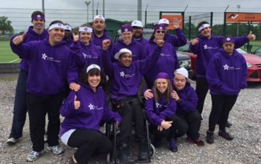

As part of the Community Learning Disability Service in Hertfordshire, the Health Liaison Team employs a Creative Practitioner. Our Creative Practitioner uses creative arts to communicate and teach key health messages to people with a learning disability and their carers. The people in this group form The Purple All Stars. They are supported by the Creative Practitioner to perform and share health messages through plays, song, and dance. Click here [The purple all stars](https://www.youtube.com/watch?v=ICV4vGSYM1k&list=PLBSjtUxPa6TVIjsjjyndYwos11B8r-MAD) to view all of videos performed by our Purple All Stars!

**YouTube channel**

**(Please subscribe!!!)**

[**community learning disability nursing service**](https://www.youtube.com/channel/UCI_FEr3X73M---A_bpnxUnQ)

**DNA CPR’s and ReSpect Documents**

**If you have any involvement in DNA CPR’s, then please make sure they have been correctly put in place.**

**The Safeguarding Board released a step by step guide to help ‘people who support someone’ and health professionals ensure these are correctly completed.**

[A step-by-step guide to putting a do not attempt cardiopulmonary resuscitation order in place (hertfordshire.gov.uk)](https://www.hertfordshire.gov.uk/media-library/documents/adult-social-services/factsheets/easy-read/dnacpr-support-guide.pdf)

SINCE Hertfordshire have adopted the ReSpect tool it has been noted that these have scope for being completed in a way that can appear that the clinician is making a value-based judgement rather than a clinical judgement. So please check the wording and that the person has been enabled to be as involved as possible.

Here is a **Link to a Guide** and some examples – but also feel free to contact us for support [purplestarstrategy@hertfordshire.gov.uk](mailto:purplestarstrategy@hertfordshire.gov.uk)

*It is essential that the person is given the opportunity to understand this medical decision too…*

Here is an easyread tool you can use to explain CPR.

[What if my heart stops? easy read](https://www.hertfordshire.gov.uk/media-library/documents/adult-social-services/factsheets/easy-read/dnacpr-easy-read-leaflet.pdf)

**Conversations when a person is unwell.**

**Abbreviations**: **DNACPR or DNAR or DNR** - Do Not Attempt Cardio-pulmonary Resuscitation

**MCA** - Mental Capacity Act  **LPA** - Lasting Power of Attorney

**IMCA** - Independent Mental Capacity Advocate

Safeguarding

Safeguarding means protecting people's health, wellbeing and human rights and enabling them to live free from harm, abuse, and neglect. It is fundamental to high-quality health and social care. The main areas of abuse are:

* + Physical
  + Sexual
  + Financial
  + Psychological/emotional
  + Neglect and acts of omission
  + Discriminatory
  + Organisational abuse
  + Neglect and poor practice
  + Self-neglect
  + Domestic Abuse
  + Modern Slavery

Report anything that may potentially be deemed abuse at any level.

Even if it is just an uncomfortable feeling you have, still report it so it can be investigated.

Never put yourself in a position where you could regret not mentioning something.

**Link to safeguarding portal:**

[Report a concern about an adult - Hertfordshire County Council](https://www.hertfordshire.gov.uk/services/adult-social-services/report-a-concern-about-an-adult/report-a-concern-about-an-adult.aspx)

**The murder of Steven Hoskin**

**What happened?**

Steven Hoskin lived alone in St Austell; he had a learning disability placing him at risk of abuse. Steven was 39 years old and was subjected to “harrowing” abuse ending in his death in St Austell, Cornwall on 6 July 2006.

He was forced to swallow a lethal dose of paracetamol, hauled around his bedsit by a dog collar and burned with cigarettes.

Darren Stewart, 29, and Sarah Bullock, 16, were convicted of Hoskin’s murder.

They had made Steven walk to a viaduct and forced him to climb over the edge leaving him holding on for his life. Bullock then made Hoskin fall 30 metres to his death by kicking his face and standing on his hands.

A serious case review and an internal management review, highlighted failings to share information between numerous agencies.

He had been placed in a bedsit by adult social care in April 2005 and he was allocated two hours of help each week, but he chose to cancel the service in August and by September the council closed his case. The serious case review found that Steven Hoskin then “lost all control of his own life” when Stewart and his girlfriend moved in and began to abuse him.

Steven’s decision to end contact with adult social care “was not investigated or explored”, the review found.

**Prior to his death, Steven had contacted different agencies over 40 times, including the police and health and social care agencies to indicate he felt he was in danger, but no report was vocalised by him well enough to be fully acted on. None of these reports were ‘joined up’ to be able to unpick the degree of risk Steven was in.**

**Actions for improvement**

Following the SCR, the following improvements and actions have been taken to improve adult safeguarding practice:

* Improved systems of information sharing and reporting, encouraging a rapid response
* Development of police and ambulance systems to indicate when there are repeat calls from the same people. This enables information to be shared between relevant agencies to develop appropriate, comprehensive responses
* Increased awareness of agencies to be more responsive to signs of suspected abuse where the adult is at risk because of a pre-existing condition. In Steven’s case this was his learning disability

**EVEN IF IT’S A SMALL CONCERN – REMEMBER!**

**EVERY TINY BIT OF INFORMATION YOU SUPPLY MAY BE A SIGNIFICANT PIECE TO A BIGGER PICTURE!**

Here is a video outlining the case study of Steven Hoskin’s murder and what has changed since. It highlights when a safeguarding response is required and what problems persist:

[Have we learned the lessons from Steven Hoskin's murder?](https://youtu.be/PuHkan39KOY)

**Time to talk and make a Pledge**

What can you do as individuals or a service to improve ensure you use the HELP needed to overcome the barriers of limited capacity and achieve equitable health outcomes?

Can you improve you use of the Purple Folder or Purple Card?

Do you ask for the Me on my Best day Videos?

Do you have a Learning Disability Champion to help staff ensure all elements of HELP are covered?

Please transfer your Pledges to the team’s pledge Document at the end of this handbook.

|  |
| --- |
|  |

**NOTES:**

**RECORD OF PLEDGES IN PRACTICE Training Completed**

**TO RECEIVE PURPLE PLEDGE OF PRACTICE RECOGNITION THE FOLLOWING DOCUMENTS CAN BE SUBMITTED TO THE PURPLE STAR TEAM.** [PurpleStarStrategy@hertfordshire.gov.uk](mailto:PurpleStarStrategy@hertfordshire.gov.uk)

We (name of service) under the organisation of (Name of Trust/organisation/company) pledge to the purple principles of enabling equitable health outcomes for patients with a learning disability and/or Autistic people.

***The named people in the team taking responsibility for this are:***

……………………………………………………………………………………………………………………………………………………………

|  |
| --- |
| **Please detail the process you will use for governance for overseeing the pledges are achieved**  (Include: who the governance lies with and when/how it will be reviewed within your organisation). |

|  |  |  |  |  |  |  |  |  |
| --- | --- | --- | --- | --- | --- | --- | --- | --- |
| **Principle number/date completed** | | | | | | | | |
| **Name/Role** | **1** | **2** | **3** | **4** | **5** | **6** | **7** | **8** |
|  |  |  |  |  |  |  |  |  |
|  |  |  |  |  |  |  |  |  |
|  |  |  |  |  |  |  |  |  |
|  |  |  |  |  |  |  |  |  |
|  |  |  |  |  |  |  |  |  |
|  |  |  |  |  |  |  |  |  |
|  |  |  |  |  |  |  |  |  |
|  |  |  |  |  |  |  |  |  |
|  |  |  |  |  |  |  |  |  |
|  |  |  |  |  |  |  |  |  |

**Record of Pledges of Purple Principles**

**Service / Teams Pledge Document**

|  |  |  |  |  |
| --- | --- | --- | --- | --- |
| **Date** | **Name (s) of people making the pledge** | **Pledge of improvement/current practice that will be maintained** | **Date of review** | **Outcome/update** |
|  |  |  |  |  |
|  |  |  |  |  |
|  |  |  |  |  |
|  |  |  |  |  |
|  |  |  |  |  |
|  |  |  |  |  |
|  |  |  |  |  |

**Useful Websites and Telephone Numbers**

Information for people with learning disabilities – [www.hertfordshire.gov.uk/LDMyHealth](http://www.hertfordshire.gov.uk/LDMyHealth)

Information for professionals – [www.hertfordshire.gov.uk/LDProfessionals](http://www.hertfordshire.gov.uk/LDProfessionals)

**Help in the Community**

Advocacy services – [www.pohwer.net/](http://www.pohwer.net/) 0300 456 2370

Carers in Herts -[www.carersinherts.org.uk/](http://www.carersinherts.org.uk/) 01992 586969

Herts Help - [www.hertshelp.net/](http://www.hertshelp.net/) 0300 123 4044

Health Watch - [www.healthwatch.co.uk/](http://www.healthwatch.co.uk/) 0300 068 3000

**Safeguarding Adults -**<http://www.hertfordshire.gov.uk/services/healthsoc/supportforadults/worriedabout/vulnadult/HSAB/>

[http://www.scie.org.uk/publications/elearning/adultsafeguarding](https://www.scie.org.uk/search/?_s=safeguarding)

Hertfordshire County Council - <http://www.hertfordshire.gov.uk/> 0300 123 4042

Hertfordshire Partnership Foundation Trust - [www.hpft.nhs.uk/](http://www.hpft.nhs.uk/)

NHS Patient advice and Liaison service - [www.hertfordshire.nhs.uk/pals.html](https://www.nhs.uk/nhs-services/hospitals/what-is-pals-patient-advice-and-liaison-service/)

Mencap - [www.mencap.org.uk/](http://www.mencap.org.uk/) 0808 808 1111

**Easy Read/Signs and symbols**

Easy read health resources - [www.easyhealth.org.uk/](http://www.easyhealth.org.uk/)

Makaton - [www.makaton.org/](http://www.makaton.org/)

Photo Symbols – [Welcome to Photosymbols](https://www.photosymbols.com/)

**Resources/Useful websites**

Mental Capacity Act - <https://www.gov.uk/government/collections/mental-capacity-act-making-decisions> A brief guide to the Mental Capacity Act (2005): Implications for people with learning disabilities.  Available from British Institute of Learning Disabilities [www.bild.org.uk](http://www.bild.org.uk) (£10.00) or as a free download at

[www.scie.org.uk/publications/mca/files/bild-mca.pdf](https://www.scie.org.uk/search/?_s=mca)

Mental Capacity consent pathway and Best Interest Decision pathway are available here <http://www.rcgp.org.uk/learningdisabilities>

<https://www.gov.uk/government/publications/reference-guide-to-consent-for-examination-or-treatment-second-edition> DoH reference guide to consent to examination and treatment

<https://www.gov.uk/government/collections/mental-capacity-act-making-decisions> Mental capacity Act 2005